A-R-E Component Practice Activity
  - Source: Umbreit, Ferro, Lane, & Liaupsin (2024)

Step 1: Use the Function Based Intervention Decision Model to Determine an Intervention Method
- Context: Whenever Marcus is given a multi-step math worksheet (i.e., > 5 problems), he begins to crumble the paper, mutter under his breath, and eventually sweeps his materials off the desk
- Hypothesized Statement of Function: When presented with independent math tasks, Marcus engages in off-task behavior to escape too difficult and effortful tasks (Function: Negative Reinforcement [Escape]: Activity/Tangible)
- Skills Assessment: Marcus has the math calculation skills to complete the math assignments (i.e., performing on-grade level per academic screener). He seemingly becomes overwhelmed by the visual density of the page.
- Tier 1 Context: Marcus’ teacher uses the district-provided Tier 1 math curriculum, directing students to complete the independent work in their math workbooks. Recent Ci3T Treatment Integrity: Direct Observation data indicates limited use of low-intensity strategies, differentiated instruction, checks for understanding, or use of school-wide universal reinforcement system (i.e., Lion Bucks) paired with behavior specific praise.
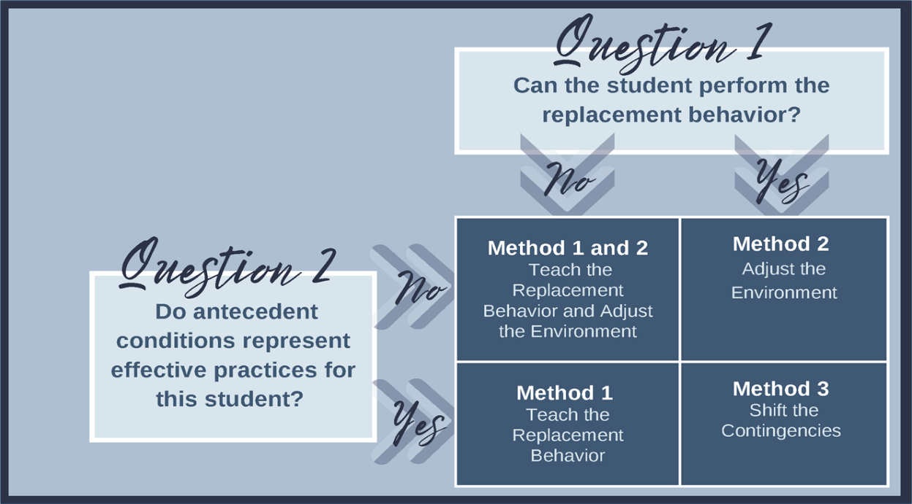

Step 2: Generate A-R-E Components (Method 2: Adjust the Environment)
Adjust Antecedents | Adjust antecedent variables so the conditions that set the occasion for the target behavior are eliminated and new conditions are established in which the replacement behavior is more likely to occur.
Reinforcement Rates | Provide appropriate reinforcement for the replacement behavior.
Extinguish Target Behavior | Withhold the consequence that previously reinforced the target behavior.

