[School Name]
  - 20XX-20XX Ci3T Leadership Team Meeting Agenda

Table of Contents and Information Hub

Ci3T Leadership Team Meeting Norms
Expectations
[expectation 1]
[expectation 2]
[expectation 3]

Meeting Schedule and Agenda Archive
Monthly Ci3T Leadership Team Meetings | Ci3T Implementation Professional Learning Series Agendas
07/xx/xx | Session 1
08/xx/xx | Session 2
09/xx/xx | Session 3
10/xx/xx | Session 4
11/xx/xx | Session 5
12/xx/xx
01/xx/xx
02/xx/xx
03/xx/xx
04/xx/xx
05/xx/xx
06/xx/xx

Meeting Logistics
Before the Meeting | After the Meeting
- Provide Ci3T Leadership Team members (including your coach and district rep) with advanced notice (e.g., week-before) and a reminder (e.g., day-before) of the meeting. | - Share meeting notes and action plans with Ci3T Leadership Team members.
- Update agenda based on school needs, previous action plans, and available data. | - Ensure all action items indicate who is responsible and when it is due.
- Share agenda with all Ci3T Leadership Team members before the meeting. | - Share updates with faculty and staff.

School Team Meeting Agenda Hub
Team Name | Link

Ci3T Documents
Document Name | Link

Ci3T Leadership Team
Name | Role | Team Role*
*Team roles commonly include team leader, timekeeper, note taker, and data analyst.

Data Collection Year-at-a-Glance

Academic Screening Window
Time | Preview | Open | Close
Fall
Winter
Spring

Behavior Screening Window
Time | Preview | Open | Close
Fall
Winter
Spring

Treatment Integrity & Social Validity
Time | Open | Close | Report
Fall
Spring

Success Sharing
Date | Successes

Action Steps

Logistics Action Items
Use for planning steps for supporting implementation (e.g., supporting Procedures for Teaching, Reinforcing, and Monitoring).
Action Item | Person(s) Responsible | Planned Completion Date | Date Completed

Completed Items

Problem-Solving Action Plan
Use for Team-Initiated Problem Solving (TIPS), which involves using school-wide data to identify challenges and make action plans.
Problem Statement | Hypothesis (why) | Solutions/Tasks | Who? | By when? | Goal, Timeline, & Decision Rules

Ci3T Leadership Team Meeting Agendas and Minutes

07/xx/xx Meeting
Meeting Information:
Time:
Room / Zoom link:
Data sources to review (provide links if able):
Identify topics to be discussed today and add additional discussion points as needed.

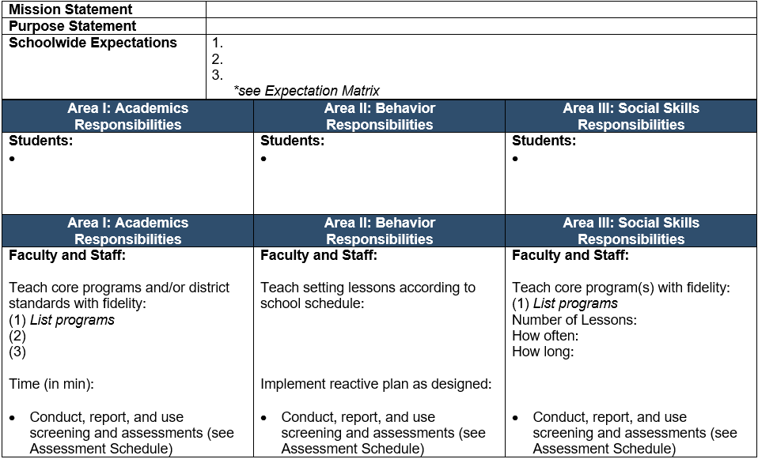
Tier 1: Primary Prevention
Considerations when planning:
- Academic, Behavior, and Social Skills Roles and Responsibilities
- Procedures for Teaching
- Procedures for Reinforcing
- Procedures for Monitoring
Topic / Notes | Time Allotted | Lead | Next Steps*
* Take notes from Next Steps to create actionable items, which should be recorded in the Action Steps following the meeting.

Tier 2: Secondary Prevention (see grids)
Considerations when planning:
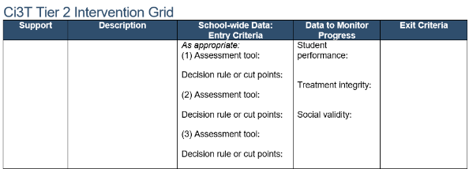
- What interventions are being used and how many students are receiving them?
- What supports do teachers need to implement interventions with integrity?
- Are students receiving Tier 2 support being successful?
Topic / Notes | Time Allotted | Lead | Next Steps*
* Take notes from Next Steps to create actionable items, which should be recorded in the Action Steps following the meeting.

Tier 3: Tertiary Prevention (see grids)
Considerations when planning:
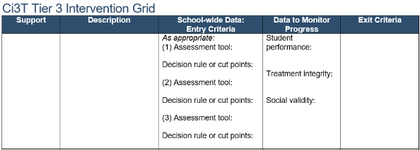
- What interventions are being used?
- What supports do teachers need to implement interventions with integrity?
- Are students receiving Tier 3 support being successful?
Topic / Notes | Time Allotted | Lead | Next Steps*
* Take notes from Next Steps to create actionable items, which should be recorded in the Action Steps following the meeting.

08/xx/xx Meeting
Meeting Information:
Time:
Room / Zoom link:
Data sources to review (provide links if able):
Identify topics to be discussed today and add additional discussion points as needed.

Tier 1: Primary Prevention
Considerations when planning:
- Academic, Behavior, and Social Skills Roles and Responsibilities
- Procedures for Teaching
- Procedures for Reinforcing
- Procedures for Monitoring
Topic / Notes | Time Allotted | Lead | Next Steps*
* Take notes from Next Steps to create actionable items, which should be recorded in the Action Steps following the meeting.

Tier 2: Secondary Prevention (see grids)
Considerations when planning:
- What interventions are being used and how many students are receiving them?
- What supports do teachers need to implement interventions with integrity?
- Are students receiving Tier 2 support being successful?
Topic / Notes | Time Allotted | Lead | Next Steps*
* Take notes from Next Steps to create actionable items, which should be recorded in the Action Steps following the meeting.

Tier 3: Tertiary Prevention (see grids)
Considerations when planning:
- What interventions are being used?
- What supports do teachers need to implement interventions with integrity?
- Are students receiving Tier 3 support being successful?
Topic / Notes | Time Allotted | Lead | Next Steps*
* Take notes from Next Steps to create actionable items, which should be recorded in the Action Steps following the meeting.

09/xx/xx Meeting
Meeting Information:
Time:
Room / Zoom link:
Data sources to review (provide links if able):
Identify topics to be discussed today and add additional discussion points as needed.

Tier 1: Primary Prevention
Considerations when planning:
- Academic, Behavior, and Social Skills Roles and Responsibilities
- Procedures for Teaching
- Procedures for Reinforcing
- Procedures for Monitoring
Topic / Notes | Time Allotted | Lead | Next Steps*
* Take notes from Next Steps to create actionable items, which should be recorded in the Action Steps following the meeting.

Tier 2: Secondary Prevention (see grids)
Considerations when planning:
- What interventions are being used and how many students are receiving them?
- What supports do teachers need to implement interventions with integrity?
- Are students receiving Tier 2 support being successful?
Topic / Notes | Time Allotted | Lead | Next Steps*
* Take notes from Next Steps to create actionable items, which should be recorded in the Action Steps following the meeting.

Tier 3: Tertiary Prevention (see grids)
Considerations when planning:
- What interventions are being used?
- What supports do teachers need to implement interventions with integrity?
- Are students receiving Tier 3 support being successful?
Topic / Notes | Time Allotted | Lead | Next Steps*
* Take notes from Next Steps to create actionable items, which should be recorded in the Action Steps following the meeting.

10/xx/xx Meeting
Meeting Information:
Time:
Room / Zoom link:
Data sources to review (provide links if able):
Identify topics to be discussed today and add additional discussion points as needed.

Tier 1: Primary Prevention
Considerations when planning:
- Academic, Behavior, and Social Skills Roles and Responsibilities
- Procedures for Teaching
- Procedures for Reinforcing
- Procedures for Monitoring
Topic / Notes | Time Allotted | Lead | Next Steps*
* Take notes from Next Steps to create actionable items, which should be recorded in the Action Steps following the meeting.

Tier 2: Secondary Prevention (see grids)
Considerations when planning:
- What interventions are being used and how many students are receiving them?
- What supports do teachers need to implement interventions with integrity?
- Are students receiving Tier 2 support being successful?
Topic / Notes | Time Allotted | Lead | Next Steps*
* Take notes from Next Steps to create actionable items, which should be recorded in the Action Steps following the meeting.

Tier 3: Tertiary Prevention (see grids)
Considerations when planning:
- What interventions are being used?
- What supports do teachers need to implement interventions with integrity?
- Are students receiving Tier 3 support being successful?
Topic / Notes | Time Allotted | Lead | Next Steps*
* Take notes from Next Steps to create actionable items, which should be recorded in the Action Steps following the meeting.

11/xx/xx Meeting
Meeting Information:
Time:
Room / Zoom link:
Data sources to review (provide links if able):
Identify topics to be discussed today and add additional discussion points as needed.

Tier 1: Primary Prevention
Considerations when planning:
- Academic, Behavior, and Social Skills Roles and Responsibilities
- Procedures for Teaching
- Procedures for Reinforcing
- Procedures for Monitoring
Topic / Notes | Time Allotted | Lead | Next Steps*
* Take notes from Next Steps to create actionable items, which should be recorded in the Action Steps following the meeting.

Tier 2: Secondary Prevention (see grids)
Considerations when planning:
- What interventions are being used and how many students are receiving them?
- What supports do teachers need to implement interventions with integrity?
- Are students receiving Tier 2 support being successful?
Topic / Notes | Time Allotted | Lead | Next Steps*
* Take notes from Next Steps to create actionable items, which should be recorded in the Action Steps following the meeting.

Tertiary (Tier 3) Prevention (see grids)
Considerations when planning:
- What interventions are being used?
- What supports do teachers need to implement interventions with integrity?
- Are students receiving Tier 3 support being successful?
Topic / Notes | Time Allotted | Lead | Next Steps*
* Take notes from Next Steps to create actionable items, which should be recorded in the Action Steps following the meeting.

12/xx/xx Meeting
Meeting Information:
Time:
Room / Zoom link:
Data sources to review (provide links if able):
Identify topics to be discussed today and add additional discussion points as needed.

Tier 1: Primary Prevention
Considerations when planning:
- Academic, Behavior, and Social Skills Roles and Responsibilities
- Procedures for Teaching
- Procedures for Reinforcing
- Procedures for Monitoring
Topic / Notes | Time Allotted | Lead | Next Steps*
* Take notes from Next Steps to create actionable items, which should be recorded in the Action Steps following the meeting.

Tier 2: Secondary Prevention (see grids)
Considerations when planning:
- What interventions are being used and how many students are receiving them?
- What supports do teachers need to implement interventions with integrity?
- Are students receiving Tier 2 support being successful?
Topic / Notes | Time Allotted | Lead | Next Steps*
* Take notes from Next Steps to create actionable items, which should be recorded in the Action Steps following the meeting.

Tier 3: Tertiary Prevention (see grids)
Considerations when planning:
- What interventions are being used?
- What supports do teachers need to implement interventions with integrity?
- Are students receiving Tier 3 support being successful?
Topic / Notes | Time Allotted | Lead | Next Steps*
* Take notes from Next Steps to create actionable items, which should be recorded in the Action Steps following the meeting.

01/xx/xx Meeting
Meeting Information:
Time:
Room / Zoom link:
Data sources to review (provide links if able):
Identify topics to be discussed today and add additional discussion points as needed.

Tier 1: Primary Prevention
Considerations when planning:
- Academic, Behavior, and Social Skills Roles and Responsibilities
- Procedures for Teaching
- Procedures for Reinforcing
- Procedures for Monitoring
Topic / Notes | Time Allotted | Lead | Next Steps*
* Take notes from Next Steps to create actionable items, which should be recorded in the Action Steps following the meeting.

Secondary (Tier 2) Prevention (see grids)
Considerations when planning:
- What interventions are being used and how many students are receiving them?
- What supports do teachers need to implement interventions with integrity?
- Are students receiving Tier 2 support being successful?
Topic / Notes | Time Allotted | Lead | Next Steps*
* Take notes from Next Steps to create actionable items, which should be recorded in the Action Steps following the meeting.

Tier 3: Tertiary Prevention (see grids)
Considerations when planning:
- What interventions are being used?
- What supports do teachers need to implement interventions with integrity?
- Are students receiving Tier 3 support being successful?
Topic / Notes | Time Allotted | Lead | Next Steps*
* Take notes from Next Steps to create actionable items, which should be recorded in the Action Steps following the meeting.

02/xx/xx Meeting
Meeting Information:
Time:
Room / Zoom link:
Data sources to review (provide links if able):
Identify topics to be discussed today and add additional discussion points as needed.

Tier 1: Primary Prevention
Considerations when planning:
- Academic, Behavior, and Social Skills Roles and Responsibilities
- Procedures for Teaching
- Procedures for Reinforcing
- Procedures for Monitoring
Topic / Notes | Time Allotted | Lead | Next Steps*
* Take notes from Next Steps to create actionable items, which should be recorded in the Action Steps following the meeting.

Tier 2: Secondary Prevention (see grids)
Considerations when planning:
- What interventions are being used and how many students are receiving them?
- What supports do teachers need to implement interventions with integrity?
- Are students receiving Tier 2 support being successful?
Topic / Notes | Time Allotted | Lead | Next Steps*
* Take notes from Next Steps to create actionable items, which should be recorded in the Action Steps following the meeting.

Tertiary (Tier 3) Prevention (see grids)
Considerations when planning:
- What interventions are being used?
- What supports do teachers need to implement interventions with integrity?
- Are students receiving Tier 3 support being successful?
Topic / Notes | Time Allotted | Lead | Next Steps*
* Take notes from Next Steps to create actionable items, which should be recorded in the Action Steps following the meeting.

03/xx/xx Meeting
Meeting Information:
Time:
Room / Zoom link:
Data sources to review (provide links if able):
Identify topics to be discussed today and add additional discussion points as needed.

Tier 1: Primary Prevention
Considerations when planning:
- Academic, Behavior, and Social Skills Roles and Responsibilities
- Procedures for Teaching
- Procedures for Reinforcing
- Procedures for Monitoring
Topic / Notes | Time Allotted | Lead | Next Steps*
* Take notes from Next Steps to create actionable items, which should be recorded in the Action Steps following the meeting.

Tier 2: Secondary Prevention (see grids)
Considerations when planning:
- What interventions are being used and how many students are receiving them?
- What supports do teachers need to implement interventions with integrity?
- Are students receiving Tier 2 support being successful?
Topic / Notes | Time Allotted | Lead | Next Steps*
* Take notes from Next Steps to create actionable items, which should be recorded in the Action Steps following the meeting.

Tier 3: Tertiary Prevention (see grids)
Considerations when planning:
- What interventions are being used?
- What supports do teachers need to implement interventions with integrity?
- Are students receiving Tier 3 support being successful?
Topic / Notes | Time Allotted | Lead | Next Steps*
* Take notes from Next Steps to create actionable items, which should be recorded in the Action Steps following the meeting.

04/xx/xx Meeting
Meeting Information:
Time:
Room / Zoom link:
Data sources to review (provide links if able):
Identify topics to be discussed today and add additional discussion points as needed.

Tier 1: Primary Prevention
Considerations when planning:
- Academic, Behavior, and Social Skills Roles and Responsibilities
- Procedures for Teaching
- Procedures for Reinforcing
- Procedures for Monitoring
Topic / Notes | Time Allotted | Lead | Next Steps*
* Take notes from Next Steps to create actionable items, which should be recorded in the Action Steps following the meeting.

Tier 2: Secondary Prevention (see grids)
Considerations when planning:
- What interventions are being used and how many students are receiving them?
- What supports do teachers need to implement interventions with integrity?
- Are students receiving Tier 2 support being successful?
Topic / Notes | Time Allotted | Lead | Next Steps*
* Take notes from Next Steps to create actionable items, which should be recorded in the Action Steps following the meeting.

Tertiary (Tier 3) Prevention (see grids)
Considerations when planning:
- What interventions are being used?
- What supports do teachers need to implement interventions with integrity?
- Are students receiving Tier 3 support being successful?
Topic / Notes | Time Allotted | Lead | Next Steps*
* Take notes from Next Steps to create actionable items, which should be recorded in the Action Steps following the meeting.

05/xx/xx Meeting
Meeting Information:
Time:
Room / Zoom link:
Data sources to review (provide links if able):
Identify topics to be discussed today and add additional discussion points as needed.

Tier 1: Primary Prevention
Considerations when planning:
- Academic, Behavior, and Social Skills Roles and Responsibilities
- Procedures for Teaching
- Procedures for Reinforcing
- Procedures for Monitoring
Topic / Notes | Time Allotted | Lead | Next Steps*
* Take notes from Next Steps to create actionable items, which should be recorded in the Action Steps following the meeting.

Tier 2: Secondary Prevention (see grids)
Considerations when planning:
- What interventions are being used and how many students are receiving them?
- What supports do teachers need to implement interventions with integrity?
- Are students receiving Tier 2 support being successful?
Topic / Notes | Time Allotted | Lead | Next Steps*
* Take notes from Next Steps to create actionable items, which should be recorded in the Action Steps following the meeting.

Tier 3: Tertiary Prevention (see grids)
Considerations when planning:
- What interventions are being used?
- What supports do teachers need to implement interventions with integrity?
- Are students receiving Tier 3 support being successful?
Topic / Notes | Time Allotted | Lead | Next Steps*
* Take notes from Next Steps to create actionable items, which should be recorded in the Action Steps following the meeting.

06/xx/xx Meeting
Meeting Information:
Time:
Room / Zoom link:
Data sources to review (provide links if able):
Identify topics to be discussed today and add additional discussion points as needed.

Tier 1: Primary Prevention
Considerations when planning:
- Academic, Behavior, and Social Skills Roles and Responsibilities
- Procedures for Teaching
- Procedures for Reinforcing
- Procedures for Monitoring
Topic / Notes | Time Allotted | Lead | Next Steps*
* Take notes from Next Steps to create actionable items, which should be recorded in the Action Steps following the meeting.

Tier 2: Secondary Prevention (see grids)
Considerations when planning:
- What interventions are being used and how many students are receiving them?
- What supports do teachers need to implement interventions with integrity?
- Are students receiving Tier 2 support being successful?
Topic / Notes | Time Allotted | Lead | Next Steps*
* Take notes from Next Steps to create actionable items, which should be recorded in the Action Steps following the meeting.

Tier 3: Tertiary Prevention (see grids)
Considerations when planning:
- What interventions are being used?
- What supports do teachers need to implement interventions with integrity?
- Are students receiving Tier 3 support being successful?
Topic / Notes | Time Allotted | Lead | Next Steps*
* Take notes from Next Steps to create actionable items, which should be recorded in the Action Steps following the meeting.

Ci3T Implementation Professional Learning Series

Session 1
[insert session agenda]

Session 2
[insert session agenda]

Session 3
[insert session agenda]

Session 4
[insert session agenda]

Session 5
[insert session agenda]

Appendix

Ci3T Leadership Team Guiding Questions

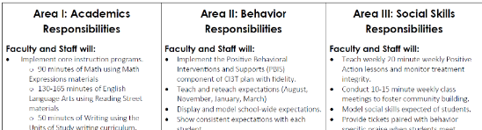
Tier 1: Primary Prevention

Academic, Behavior, and Social Skills Roles and Responsibilities:
- Academics
  - Are core curriculum and instructional resources being accessed/delivered?
  - Are proactive, teacher-delivered strategies to increase students’ engagement in place?
  - Are Tier 2 and Tier 3 supports happening in addition to core?
- Behavior
  - Are behavior expectations being taught, modeled, reviewed, and reinforced?
  - Are proactive and reactive elements being implemented with fidelity?
- Social
  - Are curriculum and instructional resources being accessed/delivered?
  - Are social skills being connected and reinforced throughout the day?
  - Are students accessing reinforcement for showing pro-social behaviors?
- Implementation (Tier 1)
  - To what extent are we addressing academic, behavioral, and social domains?
  - What can be improved?
  - What professional development opportunities are in place/needed?

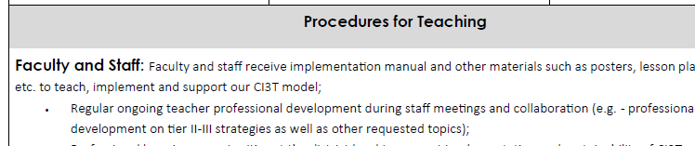
Procedures for Teaching the Plan to Faculty and Staff, Students, Parents, and Community Members
- Academics: Core
  - English language arts & Math
  - What are your expectations for differentiation and personalized learning?
  - What are the expectations regarding the use of technology?
  - What are the expectations regarding the use of low-intensity strategies?
- Behavior: Behavior Expectations
  - When are they being taught? Do we have plans for re-teaching (e.g., incidental, after winter break)?
  - Who is teaching and how is it going?
  - What expectations need to be retaught (data used to identify challenging areas)?
  - Have we identified areas of concern from our discipline data? How can we re-teach to improve student outcomes?
  - Are expectation matrices posted in all areas?
  - Are posters readily available to teachers to use as a teaching tool and consistently prompt for all?
- Social Skills Lessons
  - When are they being taught?
  - Who is teaching? (e.g., teachers, counselors)
  - How is it going?
  - What lessons need to be retaught?
  - Are social skills lessons posted?

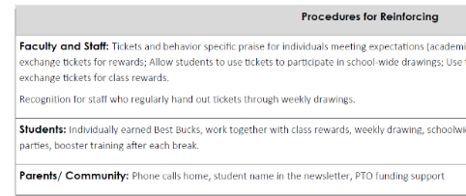
Procedures for Reinforcing
- PBIS Tickets
  - Do all adults have access to tickets?
  - Are they being distributed?
- Faculty & Staff
  - How do we recognize faculty and staff?
  - When will we reinforce faculty and staff?
  - What will the reinforcers be?
- Students
  - Are students being given tickets (with equitable access)?
  - When should we start fading tickets?
  - When is the next assembly?
    - Where?
    - Who is in charge?
  - Are students finding our reinforcers interesting/ desirable?
- Parents/Communities:
  - When will we reinforcer parents/community members?
  - How?
- Reinforcers
  - How are tickets being used, are students using tickets in meaningful ways?
  - Access/Escape
    - Attention
    - Tangible/non-tangible
    - Sensory

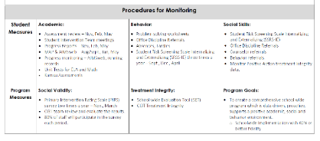
Procedures for Monitoring
- Academic screening
  - Name of screening measure
  - When?
  - Where?
  - Who is leading?
  - When will data be available to teachers for decision making?
- Behavior screening
  - When?
  - Where?
  - Who is leading?
  - When will data be available to teachers for decision making?
- Review of academic data
- Review of behavior data
- What professional learning is needed? Who should attend?
- Connecting students to supports
  - Which classrooms could benefit from focused Tier 1 instruction?
  - Who could benefit from support?
  - What support is appropriate?
  - Who is going to contact parents for permission?
- Tier 1 implementation
  - To what extent are we addressing academic, behavioral, and social domains?
  - What can be improved?
- Data sharing
  - What data will be shared?
  - When will the data be shared?
  - Who is responsible for organizing data to share with the faculty and staff?

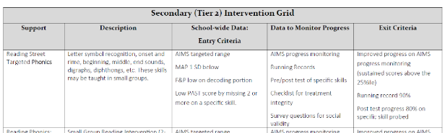
Tier 2: Secondary Prevention
- What supports are currently in place?
- What steps are needed to refine our Tier 2 intervention grids?
- Who is the expert on specific supports in our building?
- How many students could benefit from secondary supports?
- What supports? (intervention grid)
- Who will be in charge of supports?
- How are we assessing treatment integrity? What are data telling us is needed?
- How are we tracking which students participate in which supports and for how long?
- Are our current supports sufficient for student needs?

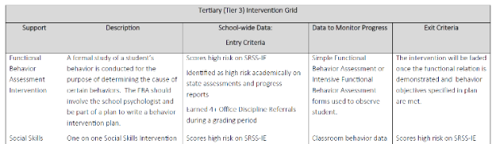
Tier 3: Tertiary Prevention
- What supports are currently in place?
- What steps are needed to refine our Tier 3 grids?
- Who is the expert on specific supports in our building?
- How many students could benefit from tertiary supports?
- What supports? (intervention grid)
- Who will be in charge of supports?
- How are we assessing treatment integrity? What are data telling us is needed?
- How are we tracking which students participate in which supports and for how long?
- Are our current supports sufficient for student needs?

