Ci3T Implementation Professional Learning Series Session 1: Setting Up for Success
  - Ci3T Sustainability Strand Handout

Work Time #1: Implementing Your Tier 1 Plan

Step 1: Reflect on Ci3T Tier 1 Roll Out
Reflect on Ci3T Tier 1 roll out for faculty and staff, students, and families. Consider:
- What part of Ci3T Tier 1 roll out was most effective?
- As you think about next year:
  - What would you like to continue?
  - What would you like to change or refine?
  - What would you like to add?
  - Is there anything you have done in prior years that you would like to re-introduce?
- Open your Ci3T Implementation Manual and navigate to Procedures for Teaching (part of your Ci3T Tier 1 Plan).
  - Is there anything you have not yet had a chance to do that you still want to within the first 60 days of the school year?
Ci3T Tier 1 Rollout for: | What Worked Well | Ideas for Next Year
Faculty & Staff
Students
Families

Step 2: Reflect on Tier 1 Implementation
- Open your Ci3T Implementation Manual and navigate to your Ci3T Tier 1 Plan. Reflect on current strengths and opportunities for refinement across domains:
Domain | Guiding Questions | Notes
Academic | - How are we doing with teaching core academic curricula?  - How are we doing with use of low-intensity strategies (e.g., behavior-specific praise, precorrection)?
Behavior | - How are we doing with teaching expectations for specific settings?  - How have we been reinforcing students for meeting expectations?  - How are behavior-specific praise and tickets being used in our school?  - To what extent are all adults familiar with the 6-step instructional approach to responding to challenging behavior?  - To what extent are we implementing the reactive plan with integrity?
Social | - How are we doing with teaching our validated social and emotional well-being curriculum?
Step 3: Complete a Ci3T Implementation Materials inventory
For each material, consider:
- Do we have this material? If not, do we want to make it now or in the future?
- De we regularly use this material? If not, why? (e.g., posters are too small, not enough copies)
- Will this material need updating prior to next school year? (e.g., printing in a different size, typos, changes to expectation matrix, new logo)

Teaching the Plan to Faculty and Staff
Material | Sample Material | Notes
IM02 Faculty and Staff Presentation | 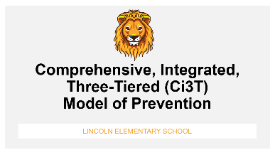
IM03 Ci3T Implementation Manual |  | *Do faculty and staff have access to the Ci3T implementation plan?
IM04 Brochure | 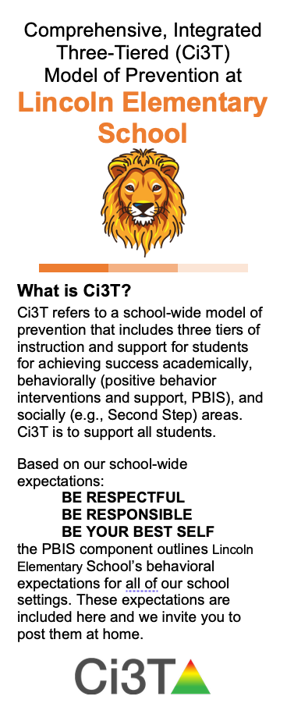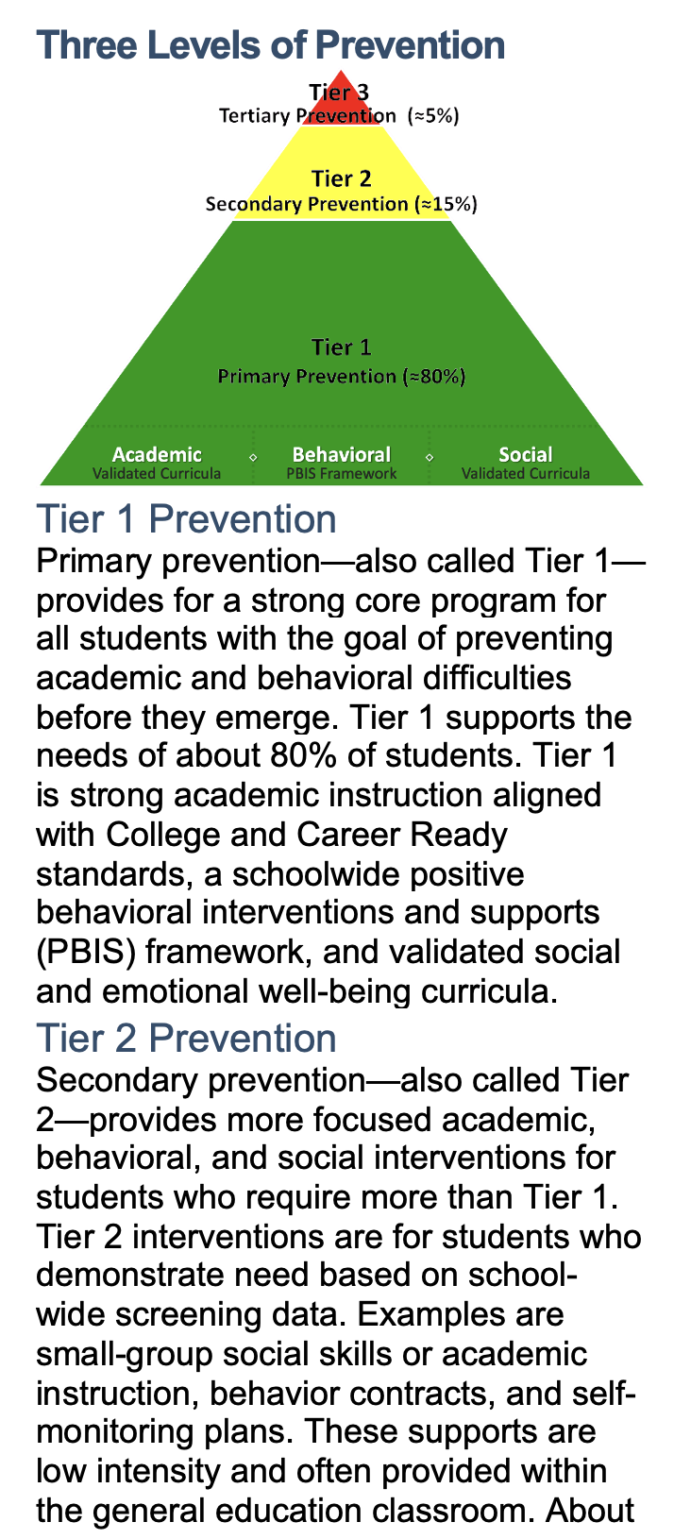
IM05 Bookmark | 
IM06 Ticket Tip Sheet | 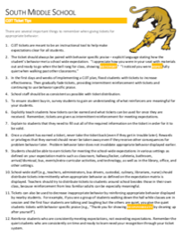
IM07 Teaching the Plan Logistics | 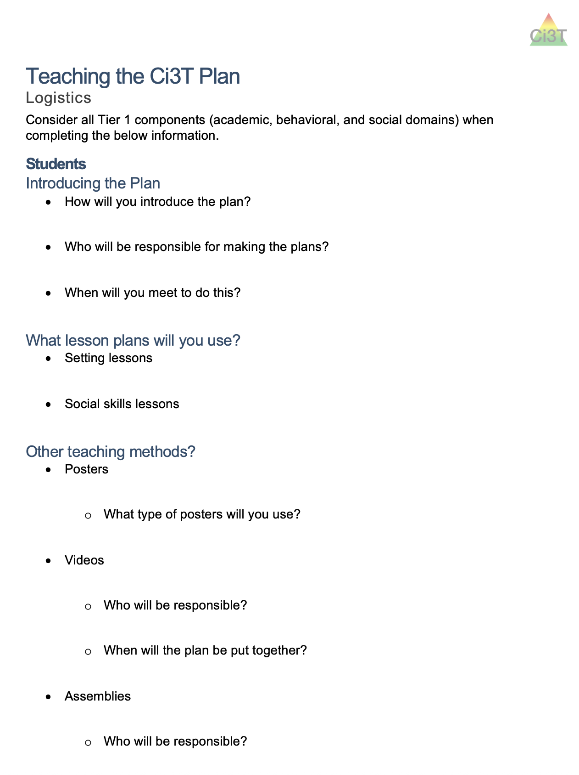

Teaching the Plan to Students
Material | Sample Material | Notes
IM08 Poster: School-Wide Expectations | 
IM08B Poster: Expectation Matrix | 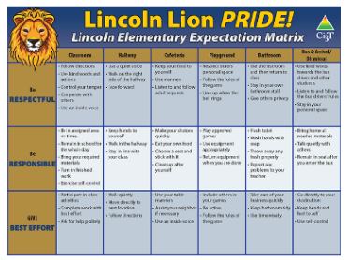
IM08C Poster: Star School-Wide Expectations | 
IM09 Poster: Expectations – Specific Settings | 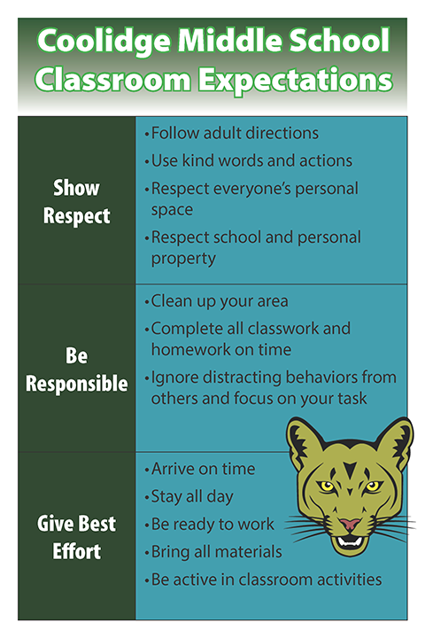
IM10 Setting Lessons | 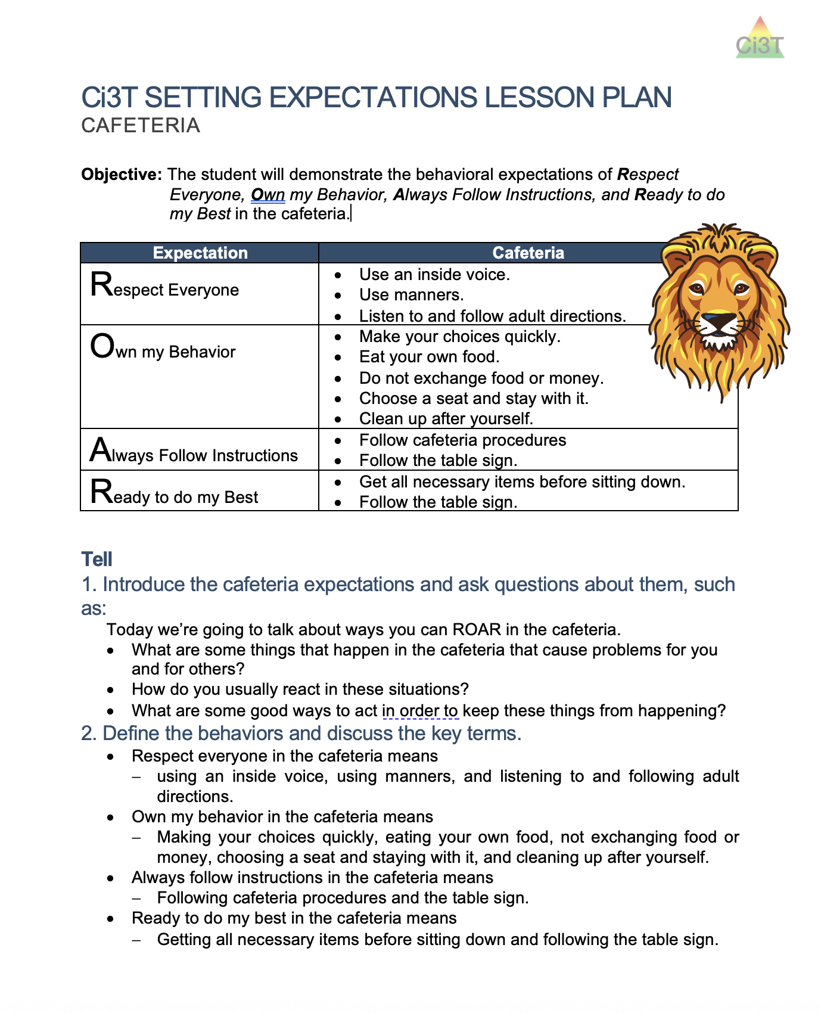

Teaching the Plan to Families
Material | Sample Material | Notes
IM11 Parent Letter | 
IM12 Home Expectation Matrix | 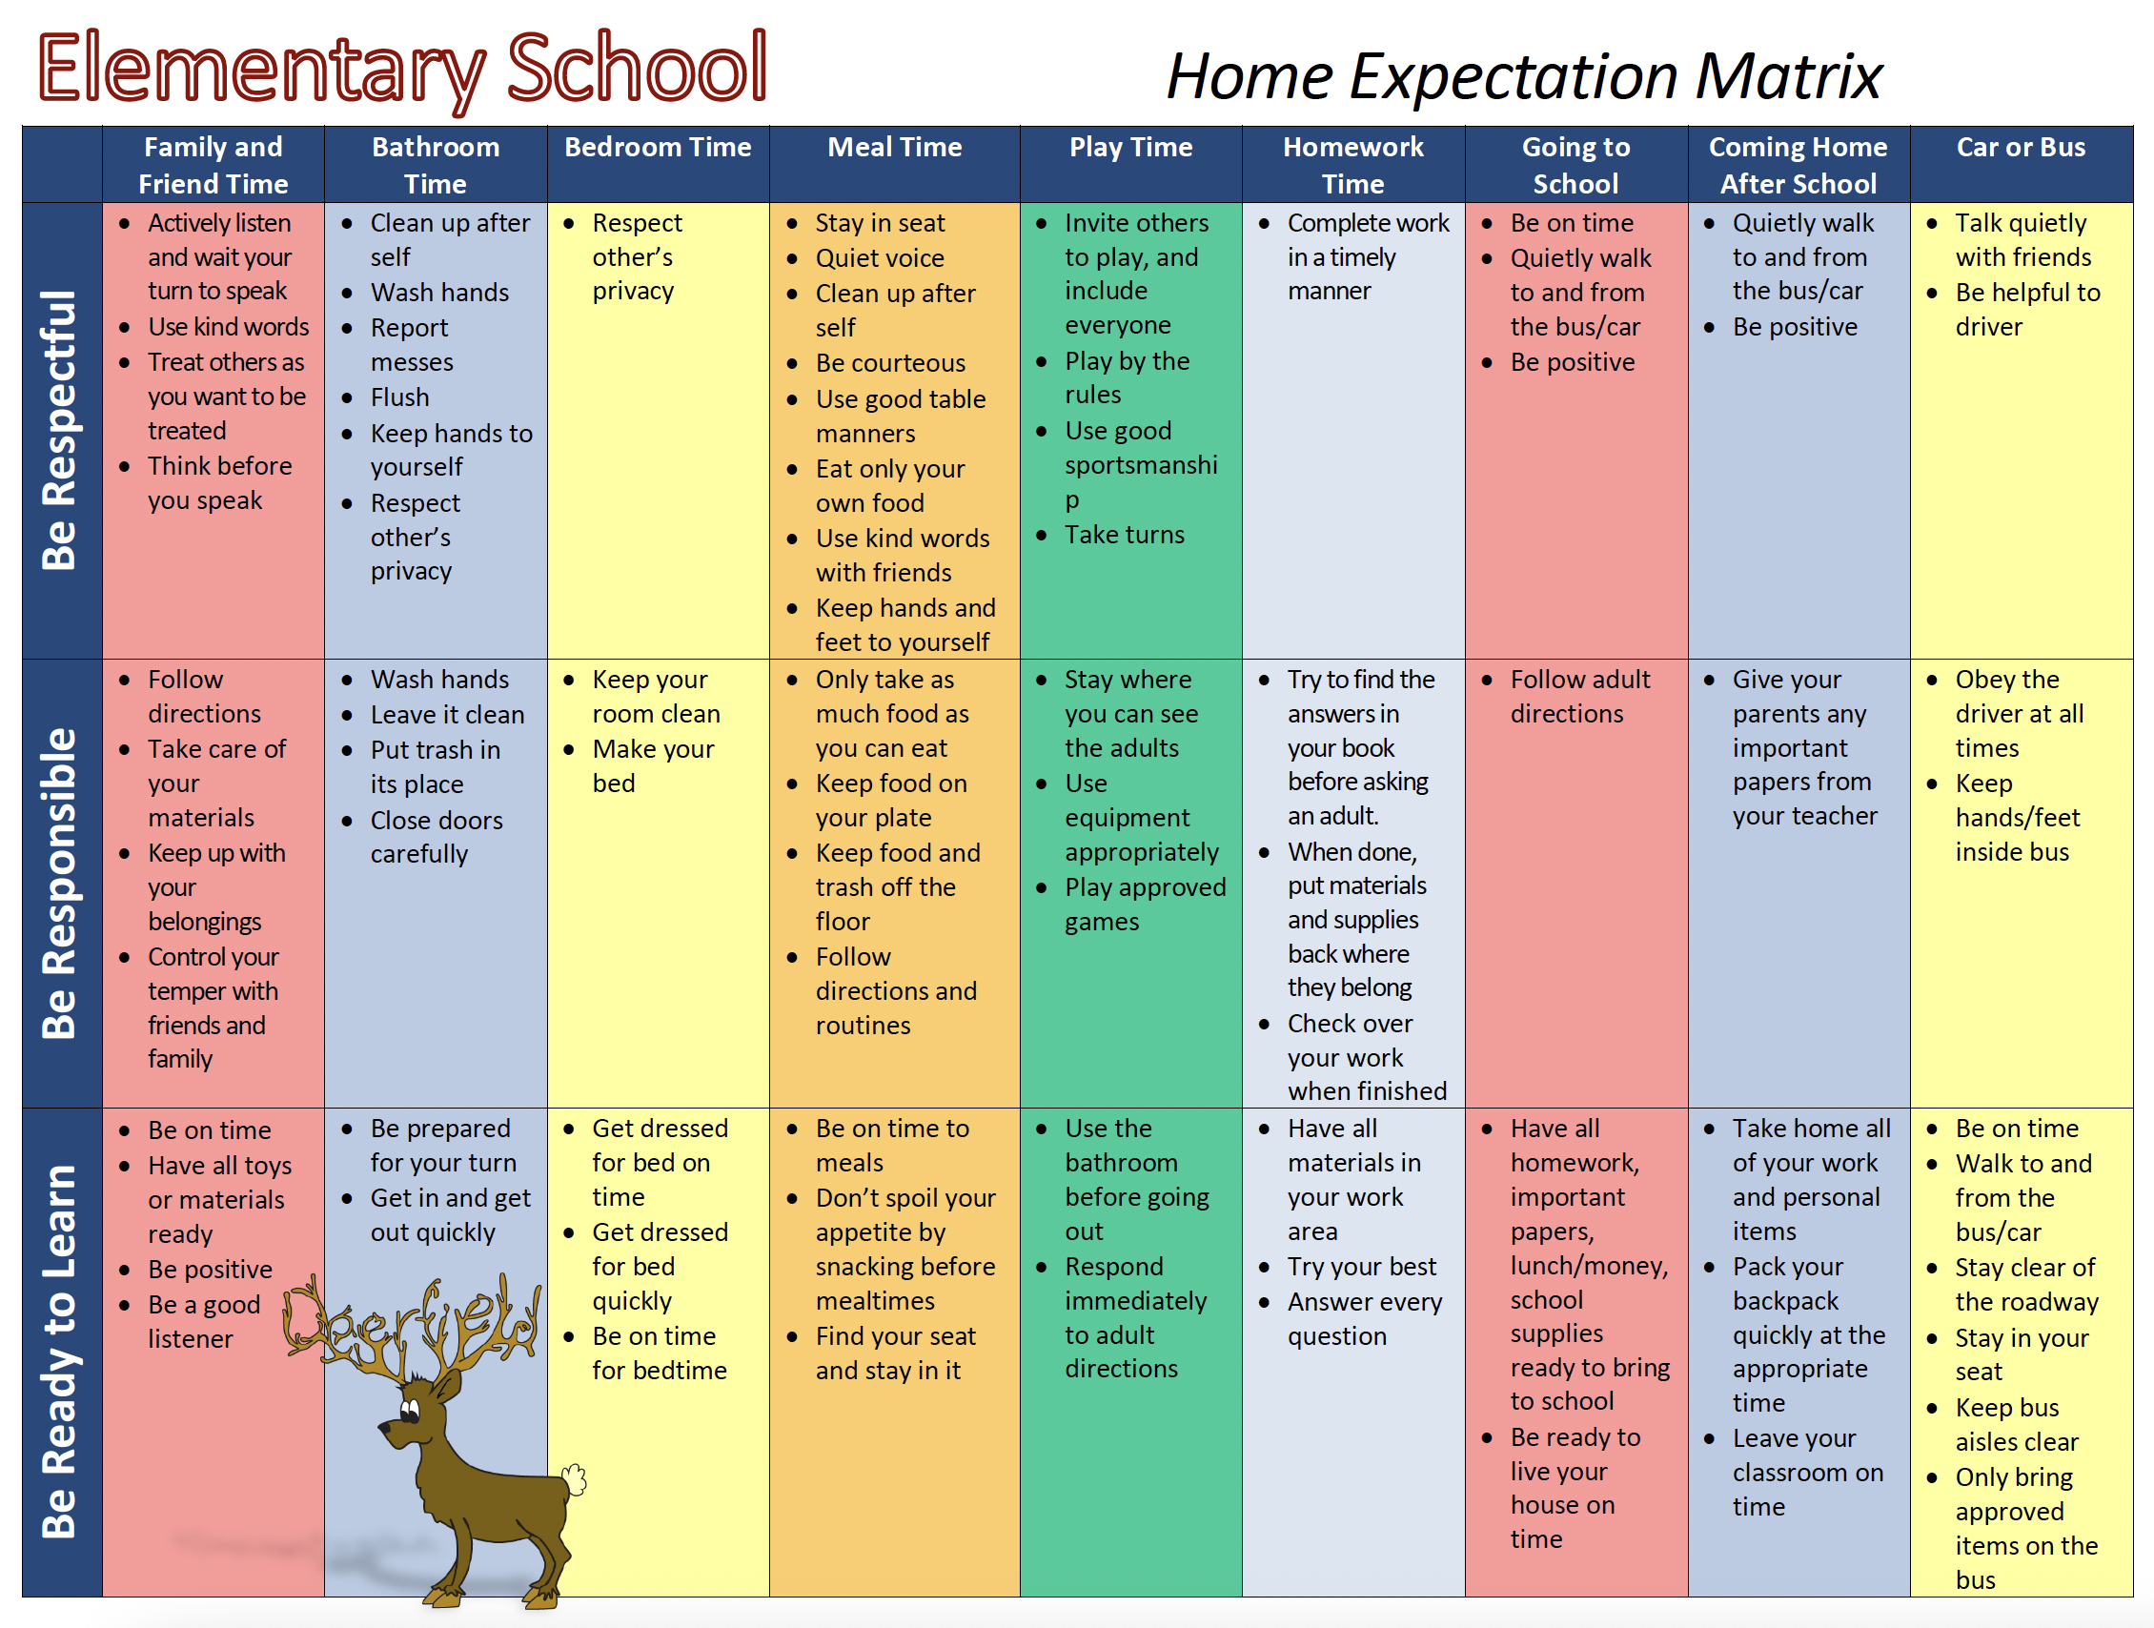

Materials for Reinforcing
Material | Sample Material | Notes
IM13 Tickets | 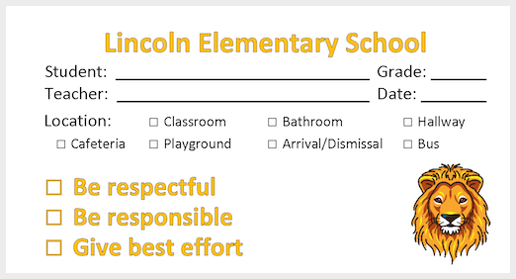
IM14 List of Reinforcers | 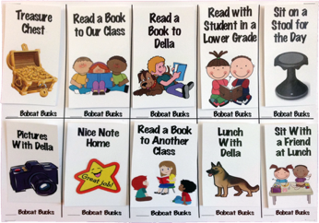
IM15 Non-tangible Certificates | 
IM16 Postcard | 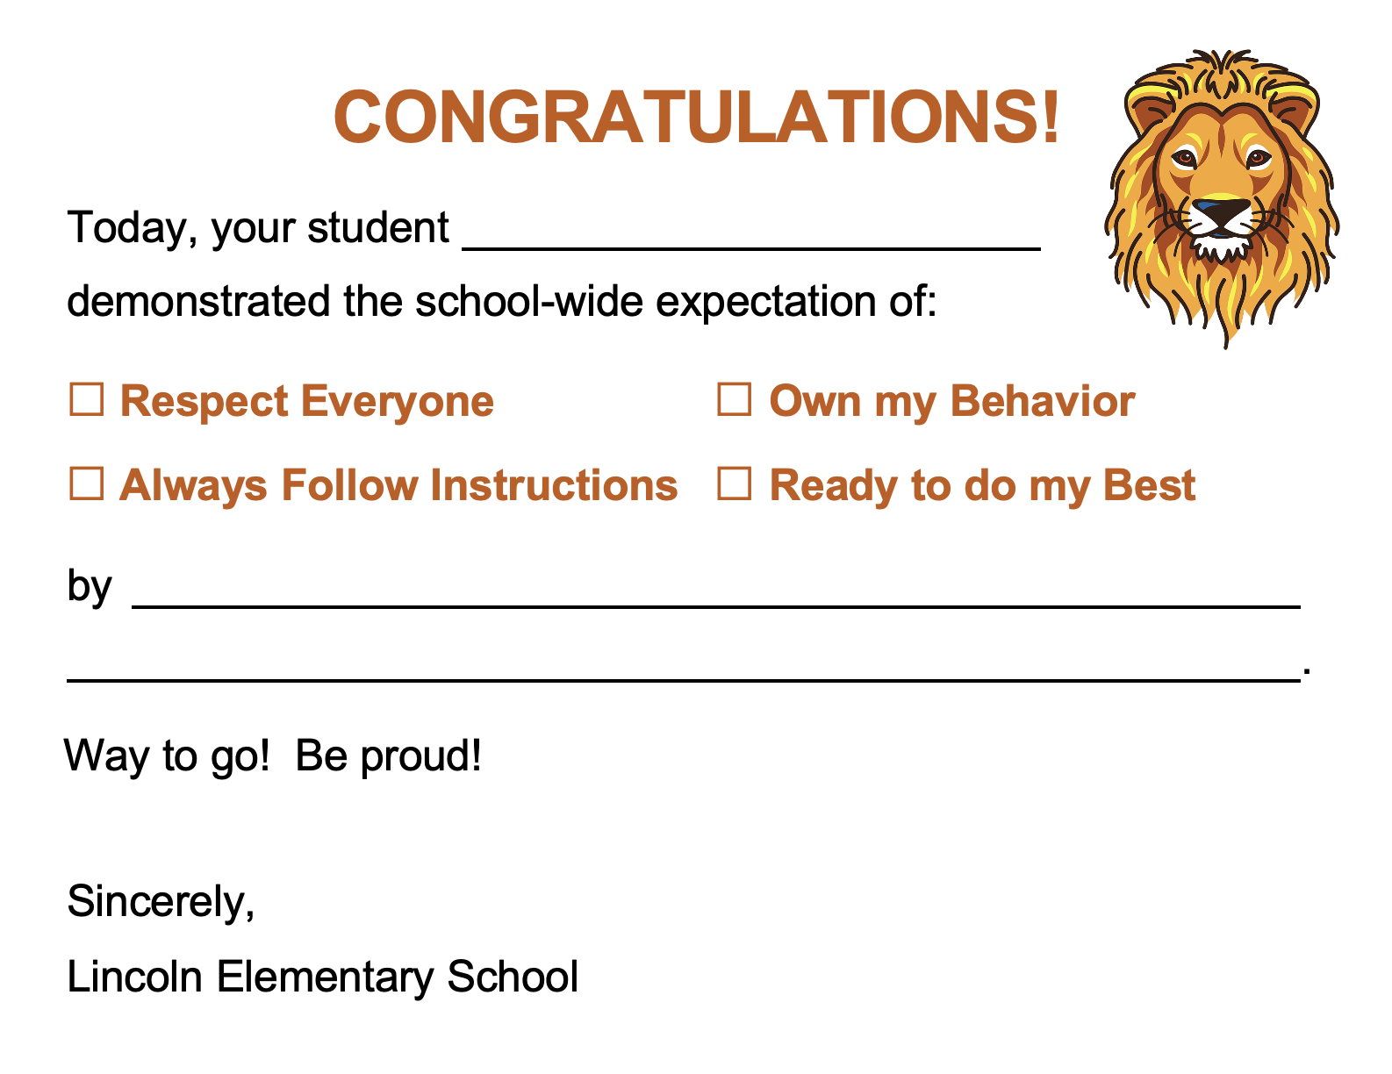

Large-Format Materials
Material | Sample Material | Notes
IM19 School-Wide Expectations Hallway Banners (8 ft) | 
IM20 Cafeteria Expectations Pendants | 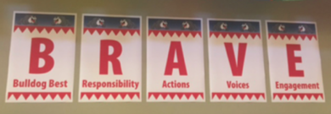
IM21 “Giant” Full Ci3T Plan | 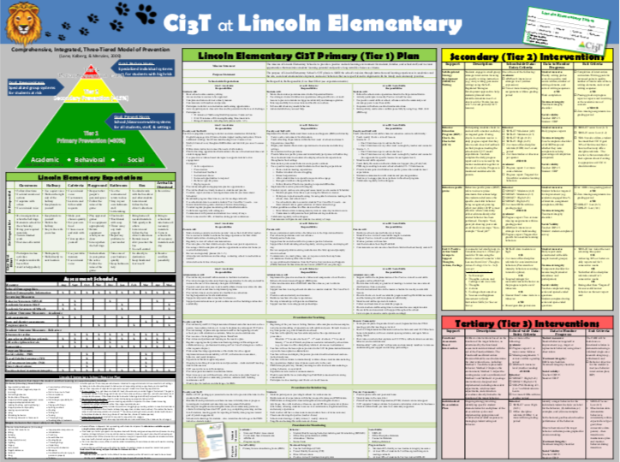

Work Time #2: Scheduling for Success
Consider each of the following guiding questions. For items not yet complete, discuss as a team during this work time or create an action plan (e.g., add to next monthly Ci3T Leadership Team meeting, assign to someone on your Ci3T Leadership Team) for how you will continue the conversation after today’s session.

Scheduling for Success Guiding Questions and Resources
Preparation Activity | Completed?  (Y / N) | Resources
- Have we finalized who serves on our Ci3T Leadership Team? |  | - Ci3T Leadership Team List
- Are we clear on the purpose of our Ci3T Leadership Team and how it interacts with other teams and committees within our building? |  | - Review Using Teams to Guide Ci3T section of the Ci3T Module Understanding Roles and Responsibilities  - Team Map Activity
- Have we scheduled our monthly Ci3T Leadership Team meetings? |  | - Ci3T Meeting Schedule  - See step-by-step scheduling guidance in Ci3T Implementers Symposium Handout 1
- Have we scheduled faculty & staff meetings for the year? |  | - Ci3T Meeting Schedule  - Consider scheduling guidance in Ci3T Implementers Symposium Handout 1 (e.g., opportunities to use faculty and staff meetings to complete treatment integrity and social validity measures, share screening data)
- Do we have an agenda for our monthly Ci3T Leadership Team meetings? If yes – is there anything we want to add or change? |  | - Review Agenda-Setting: A Road Map for Successful Ci3T Leadership section of the Ci3T Module A Guide to Effective Ci3T Leadership Team Meetings  - Ci3T Leadership Team Agenda Template 1- one document for the entire year  - video tutorial of agenda set up  - Ci3T Leadership Team Agenda Template 2 - one document per meeting
- Use guiding questions in Ci3T Leadership Team agenda templates to pre-populate agenda for your next Ci3T Leadership Team monthly meeting |  | - Ci3T Leadership Team Agenda Template 1 – see appendix  - Ci3T Leadership Team Agenda Template 2 – see guiding questions for each section
- Do we have a digital workspace set up? Can we easily locate:  - Ci3T Implementation Manual  - Ci3T LT monthly meeting agendas  - Data reports used for decision-making  - Implementation materials (e.g., editable versions of our posters, bookmark templates, tickets) |  | - Review Set Up a Digital Workspace chapter of the Ci3T Module A Guide to Effective Ci3T Leadership Team Meetings

If you finish early consider:
- Prepopulating agenda items for upcoming Ci3T Leadership Team monthly meetings
- Sending calendar invites for monthly Ci3T Leadership Team and faculty and staff meetings
- Preparing a Ci3T update for an upcoming faculty & staff meeting
- Reviewing Student Risk Screening Scale- Internalizing and Externalizing (SRSS-IE) module and considering opportunities to share resources with faculty, staff, and families

