Setting Up for the Year Ahead
  - Ci3T Implementers Symposium Session Handout
Please review IM07 Teaching the Ci3T Plan Logistics for guiding questions to support your planning efforts! You might also consider opportunities to use Ci3T Design Resources (e.g., IM04 Ci3T Brochure, IM08 Poster School-Wide Expectations) to teach your Ci3T plan to faculty, staff, students, families, and the community!

Modules to Support Your Planning
Module | Description
Effective Onboarding Processes   | This module provides an overview of the role, importance, and best practices associated with formalized onboarding procedures for faculty, staff, and leaders.  Specific resources of interest include:  - Onboarding calendar template (and sample)  - Example onboarding activities  - Recommendations for mentoring  - Video interview with Ci3T principals highlighting their experiences with facilitating onboarding for new staff
What is Ci3T  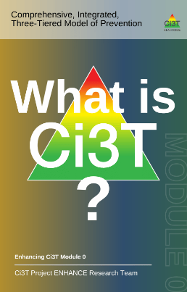 | This module highlights core components of Ci3T models of prevention emphasizing the ways in which Ci3T supports students’ academic, behavior, and social and emotional well-being. This module features user-friendly content (e.g., infographics, videos) that can be built into onboarding, beginning of the year professional learning, and family or community communication.
Embedding & Integrating Ci3T Domains into Daily Instruction  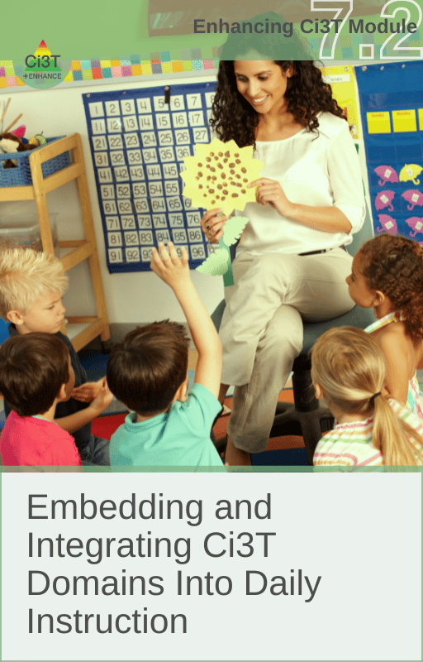 | This module describes how to embed and integrate the academic, behavior, and social and emotional well-being learning domains constituting Ci3T into daily instruction.  Specific resources of interest include:  - Integrated lesson plan template and example  - Brief video examples of integrated lesson plans  - Activities to integrate into school-wide professional learning (e.g., faculty and staff meeting, PLCs)  - Setting expectations lesson plan template
Universal Reinforcement System   | This module provides an overview of the behavioral principle of reinforcement in addition to the essential features and best practices associated with a schoolwide reinforcement system.  Specific resources of interest include:  - Video overview of universal reinforcement systems  - Considerations for building a menu of reinforcers  - Frequently asked questions (FAQ) section that responds to common questions, misconceptions, or push-back related to universal reinforcement systems  - Student reinforcer survey
Understanding Roles and Responsibilities   | This module describes the specific roles and responsibilities of Ci3T Leadership Team members, students, faculty and staff, district administrators, and parents/family members in implementing Ci3T.  Specific resources of interest include:  - Interviews with retired principals  - Team Map activity (to support consolidating teams and/or defining the role of the Ci3T Leadership Team as compared to other building leadership teams)  - Family infographics (one is editable!)

