IM01 Implementation Materials Checklist

Materials for Teaching

Teaching the Plan to Faculty and Staff
Material | School Team Leader | Due Date | Preparation Notes
IM02 Faculty and Staff Presentation |  |  | 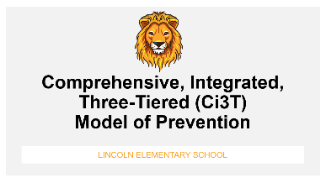
IM03 Ci3T Implementation Manual |  |  | 
IM04 Brochure |  |  | 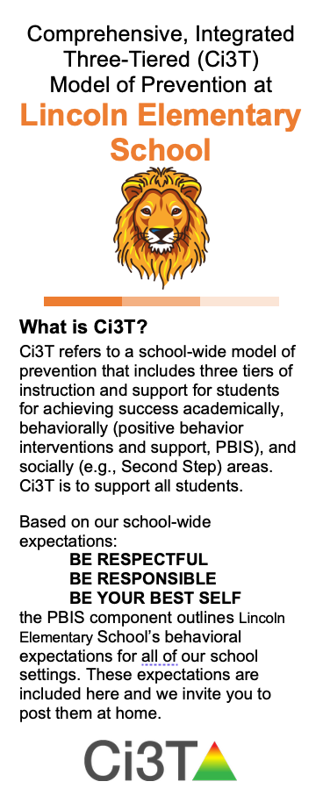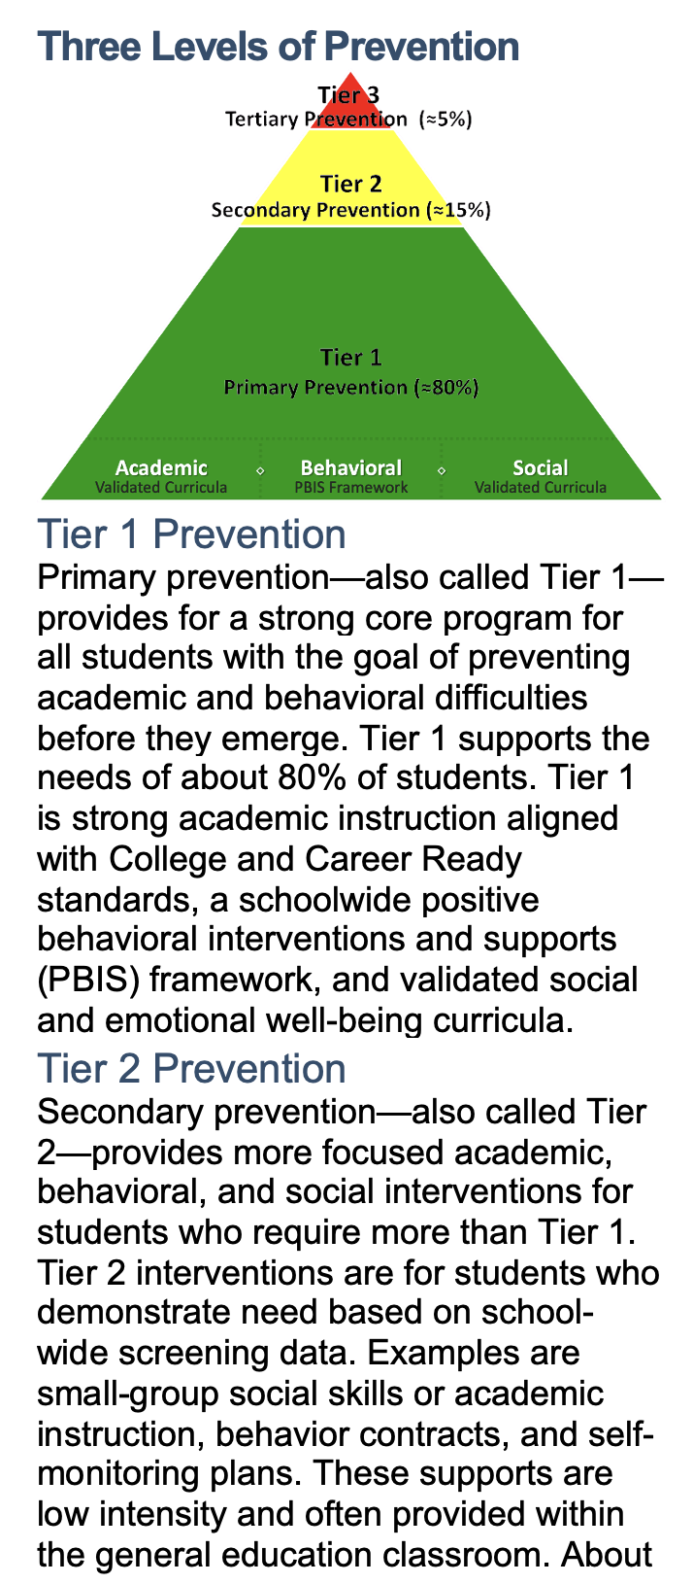
IM05 Bookmark |  |  | 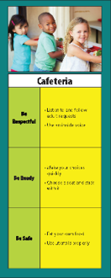
IM06 Ticket Tip Sheet |  |  | 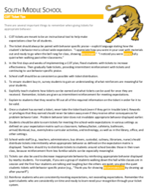
IM07 Teaching the Plan Logistics |  |  | 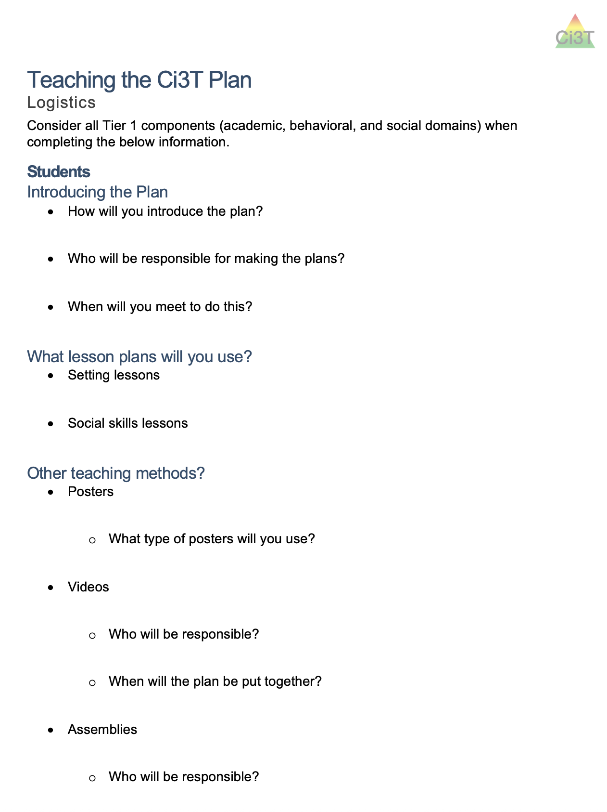

Teaching the Plan to Students
Material | School Team Leader | Due Date | Preparation Notes
IM08 Poster: School-Wide Expectations |  |  | 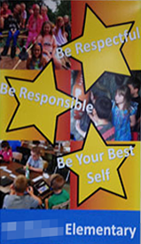
IM08B Poster: Expectation Matrix |  |  | 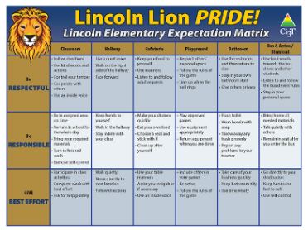
IM08C Poster: Star School-Wide Expectations |  |  | 
IM09 Poster: Expectations – Specific Settings |  |  | 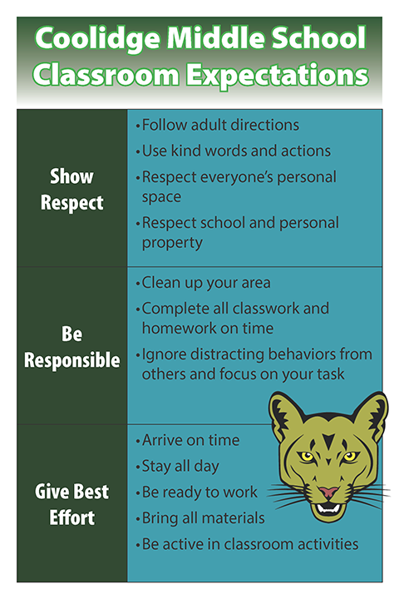
IM10 Setting Lessons |  |  | 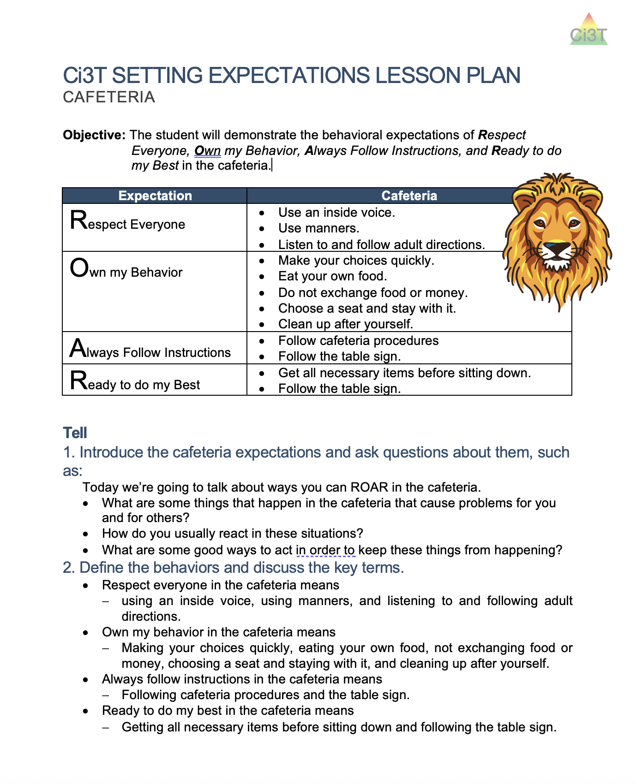

Teaching the Plan to Families
Material | School Team Leader | Due Date | Preparation Notes
IM11 Parent Letter |  |  | 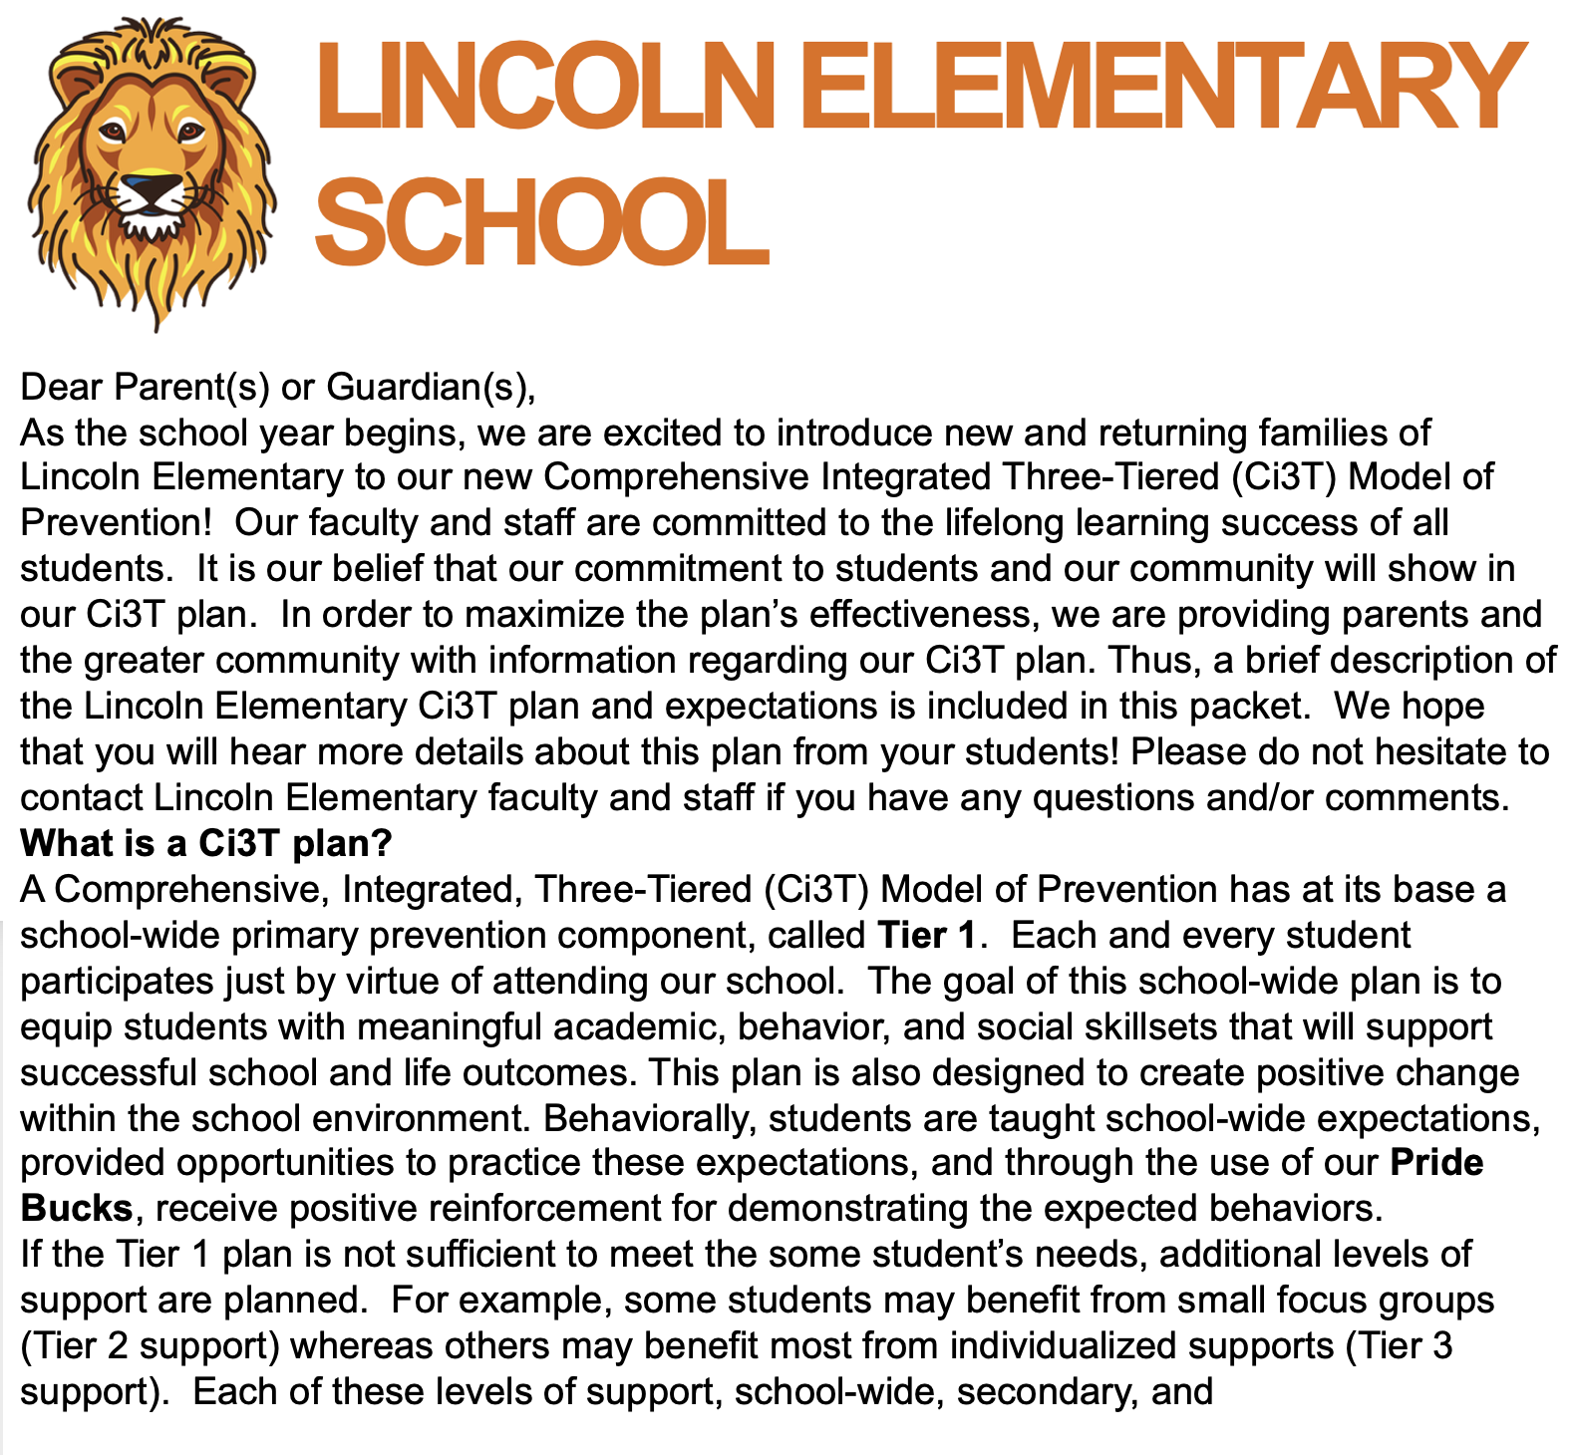
IM12 Home Expectation Matrix |  |  | 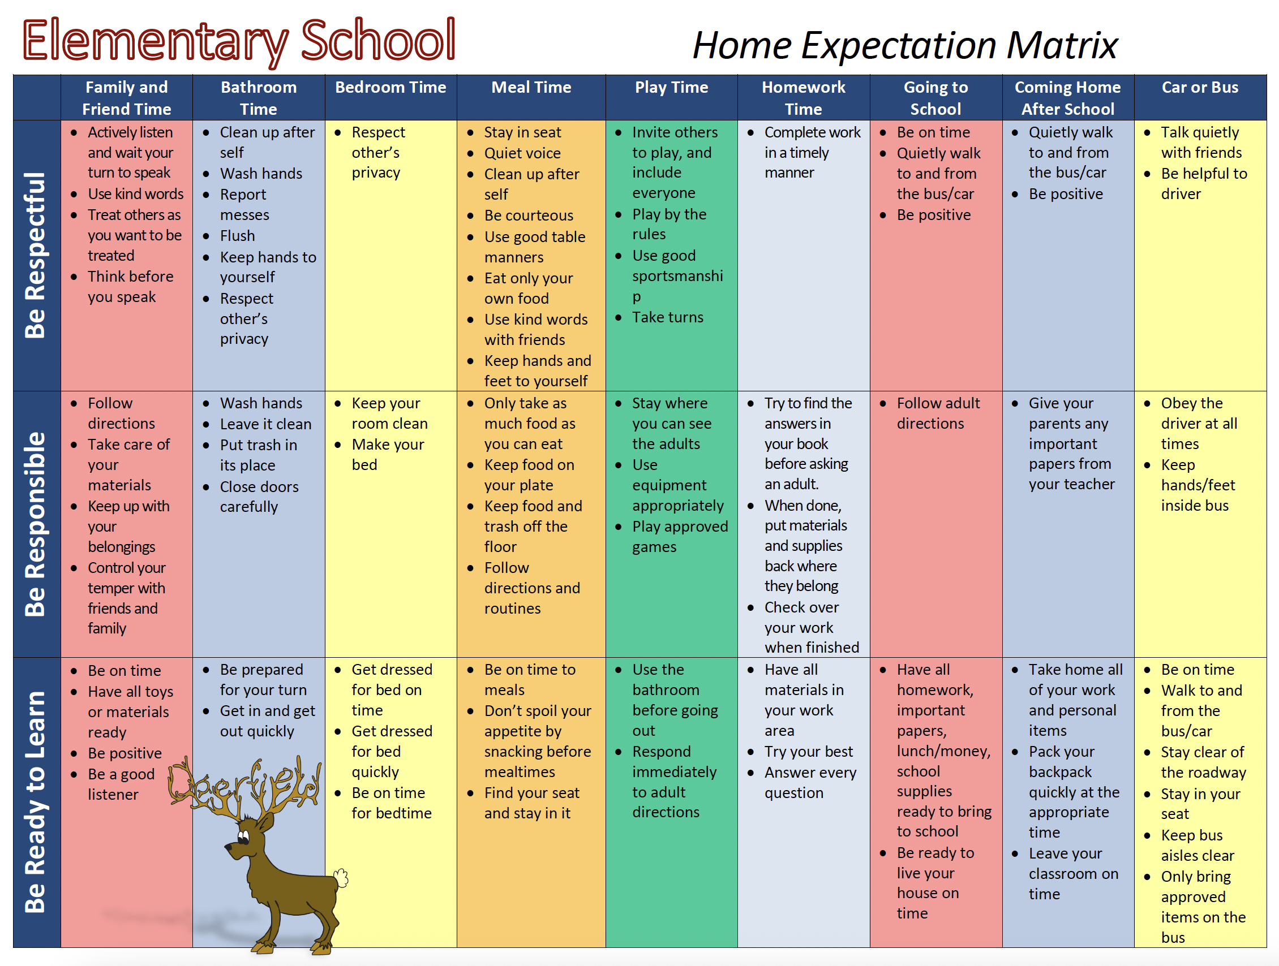

Materials for Reinforcing
Material | School Team Leader | Due Date | Prep Notes
IM13 Tickets |  |  | 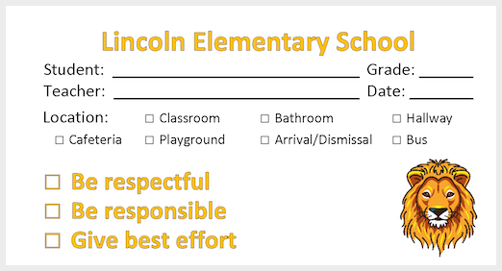
IM14 List of Reinforcers |  |  | 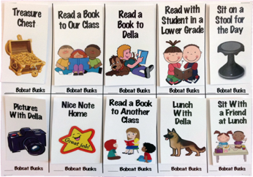
IM15 Non-tangible Certificates |  |  | 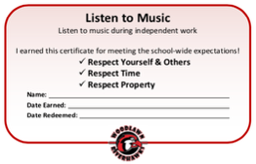
IM16 Postcard |  |  | 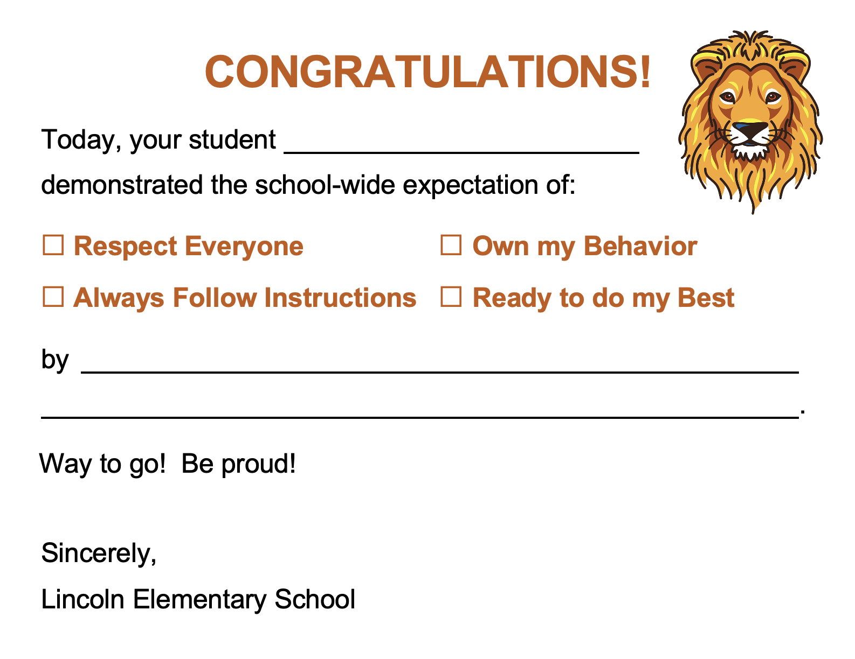

Materials for Monitoring
Material | School Team Leader | Due Date | Prep Notes
IM17 Implementation Calendar |  |  | 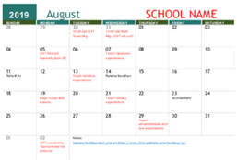
IM18 Ci3T Leadership Team Meeting Agenda |  |  | 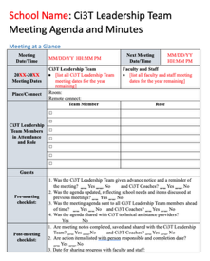

Large-Format Materials
Material | School Team Leader | Due Date | Prep Notes
IM19 School-Wide Expectations Hallway Banners (8 ft) |  |  | 
IM20 Cafeteria Expectations Pendants |  |  | 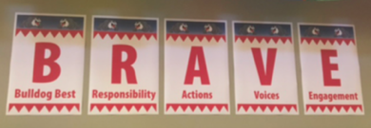
IM21 “Giant” Full Ci3T Plan |  |  | 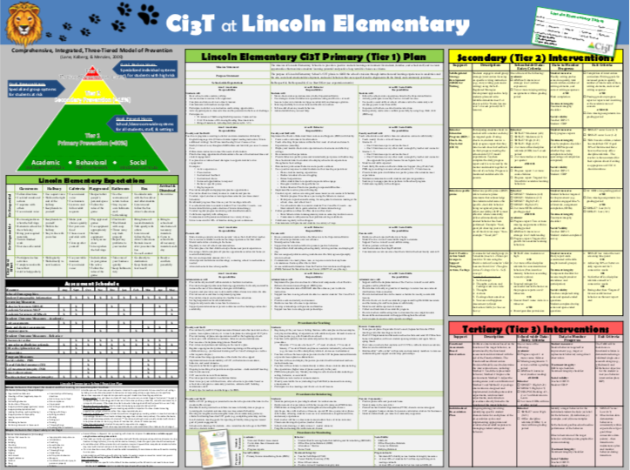

School Color Scheme for Posters
Primary Color | Secondary Color | Tertiary Color | School Mascot or Logo* | School Slogan
Please include specific name, color swatch, or attach sample file. | Please include specific name, color swatch, or attach sample file. | Please include specific name, color swatch, or attach sample file. | Describe and attach image files.
Example: Green  #347437 | Example: Yellow  #F3D526 | Example: White  #000000 | Example:  Bee (mascot)  Bee respectful  Bee responsible  Bee your best | Example:  Bee positive! Let’s bee friends! We’re un-bee-lievable! Buzzworthy!
*Please upload to your team’s digital file structure folder an original (e.g., Illustrator, Photoshop) artwork file for your logo and mascot; if .png .jpg .pdf the higher the resolution the better such as 300 dpi.

