Preparing to Design Ci3T Models in your District
  - Handout
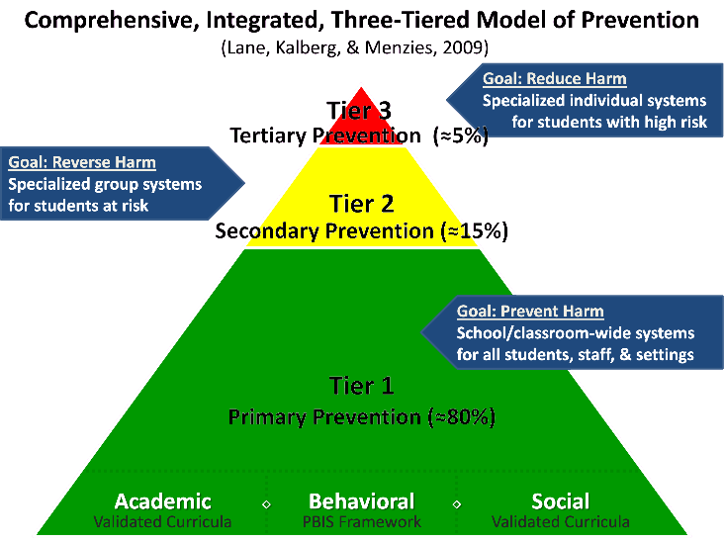
Ci3T models of prevention assist schools in creating a comprehensive systems-oriented approach to (a) integrate efforts to support the academic, behavioral, and social competencies of all students; (b) promote collaboration and teaming between all school and community stakeholders; and (c) support educators’ efficacy and well-being through data-informed professional learning, clear expectations for staff and students, and supportive, positive environments.

Advanced Planner
- Getting started (you are here!): Preparing to build Ci3T model in your district
- Designing Ci3T plans for each school: The Ci3T Professional Learning Series
- Looking ahead to implementation: Ci3T Implementation Series and Delivery
- Resources: Links to more information

Getting Started
  - Preparing to build Ci3T models in your district

How Should we Plan Ahead for Ci3T?
Adopting Ci3T in your school or district is a long-term investment to meet the goals established in the district’s strategic plan. As you begin this journey, it is helpful to consider some decisions that are on the horizon. We encourage districts to establish a District Ci3T Team, to determine available and needed resources. We have developed a district decision-making guide to help inform this work: District Decision-Making Guide Below, we provide addition guiding questions and space to generate ideas. Additionally, we have included a sample roll-out plan, with moderate sized district in mind. In optimal conditions, the District Ci3T Team responsible for planning, would meet monthly beginning in early October through February, to develop “district certainties” with input from representative K-12 school-site leaders (e.g., principals). Many districts create District Ci3T Blueprints used to inform the “designing” process school-site Ci3T Leadership Teams engage in during the manualized designing process.
- What professional learning (PL) resources (e.g., expertise, leadership capacity, facilities) can you commit to support schools in designing their Ci3T model?
- What personnel (e.g., Ci3T Coach, Ci3T Trainer) resources can you commit to support schools in designing and implementing their Ci3T model? Consider number of substitutes to support educators attending professional learning opportunities (e.g., 10 substitutes per school).
- What resources can you commit to securely gather input from faculty and staff (e.g., Ci3T Design Measures)? See Resources for a list of possible options.
- What are the adopted academic curricula (HQIM) common across schools by level?
- What are the adopted social and emotional wellbeing curricula or resources?
- What resources can you commit to securely gather student behavior screening data (e.g., using the Student Risk Screening Scale – Internalizing & Externalizing [SRSS-IE])? See Resources for a list of possible options.
- How many schools do you plan to support each year in designing their Ci3T model? Would you divide your designing process into cohorts, and if so, by what metric and over how many years? See Sample Training Plan below.

Sample Training & Roll-out Plan (to edit)
School | 2026-27 | 2027-28 | 2028-29 | 2029-30 | 2030-31 | 2031-32 | 2032-33 | 2033-34 | 2034-35 | 2035-36
1 | D | I | I | I | S | S | S | S | S | S
2 | D | I | I | I | S | S | S | S | S | S
3 | D | I | I | I | S | S | S | S | S | S
4 | D | I | I | I | S | S | S | S | S | S
5 | D | I | I | I | S | S | S | S | S | S
6 | D | I | I | I | S | S | S | S | S | S
7 | D | I | I | I | S | S | S | S | S | S
8 | D | I | I | I | S | S | S | S | S | S
9 | D | I | I | I | S | S | S | S | S | S
10 | D | I | I | I | S | S | S | S | S | S
11 | - | D | I | I | I | S | S | S | S | S
12 | - | D | I | I | I | S | S | S | S | S
13 | - | D | I | I | I | S | S | S | S | S
14 | - | D | I | I | I | S | S | S | S | S
15 | - | D | I | I | I | S | S | S | S | S
16 | - | D | I | I | I | S | S | S | S | S
17 | - | D | I | I | I | S | S | S | S | S
18 | - | D | I | I | I | S | S | S | S | S
19 | - | D | I | I | I | S | S | S | S | S
20 | - | D | I | I | I | S | S | S | S | S
21 | - | - | D | I | I | I | S | S | S | S
22 | - | - | D | I | I | I | S | S | S | S
23 | - | - | D | I | I | I | S | S | S | S
24 | - | - | D | I | I | I | S | S | S | S
25 | - | - | D | I | I | I | S | S | S | S
26 | - | - | D | I | I | I | S | S | S | S
27 | - | - | D | I | I | I | S | S | S | S
28 | - | - | D | I | I | I | S | S | S | S
29 | - | - | D | I | I | I | S | S | S | S
30 | - | - | D | I | I | I | S | S | S | S
Note. D = design Ci3T model via Ci3T Design Professional Learning Series; I = implement Ci3T with support from the Ci3T Implementation Series and Delivery; S = sustainability and innovation of Ci3T implementation

Designing Ci3T Plans for Each School: Designing with School-site Ci3T Leadership Teams
  - Ci3T Design Professional Learning Series (Ci3T PL Series)

What is the Ci3T PL Series?
- 6-part series attended by each schools’ Ci3T Leadership Team
- Often led by district Ci3T trainers with support from Ci3T Research Team
- Each school produces a Ci3T Implementation Manual to-be implemented in the next school year
- Learn more on http://www.ci3t.org/design
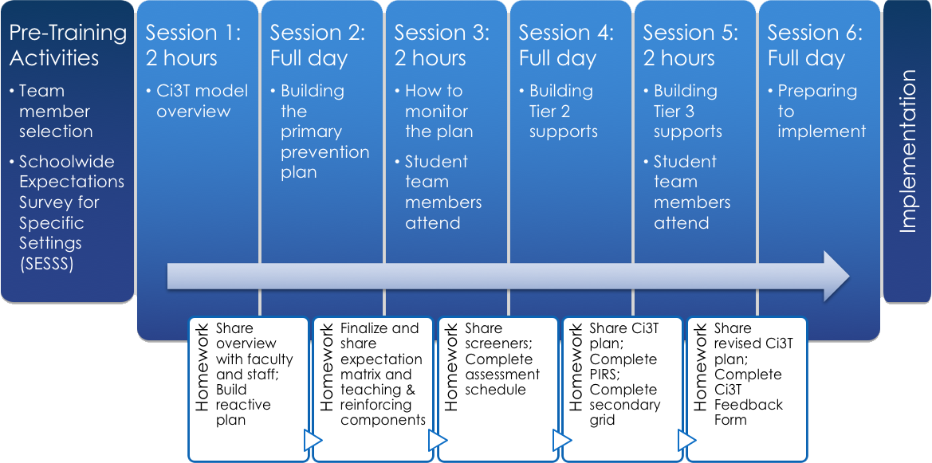
Example Professional Learning Schedule
Ci3T Design Professional Learning Series
Attended by: School Ci3T Leadership Teams | Ci3T District Trainers and Coaches
Session | Date | Time | Location
- Session 1 | 10/28/25 | 4:30–6:30 pm | TBD
- Session 2 | 12/09/25 | 8:00–4:00 pm | TBD
- Session 3 (with students) | 01/27/26 | 4:30–6:30 pm | TBD
- Session 4 | 02/24/26 | 8:00–4:00 pm | TBD
- Session 5 (with students) | 03/24/26 | 4:30–6:30 pm | TBD
- Session 6 | 04/21/26 | 8:00–4:00 pm | TBD

How Should we Plan Ahead for the Ci3T PL Series?
The Ci3T PL Series is in your future but now is a good time to start planning. See considerations below. You may also benefit from reviewing the District Decision-Making Guide (available via http://www.ci3t.org/design)
- Identify potential District Ci3T Trainers and Coaches (people who would be willing to build their capacity to support schools’ Ci3T design and implementation).
- Prepare for selecting systematic screening tools for academics and behavior. Consider local and state laws, available resources (e.g., IT, funding), and priorities for screening (e.g., what kinds of behavior).
- Prepare for selecting a social skills curriculum. Consider local and state laws, priorities (e.g., what behaviors are most important for success at school and beyond?), research on effectiveness of curricula under consideration.
- Consider whether currently implemented academic curricula are meeting your district’s needs (e.g., do local data and research indicate effectiveness?).
- Consider what professional learning is likely to be needed to support new practices, strategies, and programs installed as part of designing Ci3T models.
- Identify potential barriers to designing Ci3T models (e.g., buy-in, funding, capacity). Strategize methods for proactively addressing these barriers.

Looking Ahead to Implementation
  - Ci3T Implementation Series and Delivery

What is the Ci3T Implementation Series and Delivery?
- The Ci3T supports a customizable professional learning journey supported by free-access resources:
  - 6-part Ci3T Implementation Professional Learning Series for Ci3T Leadership Team members (hosted by the Ci3T Research Team)
  - 40+ Enhancing Ci3T Modules (available via ci3t.org/enhance)
  - Project EMPOWER sessions (stand-alone on Ci3T topics for any interested parties, hosted by the Ci3T Research Team)
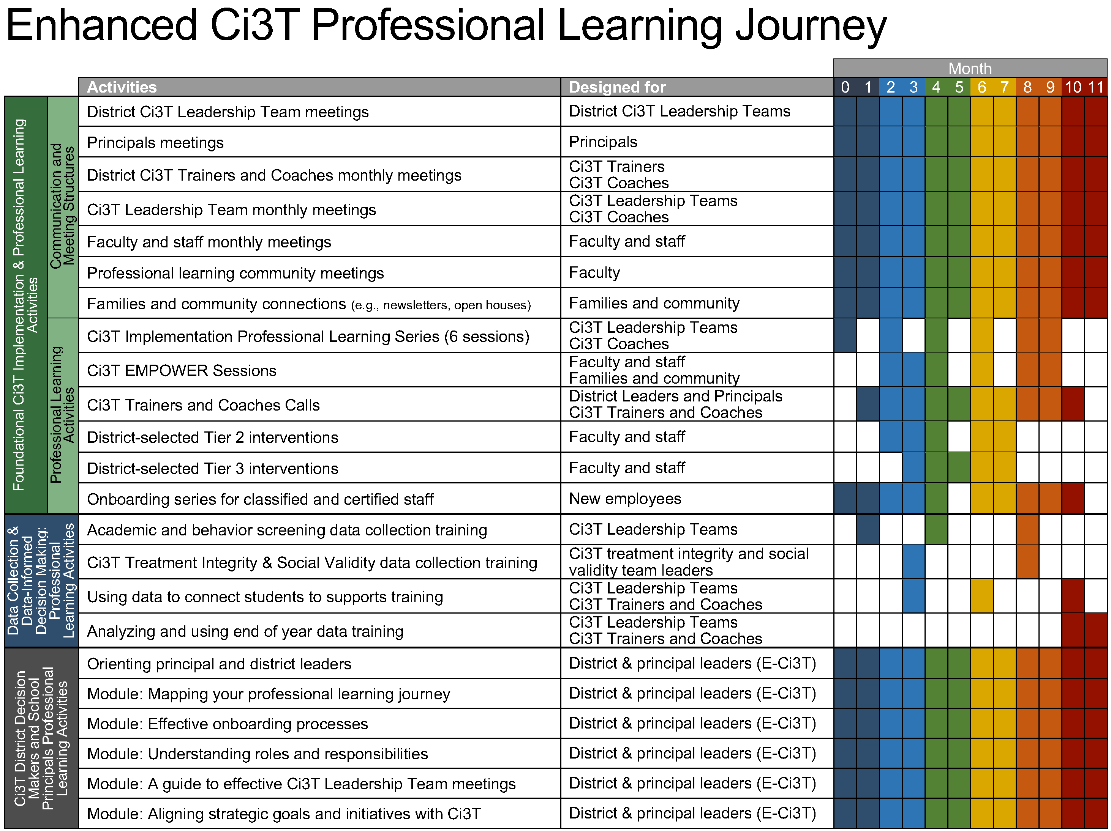
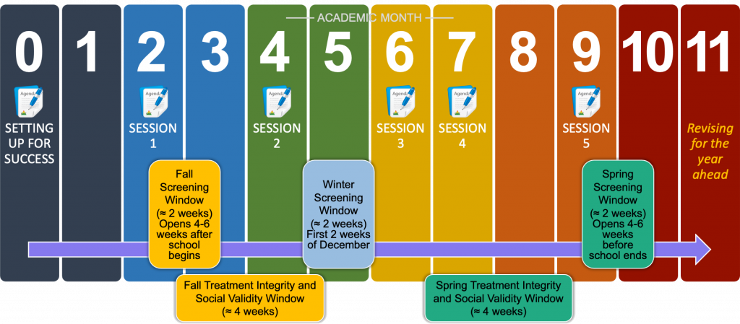
Example Professional Learning Schedule
Ci3T Implementation Professional Learning Series
Location: Remote via Zoom
Attended by: Ci3T Leadership Teams
Sessions A and B are available. Ci3T Leadership Teams select which one they would like to attend.
Session | Date | Session A (Central) | Session B (Central)
Implementers Symposium | June 18, 2025 | 9:30 – 3:30 pm | N/A
Session 1 | Sept.11, 2025 | 12:00 – 2:00 pm | 4:30 – 6:30 pm
Session 2 | Nov. 13, 2025 | 12:00 – 2:00 pm | 4:30 – 6:30 pm
Session 3 | Jan. 13, 2026 | 12:00 – 2:00 pm | 4:30 – 6:30 pm
Session 4 | Mar. 03, 2026 | 12:00 – 2:00 pm | 4:30 – 6:30 pm
Session 5 | Apr. 14, 2026 | 12:00 – 2:00 pm | 4:30 – 6:30 pm

How Should we Plan Ahead for the Ci3T Implementation Series and Delivery?
The Ci3T Implementation Series and Delivery experience is in your future but now is a good time to start planning. See considerations below:
- To make Ci3T Implementation Series and Delivery (Ci3T ISD) experiences meaningful, Ci3T Leadership Teams require access to data at specific times during the year (e.g., screening, treatment integrity and social validity). Do you have the necessary systems established to make feasible collecting and reporting these data to teams feasible? See Resources for a list of possible options.
- A common need with ongoing professional learning (PL) is helping faculty and staff make time to access it. Some districts prefer to prioritize PL in the evening and provide extra pay. Others prefer to prioritize PL during the school day and pay for substitutes. Consider how you might incentivize and facilitate ongoing participation at Ci3T PL events.
- Schools-site Ci3T Leadership Teams will need a Ci3T coach to facilitate implementation. Consider your capacity for supporting coaching not just during the design year, but also through implementation.
- Some districts provide a great deal of flexibility when it comes to schools making use of Ci3T ISD activities, whereas others are more prescriptive (e.g., if data collection and participation is a key component of district strategic plans). What do you anticipate this looking like in your district over time? How can you provide flexibility while also maintaining accountability for ongoing implementation?

Resources
  - Links to more information
- Resources for collecting data from faculty and staff
  - Qualtrics
    - Surveys and reports available for all Ci3T Design Measures (see ci3t.org/measures)
    - Surveys and reports available for all Ci3T Implementation Measures (see ci3t.org/measures)
  - Kite Suite
    - Surveys and reports available for all Ci3T Implementation Measures (see ci3t.org/measures)
- Resources for collecting Student Risk Screening Scale – Internalizing and Externalizing (SRSS-IE), a systematic screening tool for behavior
  - Standard Co
    - Contact TJ Muehleman (tj@standardco.de)
  - Branching Minds
  - ProactPulse
    - Contact Tom Long (tom.long@cfwebtools.com)
- Sample Ci3T Implementation Plans

Citation
To cite this resource, use the following citation:
Lane, K. L., Buckman, M. M., Oakes, W. P. (2025). Preparing to Design Ci3T Models in your District. Retrieved from ci3t.org.

