Implementing Comprehensive, Integrated, Three-tiered (Ci3T) Models: Using Data to Inform Instruction
  - Session 2 Talk Time Slides

Team Time #1

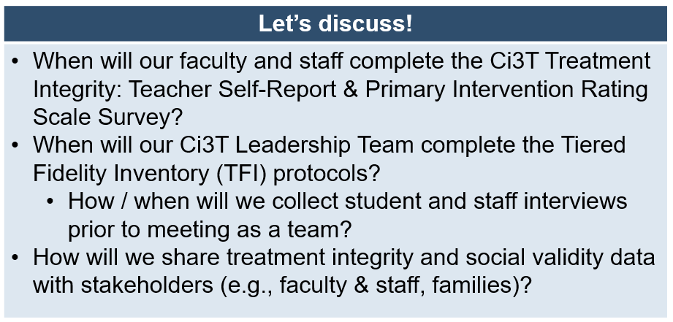

Notes

Team Time #2

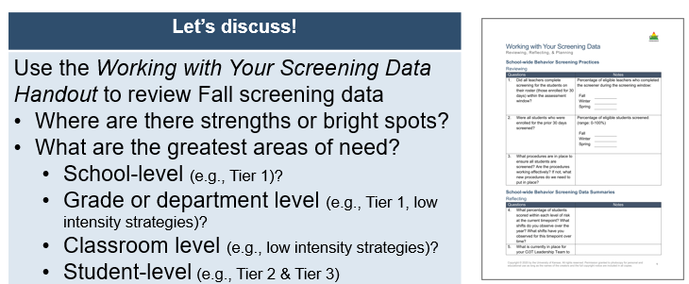

Notes

Team Time #3

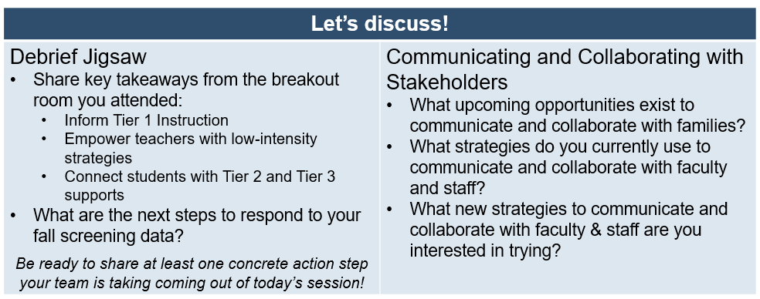

Notes

