Planning Block 1: Planning for your 2024-2025 Ci3T Journey

Step 1: Schedule Ci3T Leadership Team Meetings & Faculty and Meetings

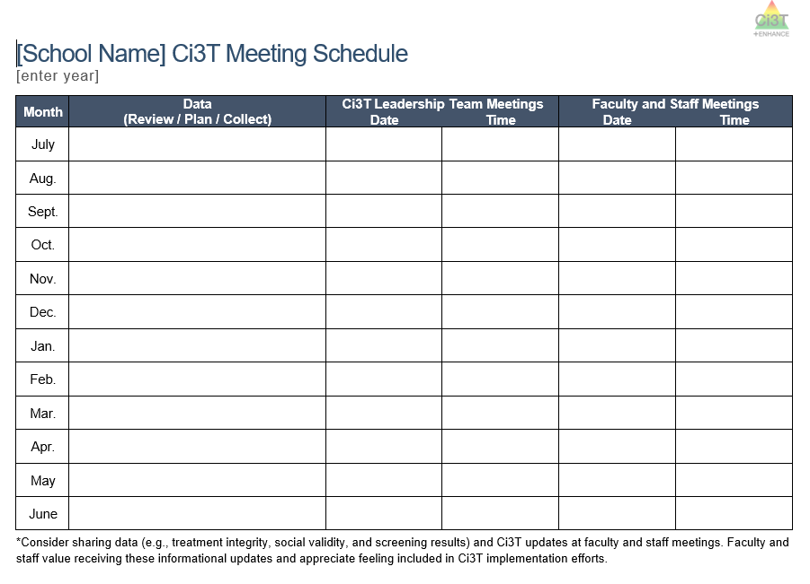
Materials:
- School’s master or shared calendar
- District Calendar (e.g., parent teacher conferences, breaks, staff PD days)
- Ci3T Meeting Schedule document
Ci3T Leadership Team & Faculty and Staff Meetings
☐ | Schedule monthly Ci3T Leadership Team meetings
☐ | Schedule faculty & staff meetings  - If possible, schedule faculty meetings after Ci3T Leadership Team meetings
☐ | Add any anticipated parent and family events (e.g., Back to School night)
☐ | Share your Ci3T Meeting schedule with your district coach

Step 2: Schedule professional learning opportunities
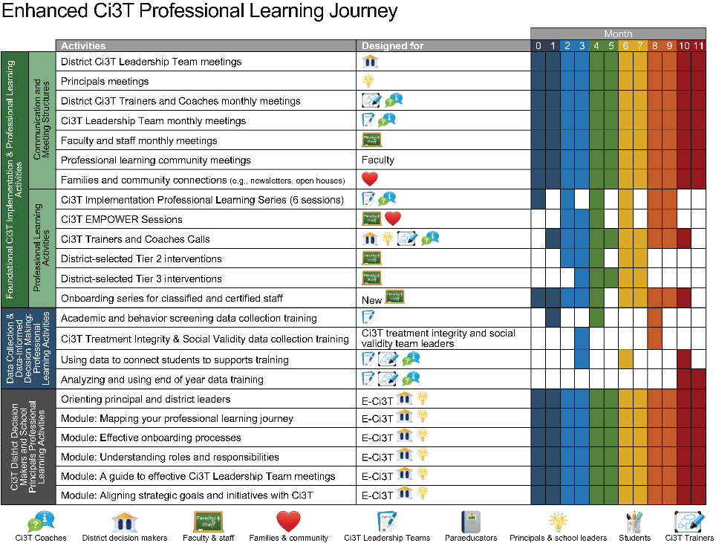
Materials
- School’s master or shared calendar
- Spring Treatment Integrity & Social Validity Reports
- Spring Screening Data (academic and behavior)
- Ci3t Website (https://www.ci3t.org/enhance)
- Enhanced Ci3T Professional Learning Journey template
  - To support your planning, we have pre-populated this template with 2024-2025 Ci3T professional learning dates (e.g., Implementation Sessions, EMPOWER sessions, Trainer and Coaches Calls)
Professional Learning
☐ | What priorities or SMART goals will you set based on Spring screening, treatment integrity, and social validity data?
☐ | What type(s) of school-level professional learning (e.g., PLC, book club, weekly email, mini-PD) will help you achieve those goals?
☐ | Add dates for these school-level professional learning to your calendar  - Be sure to consider any district-wide opportunities (e.g., teacher workdays, early releases)
☐ | How might you leverage EMPOWER sessions? Add to your calendar accordingly
☐ | How might you leverage Ci3T Trainer & Coaches Calls? Add to your calendar accordingly
Resources to support your planning:
Module | Description
Mapping your Professional Learning Journey   | This module highlights the importance of data-informed professional learning in the successful implementation of Ci3T and illustrates what this process looks like in action.  Specific resources of interest include:  - Example professional learning activities  - Sample email communication  - Video interview with a retired Ci3T principal highlighting their experience using treatment integrity and social validity data to inform professional learning  - Overview and considerations for use of Enhanced Ci3T modules
Low Intensity Teacher-Delivered Strategies  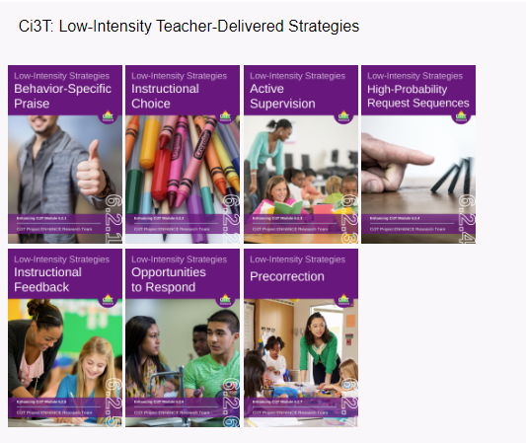 | Each module highlights a specific low-intensity strategy and is designed to be used in its entirety (e.g. entire eBook or Interactive Resource) or a la carte by pulling out specific components (e.g., infographics, videos, implementation checklists). A module exists for each of the following low-intensity strategies:  - Behavior-specific praise  - Instructional choice  - Active supervision  - High-probability request sequences  - Instructional feedback  - Opportunities to respond  - Pre-correction
A 6-Step Instructional Approach for Responding to Challenging Behavior  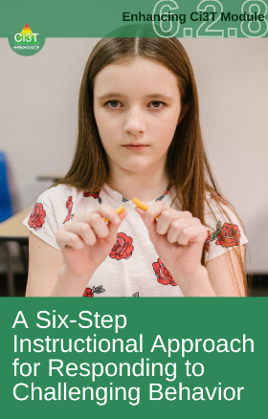 | This module provides an in-depth overview of the 6-step instructional approach to responding to behavior including opportunities for faculty and staff to practice their skills and engage in collaborative conversations. It is a helpful resource to teach (and re-teach!) skills related to your school’s Reactive Plan at the beginning of the year and in booster sessions throughout the year (e.g., after winter break).  Specific resources of interest include:  - Video overview  - Infographic  - 2 simulations  - Discussion guide
The Tier 2 Process: Using Data to Connect Students to Validated Supports  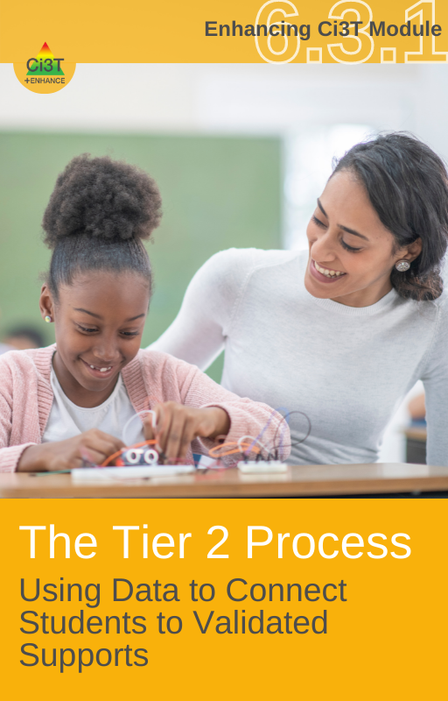 | This module explains the process of engaging in integrated, data-informed decision-making efforts with an emphasis on designing, implementing, and evaluating research-based Tier 2 and Tier 3 supports as described in your Ci3T Implementation Manual.  Specific resources of interest include:  - Activities to integrate into school-wide professional learning (e.g., faculty and staff meeting, PLCs) to build familiarity with the Tier 2 and Tier 3 supports featured in your Ci3T Implementation Manual.  - Template and video tutorial of a customizable Ci3T Data Dashboard  - Template and video tutorial of a customizable Ci3T Class-at-a-Glance Intervention Planning  - Template and video tutorial of a customizable Tier 2 and Tier 3 Intervention Tracker

Step 3: Schedule professional learning to support data collection and data-informed decision making
Materials
- School’s master or shared calendar
- Ci3T Meeting Schedule document (from Step 1)
- District windows for:
  - screening (3x year)
  - treatment integrity and social validity (2x year)
Academic and Behavior Screening Windows
 | SRSS-IE |  |  | Academic Screeners
Time Point | Preview | Open | Close | Preview | Open | Close
Fall
Winter
Spring

Academic and Behavior Screening Windows
☐ | Add screening (academic and behavior) windows to calendar
☐ | When and how will you train staff to collect academic and behavior screening data? Add this to the calendar.  - Consider using existing structures (e.g., faculty and staff meeting, PLC, grade-team meetings)
☐ | When can you set aside time for staff to complete behavior screening (e.g. faculty and staff meeting, PLC meeting)? Add to calendar
☐ | Which Ci3T Leadership Team meetings will you allocate to review and action-plan around school-wide screening data?  - Make a note on your Ci3T Meeting Schedule and/or update the calendar invite
☐ | When and how will you share school-wide screening results? Add this to the calendar.
☐ | When and how will teachers analyze their classroom or grade-level screening data? Add this to the calendar.
☐ | When and how will you provide professional learning regarding how to use data to connect students with Tier 2 and Tier 3 supports? Add this to the calendar.

Treatment Integrity & Social Validity
- Ci3T Treatment Integrity: Teacher Self-Report (Ci3T TI: TSR)
- Ci3T Treatment Integrity: Direct Observation (Ci3T TI: DO)
- Tiered Fidelity Inventory (TFI)
- Primary Intervention Rating Scale (PIRS)
 | Open | Close | Report
Fall
Spring

Treatment Integrity and Social Validity Windows
☐ | Add treatment integrity and social validity windows to the calendar
☐ | When and how will you communicate with staff to share the purpose of and preview treatment integrity and social validity measures. Add to calendar.  - Consider setting aside 10 minutes at a faculty meeting or sending an email prior to the window opening to restate the “why”, share how data will be used, and share when you have set aside time for staff to complete the measures
☐ | When can you set aside time for staff to complete treatment integrity and social validity measures (e.g. faculty and staff meeting, PLC meeting)? Add to calendar
☐ | Which Ci3T Leadership Team meetings will you dedicate to completing the Tiered Fidelity Inventory (TFI?)  - Make a note on your Ci3T Meeting Schedule and/or update the calendar invite  - You might consider splitting across two meetings
☐ | Which Ci3T Leadership Team meetings will you allocate to review and action-plan around treatment integrity and social validity data?  - Make a note on your Ci3T Meeting Schedule and/or update the calendar invite
☐ | When and how will you share school-wide treatment integrity and social validity results? Add this to the calendar.
☐ | Share your Ci3T Meeting schedule with your district coach

If you finish early…
- Create calendar invites for planned meetings and professional learning
- Create your Ci3T Leadership Team meeting agendas and pre-populate agenda items based on your discussion today
  - See the module A Guide to Effective Leadership Team Meetings for more information and an agenda template
  - For assistance setting up your agenda, please see this video tutorial
- Assign leaders and start drafting school-level professional learning

Planning Block 2: Setting up for the Year Ahead

Let’s talk…and make plans!
- What professional learning is needed to onboard new staff?
- What beginning of year professional learning is needed for all staff (e.g., understanding tickets and reinforcement, integrated lesson planning).
- How and when will expectations lessons be taught to students?
- How and when will you share your Ci3T plan with families and the community?
- What procedures for reinforcement are in place for students?
- How will you reinforce staff for implementing your school’s Ci3T plan?

Module | Description
Effective Onboarding Processes   | This module provides an overview of the role, importance, and best practices associated with formalized onboarding procedures for faculty, staff, and leaders.  Specific resources of interest include:  - Onboarding calendar template (and sample)  - Example onboarding activities  - Recommendations for mentoring  - Video interview with Ci3T principals highlighting their experiences with facilitating onboarding for new staff
Ci3T as a Structure to Create Positive, Productive, Safe Learning Environments   | This module highlights core components of Ci3T models of prevention emphasizing the ways in which Ci3T supports students’ academic, behavior, and social and emotional well-being. This module features user-friendly content (e.g., infographics, videos) that can be built into onboarding, beginning of the year professional learning, and family or community communication.
Embedding & Integrating Ci3T Domains into Daily Instruction  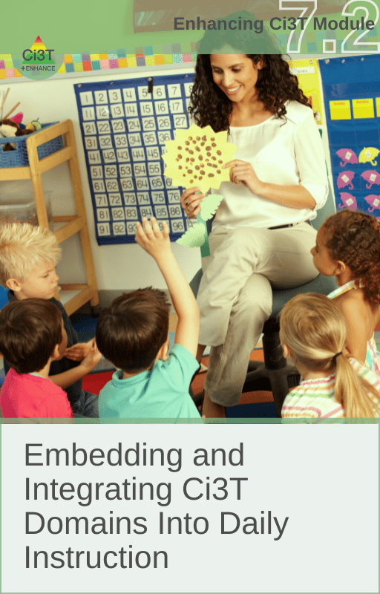 | This module describes how to embed and integrate the academic, behavior, and social and emotional well-being learning domains constituting Ci3T into daily instruction.  Specific resources of interest include:  - Integrated lesson plan template and example  - Brief video examples of integrated lesson plans  - Activities to integrate into school-wide professional learning (e.g., faculty and staff meeting, PLCs)  - Setting expectations lesson plan template
Universal Reinforcement System   | This module provides an overview of the behavioral principle of reinforcement in addition to the essential features and best practices associated with a schoolwide reinforcement system.  Specific resources of interest include:  - Video overview of universal reinforcement systems  - Considerations for building a menu of reinforcers  - Frequently asked questions (FAQ) section that responds to common questions, misconceptions, or push-back related to universal reinforcement systems  - Student reinforcer survey
Understanding Roles and Responsibilities   | This module describes the specific roles and responsibilities of Ci3T Leadership Team members, students, faculty and staff, district administrators, and parents/family members in implementing Ci3T.  Specific resources of interest include:  - Interviews with retired principals  - Team Map activity (to support consolidating teams and/or defining the role of the Ci3T Leadership Team as compared to other building leadership teams)  - Family infographics (one is editable!)

