Implementing Ci3T Models: Supporting Student Success Across the Tiers
  - Session 4 Talk Time Slides

Team Time #1
Let’s discuss!
- How did we share treatment integrity, social validity, and winter screening data with stakeholders (e.g., faculty & staff, families)?
  - Are there any additional steps we need to take to share these data?
- How did we respond to our treatment integrity, social validity, and winter screening data based on the ideas we generated in Session 3?
  - Are there any additional steps we need to take to complete action items?
- What systems do we have in place to examine multiple sources of data to inform professional learning and instruction?
- What professional learning needs might we address next, based on our treatment integrity, social validity, and winter screening data?

Notes

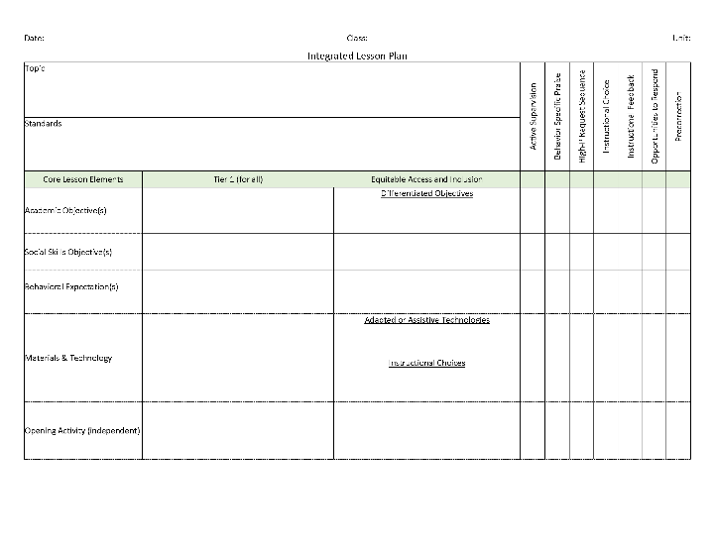
Team Time #2
Let’s discuss!
Work with your Ci3T Leadership Team to develop an integrated lesson plan
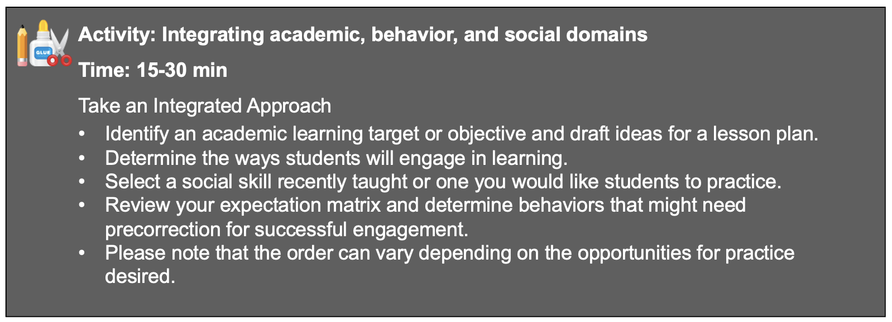

Notes

Team Time #3
Let’s discuss!
- Read over the list of Tier 2 and Tier 3 supports listed in your school’s Ci3T Implementation Manual.
- Jigsaw breakout session: Divide your team members to attend these sessions:
  - Tier 2 Check-In/Check-out
  - Tier 2 Recognize. Relax. Record.
  - Tier 3 Managing Acting-Out Behavior at Tier 3
  - Tier 3 Functional Assessment-Based Intervention (FABI)
  - Structures for Success (e.g., shared digital space, intervention tracker)
- Post in the chat the one you would like to attend so your Ci3T Leadership Team members can divide up to learn more!

Notes

