Implementing Comprehensive, Integrated, Three-tiered (Ci3T) Models: Using Data to Inform Instruction

Session 2 Talk Time Slides

# Team Time #1

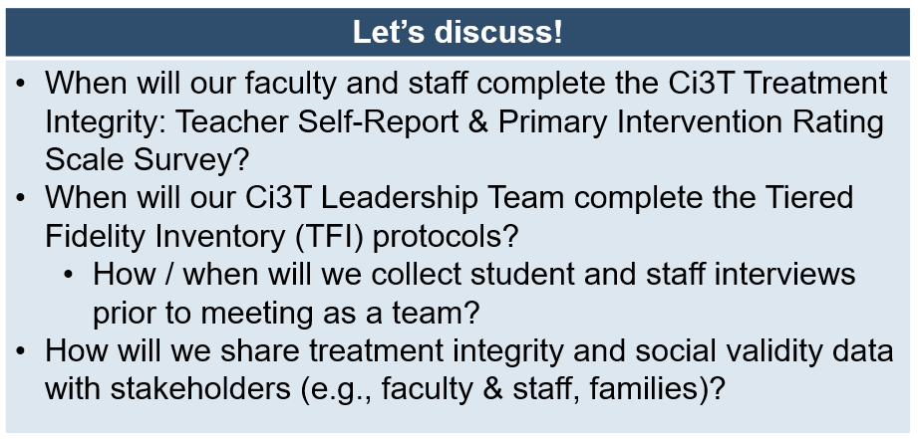

## Notes

# Team Time #2

## 

## Notes

# Team Time #3

## Notes