Ci3T Implementation Manual Review
  - A guide to support updating your school’s Ci3T Implementation Manual
Directions. Consider using this guide at the end of each academic year, incorporating new lessons learned and guidance from Ci3T District Leaders (e.g., incorporating new guidance from District Level Ci3T Implementation Manual – Masters). Review treatment integrity (Ci3T Treatment Integrity: Teacher Self-Report and Direct Observation measures; Tiered Fidelity Inventory) and social validity (Primary Intervention Rating Scale) data from fall and spring as well as student level data (e.g., screening data collected in fall, winter, and spring) to inform potential revisions.
School:
Date of completion:Click here to enter a date.

Ci3T Primary (Tier 1) Prevention Plan [Blueprint A]
Do We Have… | Guiding Questions and Considerations | Notes
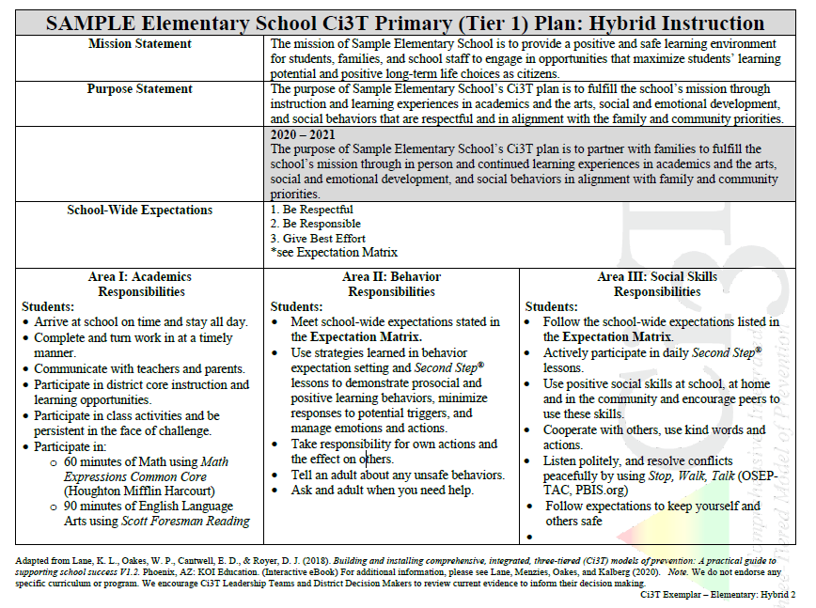
☐ A properly formatted Ci3T Primary (Tier 1) Plan (Blueprint A)? | Are tables properly formatted, and is the document easy to read?  Use Blueprints (ci3t.org/building, see accordion file) or Ci3T Exemplars (ci3t.org/COVID) from ci3t.org as examples. When pasting from sample documents, use Keep Source Formatting to keep correct format (right click when pasting and select Keep Source Formatting; see below).  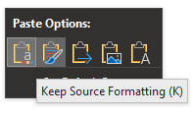  Are there page breaks after each table ends (e.g., after Roles and Responsibilities; after Procedures for Teaching, after Procedures for Reinforcing, after Procedures for Monitoring)?  If not, add page breaks using Insert > Page Break.
☐ Our district mission stated? | Is the mission of the district included?
☐ Our purpose statement? | Does the statement specifically address academic, behavioral, and social components?  Does the purpose statement answer the question: “Why is our district and/or school implementing Ci3T?”
☐ Three to five schoolwide expectations and reference to the Expectation Matrix? | Are the expectations listed in a manner consistent with your school-wide expectation matrix (Ci3T Blueprint C Expectation Matrix)?
☐ Defined roles and responsibilities for each stakeholder? | Are roles and responsibilities stated positively (e.g., students will do...)?  Consider using treatment integrity and social validity data to inform addition or clarification of roles and responsibilities. For example, look at item-level data on the Ci3T Treatment Integrity: Teacher Self-Report. What items were rated as implemented less frequently (i.e., lower mean scores)? Could you add or clarify responsibilities to address these areas for growth?
☐ A statement in faculty and staff academic and social skills roles and responsibilities clarifying expectations regarding core instructional programs and dosage? | Is it clear what resources are used to teach each subject area (e.g., reading and math), as well as the expected doses (e.g., minutes per day, days per week)?  Examples:  All classroom teachers teach Reading Street with fidelity (according to scope and sequence), and ensure instruction is provided for at least 90 uninterrupted minutes, five days per week.  All classroom teachers teach Second Step lessons each week (e.g., 6th grade 50 min weekly lesson, can be broken out into two 25 min; 1st grad 30-35 min weekly, with 5-10 min daily activities) and incorporate Second Step content and vocabulary into daily instruction.  Teachers provide Connect with Kids lessons weekly during Advisory period (30 min) and make links to Connect with Kids lesson objectives and vocabulary during content instruction.
☐ A statement in faculty and staff academic responsibilities stating the use of proactive strategies (e.g., instructional choice, active supervision)? | Suggested addition:  Use proactive evidence-based strategies to support students being academically engaged. Examples of such strategies include:  - Instructional Choice  - Instructional Feedback  - Increased Opportunities to Respond  - Active Supervision  - Behavior-specific Praise  - Access professional learning and implementation materials for these strategies at ci3t.org/pl and ci3t.org/covid if applying these strategies in remote or hybrid learning environments
☐ A statement for all stakeholders’ Behavior Responsibilities using the term positive behavior interventions and supports (PBIS)? | Suggested addition:  [for faculty and staff]: Implement Positive Behavior Intervention and Support (PBIS; pbis.org) with fidelity.  [for all stakeholders]: Access information to learn more about PBIS using the national center website pbis.org
☐ A statement for all stakeholders’ Behavior Responsibilities for responding to behavioral challenges using the Reactive Plan with fidelity using data to make decisions about the need for Secondary and Tertiary Interventions? | Suggested addition:  - Use a positive response to initial indicators of not meeting expectations:  - Praise students meeting expectations first  - Redirect student who are struggling  - Reteach expectations  - Follow Reactive plan for responding to repeated difficulties.  - Use schoolwide data to consider students’ Tier 2 and Tier 3 Needs – Use the intervention grids to guide selection of intervention strategy for students.
☐ A statement in administrator responsibilities supporting professional learning opportunities and plans for sharing schoolwide data with faculty and staff? | Suggested addition for administrator roles and responsibilities (add in academic, behavioral, social columns as appropriate):  - Provide and support professional learning opportunities for faculty and staff to increase the use of low-intensity strategies with fidelity  - Provide instructional time in the master schedule necessary for teachers to meet expectations related to academic and social skill instruction (e.g., providing the expected number of lessons and dosage of instruction).  - Provide guidance (e.g., instructional schedule), training, and materials (e.g., posters) to support faculty and staff in teaching school-wide behavior expectations developed as part of implementing PBIS  - Provide leadership for faculty and staff related to the importance of their contributions to program evaluation measures.  - Follow up to confirm all assessments are completed within assessment windows.  - Support and provide data to teachers for decision making.  - Provide time and support the CI3T Team in sharing schoolwide aggregated data at least three times per year.  Consider reviewing treatment integrity and social validity data to inform (a) additions or clarifications of roles and responsibilities and/or (b) areas of emphasis this year. For example, one item on the Ci3T Treatment Integrity: Teacher Self-Report is: Did I receive positive feedback from my colleagues or administrators about my school’s Ci3T plan? If this item received a low rating (e.g., low mean score) consider addressing in administrator roles and responsibilities. For example:  - Provide feedback, including reinforcement, to staff regarding Ci3T implementation efforts.
☐ Procedures for Teaching for all stakeholders with revisions based on faculty and staff feedback? | Does this section refer to procedures and materials you use to support teaching the plan – including academic, behavioral, and social components – to all stakeholders (i.e., students, faculty and staff, families, and administrators)?  For example, review the procedures for teaching faculty and staff:  Ci3T Leadership Teams and District Leaders may teach procedures for integrating Tier 1 instruction to faculty and staff using a variety of tools and procedures, which might include:  - Provide Ci3T Implementation Manual (paper copy and electronic access) to all faculty and staff and use regularly during faculty and staff meetings  - Provide expectations posters and expectation matrix to be displayed in all classrooms and other settings (e.g., cafeteria, hallways)  - Instructional schedules for teaching:  - academic content areas  - school-wide expectations  - social skill lessons  - Providing Ci3T Bookmarks to support staff (e.g., substitute teachers, bus drivers, itinerant staff)  - Provide professional learning to support Tier 1, 2, and 3 components,  - Provide district- and school-led professional learning and coaching support for curriculum, strategies, low-intensity strategies, assessment tools, data management systems  - Provide updates at faculty meetings of Ci3T activities and data summaries from monthly Ci3T Leadership Team meetings  - Send regularly (weekly) communicating through email and announcements (PBIS tips, social skill lessons, successes)  Have you revised your plans for teaching staff based on your treatment integrity and social validity data? You may consider revising plans for training staff across components (academic, behavior, social).  For example, you might draft a professional learning plan to train staff on implementing PBIS (refer to your TFI data; do you have a written plan for how to orient and train all Faculty and Staff to the 4 core components of Tier 1 school-wide positive behavioral interventions and supports (SW-PBIS) which include (a) teaching school-wide expectations, (b) acknowledging appropriate behavior, (c) correcting errors, and (d) requesting assistance).  After reviewing data from treatment integrity (Ci3T Treatment Integrity: Teacher Self-Report and Direct Observation measures; Tiered Fidelity Inventory) and social validity (Primary Intervention Rating Scale) collected in fall and spring as well as student level data (e.g., screening data collected in fall, winter, and spring), feel free to utilize the example written process below by updating to reflect practices and plans in your school. Below this written example you will find links to resources you can use to support this action plan, such as lesson plan templates and examples.  - Faculty and staff will receive orientation and training on the 4 core Tier 1 school-wide positive behavioral interventions and supports (SW-PBIS): (a) teaching school-wide expectations, (b) acknowledging appropriate behavior, (c) correcting errors, and (d) requesting assistance:  - Teaching school-wide expectations: At the beginning of the year, all teachers will receive lesson plans, instructional materials (e.g., posters, presentations), and training related to teaching school-wide expectations to all students across all settings.  - Teaching school-wide expectations: Teachers will receive an instructional schedule indicating when to provide booster instruction on school-wide expectations (e.g., before and after breaks, intermittently throughout the year).  - Acknowledging appropriate behavior: At the beginning of the year, all staff will receive training on how to use the school-wide reinforcement system [add the specific name of your school’s ticket, e.g., BEST Bucks], including how to use behavior-specific praise when providing reinforcement, how students can use tickets, and example and non-examples of appropriate ways to use the reinforcement system.  - Correcting errors: All staff will receive training at the beginning of the year, as well as booster sessions throughout the year, regarding how to follow the Reactive Plan when responding to behavioral challenges. All staff will learn to use an instructional, respectful approach to responding to behavioral challenges.  - Requesting assistance: Teachers will receive training at the beginning of the year regarding procedures for connecting students to Tier 2 and/or Tier 3 supports specified in the Tier 2 or Tier 3 Intervention Grids. All faculty and staff will receive training on use of intervention practices including intensified use of low-intensity strategies (e.g., behavior-specific praise, precorrection, instructional choice) and common, district-supported Tier 2 and Tier 3 interventions specified in the Secondary (Tier 2) and Tertiary (Tier 3) Intervention Grids (e.g., [enter names of interventions commonly used in your school on which faculty and staff will be trained]).  Professional Learning for Procedures for Teaching Tier 1 efforts:  If you are looking for resources to support your action plan for providing professional learning of Tier 1 we offer a few ideas below:  - Resources for teaching and acknowledging students for meeting expectations  - 2020-2021 EMPOWER Session “Using your Ci3T Structures at school and at home” (ci3t.org/pl):  - Setting Expectations Lesson Plan Template  - Ci3T Integrated Lesson Plan Template  - Recorded EMPOWER Session explaining how these materials can be used (YouTube link; look in the description on the video page to find a table of contents for specific sections of the video)  - 2020-2021 Ci3T Trainer and Coaches calls held monthly (drop in to ask individual questions or just listen to other implementers).  - Behavior-specific Praise training materials  - Training PowerPoint (for staff PD), implementation checklist, resource guide, and more available at ci3t.org/pl – scroll down to Tiered Intervention Library and look for behavior-specific praise accordion  - Precorrection training materials  - Training PowerPoint (for staff PD), implementation checklist, resource guide, and more available at ci3t.org/pl – scroll down to Tiered Intervention Library and look for behavior-specific praise accordion  - Resources for teaching how to correct errors (e.g., responding when challenging behavior occurs):  - Your school’s reactive plan, which should include both a flowchart and definitions of behaviors is the best resource as this contains procedures specific to your school  - the IRIS Center has excellent resources, such as self-guided modules, for training staff on general principles of how to respond to challenging behavior  - Addressing Disruptive and Noncompliant Behaviors
☐ Procedures for Reinforcing all stakeholder groups with revisions based on faculty and staff feedback? | Does this section specify reinforcement options/choices that allow students to access and/or avoid attention, activities, tangibles, and sensory in procedures for reinforcement?  Reflection and consideration of PIRS data: Procedures for reinforcing and teaching  - What is working well?  - What is not as successful?  - What changes do you recommend for the coming year?  Did you clearly state any expected changes to your reinforcement procedures (e.g., moving from a marble jar to a ticket jar)? (Also consider adding language to the Responsibilities section)  Does this section include procedures for reinforcing the implementation/support of the plan for all stakeholders (i.e., students, staff, administrators, families)?
☐ Procedures for Monitoring with all data collection measures and procedures transparent for all stakeholders? | Is the Procedures for Monitoring section present in your Ci3T Implementation Manual?  If not, copy and paste the procedures for monitoring table (below) in the manual directly following the Procedures for Reinforcing. Edit this table to align with your district and school assessment schedule.  - Click under the Procedures for Reinforcing table so the blinking text cursor is beneath the table.  - In the Insert ribbon at the top of the word document, click Page Break.  - 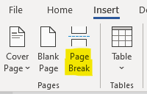  - Then select the Procedures for Monitoring table below and insert it into the manual by right clicking in the newly created page and selecting Keep Source Formatting.  - Update the Table with additional measures used and school specific program goals with corresponding data sources.  Are your screening tools accurately named (e.g., academic and behavioral)?  Is there a plan listed to monitor the treatment integrity of our social skills curriculum (e.g., logging social skill lessons taught; also consider including this in faculty and staff responsibilities)?  Examples (listed under treatment integrity):  Log teaching of Second Step lessons according to scope and sequence in school-provided format.  Do you have program goals included that align with your school improvement goals (e.g., KESA)?  Are your program goals in SMART Goal format?  S – Specific  M – Measurable  A – Achievable  R – Relevant  T – Timely  Consider adding a school improvement goal action plan as an Appendix.

Exemplar Procedures for Monitoring Table
Procedures for Monitoring
Student Measures | Academic:  - DIBELS  - Scantron  - District assessment  - State assessments  - Unit assessments  - Progress reports | Behavior:  - Student Risk Screening Scale Internalizing and Externalizing (SRSS-IE) *note instructional method selected (e.g., in-person, remote, or hybrid)  - Attendance (absence)  - Tardies  - Office discipline referrals (ODR)  - Nurse visits | Social Skills:  - Student Risk Screening Scale Internalizing and Externalizing (SSRS-IE) *note instructional method selected (e.g., in-person, remote, or hybrid)  - Office discipline referrals (ODR)  - Counselor referrals  - Bullying referrals
Program Measures  (School-level) | Social Validity:  - Primary Intervention Rating Scale (PIRS) | Treatment Integrity:  - Tiered Fidelity Inventory (TFI)  - Ci3T Treatment Integrity: Teacher Self-Report (Ci3T TI: TSR)  - Ci3T Treatment Integrity: Direct Observations (Ci3T TI: DO)  - Second Step® treatment integrity data | Program Goals:  1. Goal (data source)  2. Goal (data source)  See Appendix [Insert] School Improvement Goal Ci3T Action Plan

Reactive Plan [Ci3T Blueprint B]
Do We Have… | Guiding Questions and Considerations | Notes
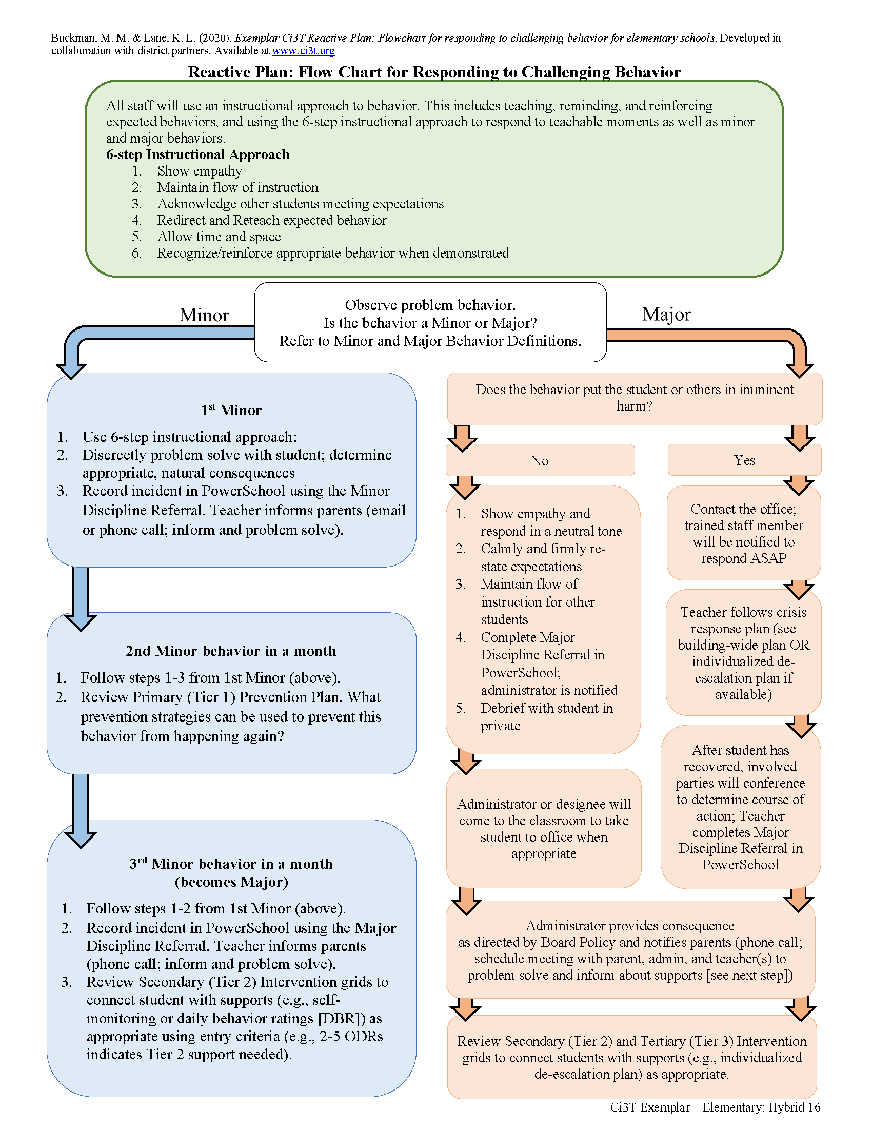
☐ A properly formatted Reactive Plan (Ci3T Blueprint B)? | Is the flowchart properly formatted, clear, and easy-to-follow?  Reference Ci3T Implementation Manual exemplars if needed (see new exemplars on  in the Resource for Educators accordion. Look for elementary, middle, and high school versions under Ci3T Exemplars for Hybrid (In-person and Remote) Learning Experiences (2020-2021).  When pasting from sample documents, use Keep Source Formatting to maintain the correct format.  Add a Page Break after the table ends (Insert > Page Break)
☐ Definitions of major and minor behaviors that make it clear which behaviors are office managed, and which are managed in the classroom? | Are behavior definitions sufficiently clear to help staff accurately follow the reactive plan (e.g., deciding when to involve office staff in managing challenging situations)?  See example behavior definitions for elementary, middle, and high school in Ci3T Implementation Manual exemplars (https://www.ci3t.org/covid in the Resource for Educators accordion…look for elementary, middle, and high school versions under Ci3T Exemplars for Hybrid [In-person and Remote] Learning Experiences [2020-2021]).
☐ Your reactive plan included in your current manual with information on how to access the data reporting system? | Did we incorporate or add any updates from the district master?  When and how will you teach your faculty and staff how to respond when students do not meet expectations for next year?  Consider writing your plans to teach faculty and staff to use the Reactive Plan in the Procedures for Teaching section of your Primary (Tier 1) Prevention Plan.  When will training on the data management system occur? When will follow up sessions be offered through the year? Consider adding to your master school/district schedule.  How and when will data be shared with faculty and staff? (recommendation: three times per year, minimum)  Consider creating a data sharing calendar (click here to download a Ci3T Data Sharing Calendar template), which can be used to plan when/what data will be shared with staff.

Expectation Matrix [Ci3T Blueprint C]
Do We Have… | Guiding Questions and Considerations | Notes
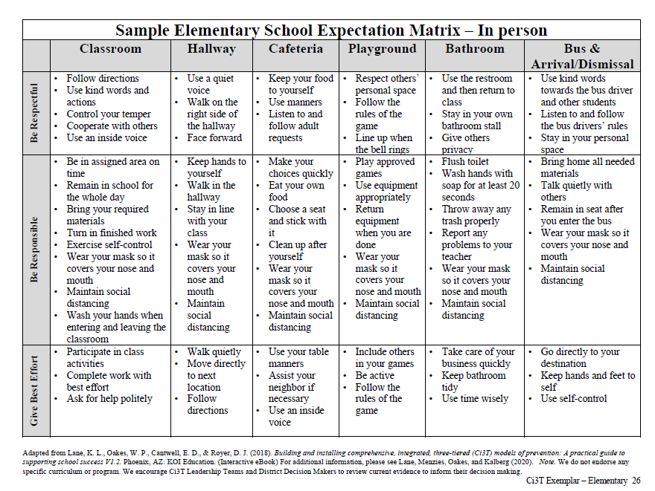
☐ A properly formatted Ci3T School-wide Expectation Matrix (Blueprint C)? | Is the expectation matrix properly formatted?  Use Blueprints from ci3t.org as examples.  When pasting from sample documents, use Keep Source Formatting to maintain the correct format.  Add a Page Break after the table ends (Insert > Page Break)
☐ Positively stated behaviors for demonstrating meeting the 3-5 schoolwide expectations? | Are there any new settings to be added to your Ci3T Blueprint C Expectation Matrix? Any to be revised, combined, or renamed for clarification?  Have you included all key settings (e.g., If buses bring students to school or are used for student club events or field trips, do you have a bus column)?
☐ At least 2 behaviors for demonstrating the expectation per setting? | Are there any edits needed to the behaviors defining the schoolwide expectation in your Ci3T Blueprint C Expectation Matrix?  Consider social validity feedback from faculty and staff surveys.  Consider whether you need to add any safety-related procedures to your expectation matrix (e.g., procedures related to wearing a mask, social distancing, and hand-washing)  If updating your schoolwide expectation matrix, consider gathering information from your faculty and staff to inform these revisions using the Schoolwide Expectations Survey for Specific Settings (SESSS; Lane & Menzies, 2010)  Keep in mind any edits to the expectation matrix will require re-printing posters for classrooms and other settings (e.g., matrix posters, specific-setting posters)
☐ Necessary supporting materials (e.g., printed expectation matrix posters for classrooms, specific-setting posters)? | As you reflect on whether edits are necessary to your school-wide expectation matrix, consider whether additional supporting materials are needed to be printed and shared with staff to support ongoing teaching and prompting of school-wide expectations.  Consider whether additional school-wide expectation matrix posters (see example school-wide expectation poster) need to be printed to post in various settings (e.g., each classroom, cafeteria, hallway).  Consider whether additional specific-setting posters need to be printed and shared with staff (e.g., example classroom setting expectation poster, example hallway setting expectation poster, example of additional setting signage).

Assessment Schedule [Ci3T Blueprint D]
Do We Have… | Guiding Questions and Considerations | Notes
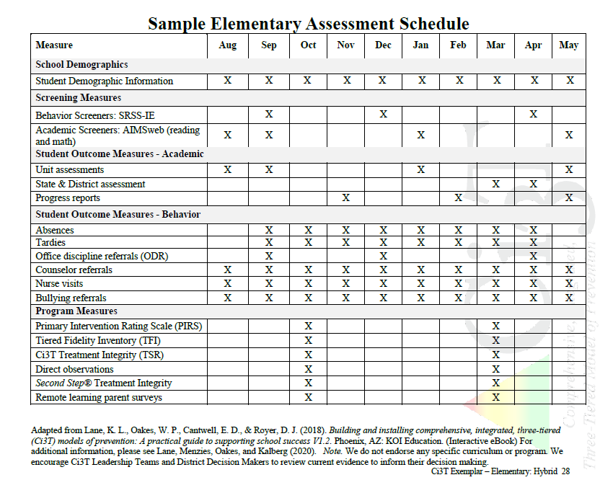
☐ A properly formatted Ci3T Assessment Schedule (Blueprint D)? | Are the tables properly formatted?  Use Blueprints from ci3t.org as examples.  When pasting from sample documents, use Keep Source Formatting to maintain the correct format.  Add a Page Break after the table ends (Insert > Page Break)
☐ The academic screener(s) listed and indicated for use 3 times per year | Is the academic screener listed under screening measures?
☐ The behavior screener listed and indicated for use 3 times per year? | Is the behavior screener listed under screening measures?
☐ Treatment Integrity, social validity windows indicated? (October/November & February/April) | Are all programmatic measures listed (e.g., methods to assess treatment integrity and social validity; see list below)?  Currently, the common measures used include:  - Ci3T Treatment Integrity: Teacher Self-Report  - Ci3T Treatment Integrity: Direct Observation  - Tiered Fidelity Inventory (TFI)  - Treatment Integrity log for [enter name of social-emotional resource e.g., Second Step]  - Primary Intervention Rating Scale
☐ All outcome measures collected for students listed (behavior and academic)? | Are there any new measures you are including for next year (e.g., new academic screening measures)?  For example, consider adding counselor referrals and nurse visits as student outcome measures for behavior – these can be useful data sources in conjunction with screening information to know when students may be experiencing internalizing challenges (e.g., withdrawn, anxious, making somatic complaints).  Are there measures that are no longer used or expected schoolwide that might be removed?
☐ A plan for who will be responsible for collecting and organizing the data for use? | Who will be responsible for collecting and analyzing the data?  Consider adding a prompt to your Ci3T Leadership Team agenda to indicate when data will be analyzed and discussed.  How often will those data be shared and used to make decisions to support students?  Consider creating a data sharing calendar (click here to download a Ci3T Data Sharing Calendar template), which can be used to plan when/what data will be shared with staff.  What is the plan for professional development on the management system so that the team can support faculty and staff in accessing usable data?

Secondary (Tier 2) Intervention Grid [Ci3T Blueprint E]
Do We Have… | Guiding Questions and Considerations |  | Notes
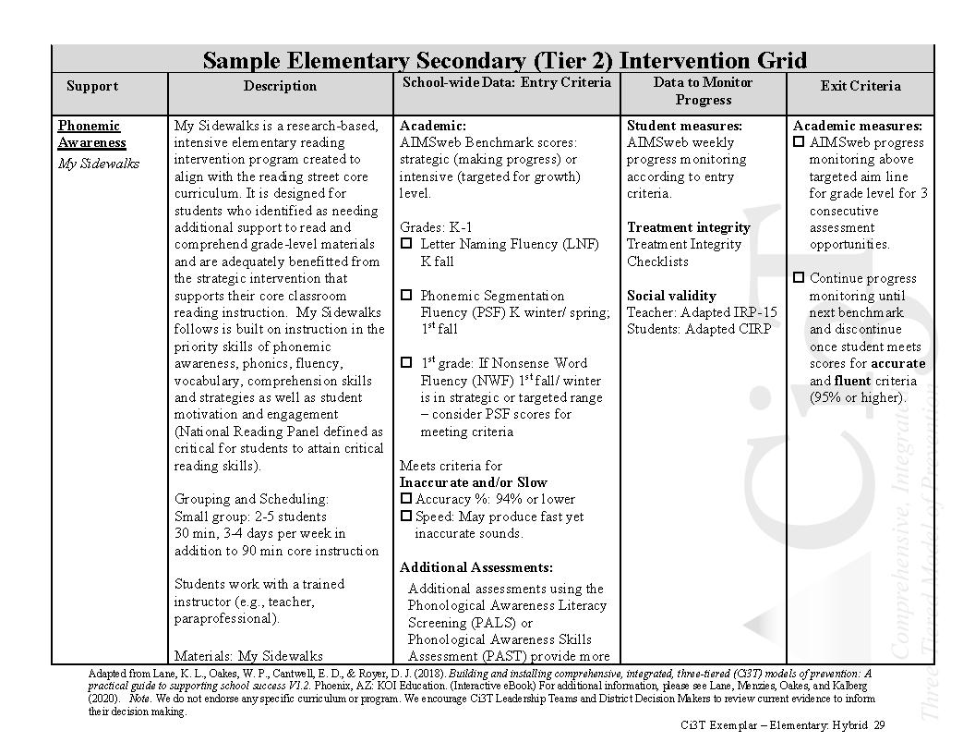
☐ A properly formatted Ci3T Secondary (Tier 2) Intervention Grid (Blueprint E)? | Are the tables properly formatted?  Use Blueprints from ci3t.org as examples.  When pasting from sample documents, use Keep Source Formatting to maintain the correct format.  Add a Page Break after the table ends (Insert > Page Break)
☐ Clear intervention descriptions that describe “who does what to whom and under what conditions”? | Are there additional interventions to include on your intervention grid based on needs from the upcoming school year?  Are listed interventions representative of district-supported Tier 2 interventions? Refer to district master intervention grid (if available).  Have you considered adding targeted low-intensity supports such as Opportunities to Respond, Active Supervision, Precorrection, etc.?  Are the interventions supported with evidence (e.g., experimental studies) for their use for the intended outcomes?
☐ Clear entry criteria based on data sources and cut scores or categories; refraining from the use of teacher nomination? | Have any data collection procedures changed for the upcoming year (e.g., new academic or behavior screening measures)?  Check that entry/exit criteria are based on data sources noted in the Ci3T Blueprint D Assessment Schedule and include specific cut scores for decision making (e.g., at what risk level does is an intervention considered for a student?).
☐ Treatment integrity and social validity data collection procedures used as part of monitoring progress in addition to student level data? | Who might serve as the two faculty/ staff members to become or serve as experts for each intervention?  Consider what professional learning, coaching, and support can be offered in your building to support training all relevant faculty and staff on Tier 2 interventions. Consider how to leverage resources shared on ci3T.org/pl (e.g., treatment integrity and social validity measures, training materials, implementation checklists).
☐ Clear exit criteria based on data and/or successful completion of the intervention? | Are screening data, behavior outcome data, and academic data, or program completion data used to determine exit criteria?

Tertiary (Tier 3) Intervention Grid [Ci3T Blueprint F]
Do We Have… | Guiding Questions and Considerations | Notes
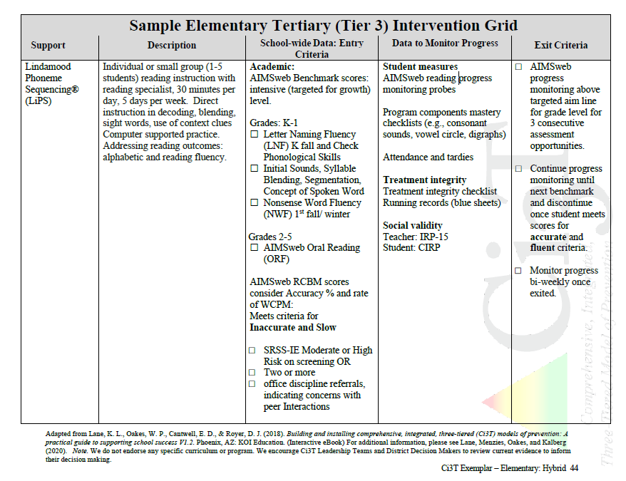
☐ A properly formatted Ci3T Tertiary (Tier 3) Intervention Grid (Blueprint F)? | Are the tables properly formatted?  Use Blueprints from ci3t.org as examples.  When pasting from sample documents, use Keep Source Formatting to maintain the correct format.  Add a Page Break after the table ends (Insert > Page Break)
☐ Clear intervention descriptions that describe “who does what to whom under what conditions”? | Are there additional interventions to include on your intervention grid based on needs from the upcoming school year?  Are listed interventions representative of district-supported Tier 3 interventions? Refer to district master intervention grid (if available).  Are there professional learning opportunities that are needed to address supports that are identified through student data?
☐ Clear entry criteria based on data sources and cut scores or categories refraining from the use of teacher nomination? | Have any data collection procedures changed for the upcoming year (e.g., new academic or behavior screening measures)?  Check that entry/exit criteria are based on data sources noted in the Ci3T Blueprint D Assessment Schedule and include specific cut scores for decision making (e.g., at what risk level does is an intervention considered for a student?).  Have you considered progress on secondary interventions as an entry criterion?
☐ Treatment integrity and social validity data collection procedures used as part of monitoring progress in addition to student level data? | Who might serve as the two faculty/ staff members to become or serve as experts for each intervention?  Consider what professional learning, coaching, and support can be offered in your building to support training all relevant faculty and staff on Tier 2 interventions. Consider how to leverage resources shared on ci3T.org/pl (e.g., treatment integrity and social validity measures, training materials, implementation checklists).  What school or district specialists could review these intervention monitoring tools for feedback?  Could these be shared across district schools and stored in a central location (e.g., Google, SharePoint, Student Information System)?
☐ Clear exit criteria based on data and/or successful completion of the intervention? | Are screening data, behavior outcome data, and academic data, or program completion data used to determine exit criteria?

Date Draft Ci3T Implementation Manual Submitted: Click here to enter a date.
Date Returned with Feedback: Click here to enter a date.
Final version for Current Year Submitted to district: Click here to enter a date.

