Tier 3 Interventions in Ci3T Models:
Assisting Students with Intensive Intervention Needs
  - Resource Guide

Extra Resources

IRIS Modules: Addressing Challenging Behaviors
Part 1: Understanding the Acting-Out Cycle
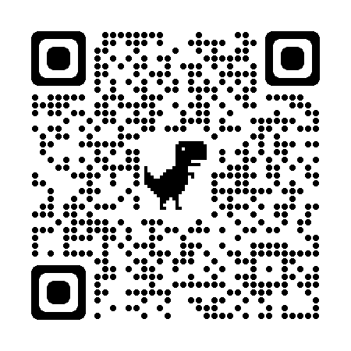
Part 2: Behavioral Strategies
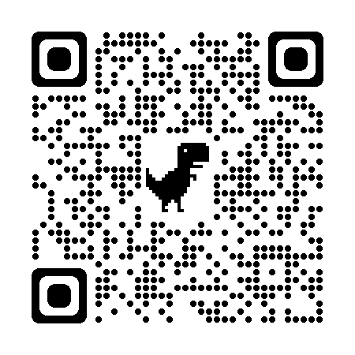

Video Resources

Disruptive Behavior Example Videos (2 videos)
https://kcpt.pbslearningmedia.org/resource/ket-pd-deescalation3/disruptive-behavior/
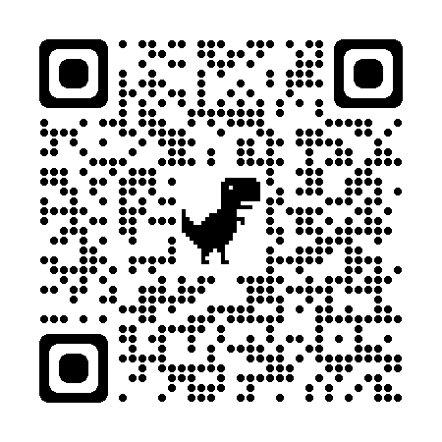

Non-compliant and Defiant Behavior Example Videos (3 videos)
https://kcpt.pbslearningmedia.org/resource/ket-pd-deescalation6/noncompliant-and-defiant-behavior/

Provocative Behavior Example Videos (3 videos)
https://kcpt.pbslearningmedia.org/resource/ket-pd-deescalation5/provocative-behavior/
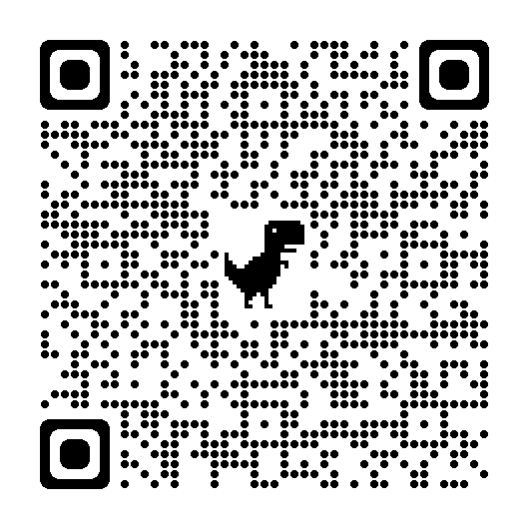

Aggressive Behavior and Fighting (3 videos)
https://kcpt.pbslearningmedia.org/resource/ket-pd-deescalation7/agressive-behavior-and-fighting/

Off-task Behavior Example Video (1 video)
https://kcpt.pbslearningmedia.org/resource/ket-pd-deescalation1/off-task-behavior/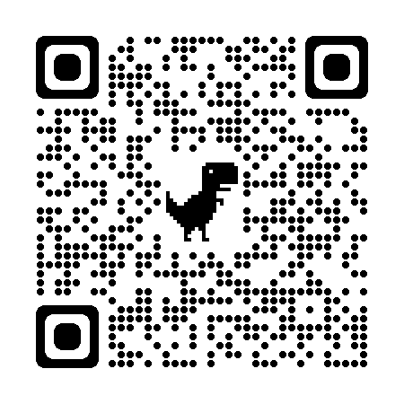

Escalating Behavior Example Video (1 video)
https://vimeo.com/196772653 (timestamp: 1:03 – 2:40)
