XXXX Expectation Matrix
Expectation 3 | Expectation 2 | Expectation 1
 |  |  | Setting 1
 |  |  | Setting 2
 |  |  | Setting 3
 |  |  | Setting 4
 |  |  | Setting 5
 |  |  | Setting 6
 |  |  | Setting 7

Comprehensive, Integrated Three-Tiered (Ci3T) Model of Prevention at
XXXX
School

What is Ci3T?
Ci3T refers to a school-wide model of prevention that includes three tiers of instruction and support for students for achieving success academically, behaviorally (positive behavior interventions and support, PBIS), and socially (e.g., school selected social skills program) areas. Ci3T is to support all students.

Based on our school-wide expectations:
EXPECTATION 1
EXPECTATION 2
EXPECTATION 3
the PBIS component outlines XXXX School’s behavioral expectations for all of our school settings. These expectations are included here and we invite you to post them at home.

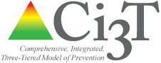

Three Levels of Prevention

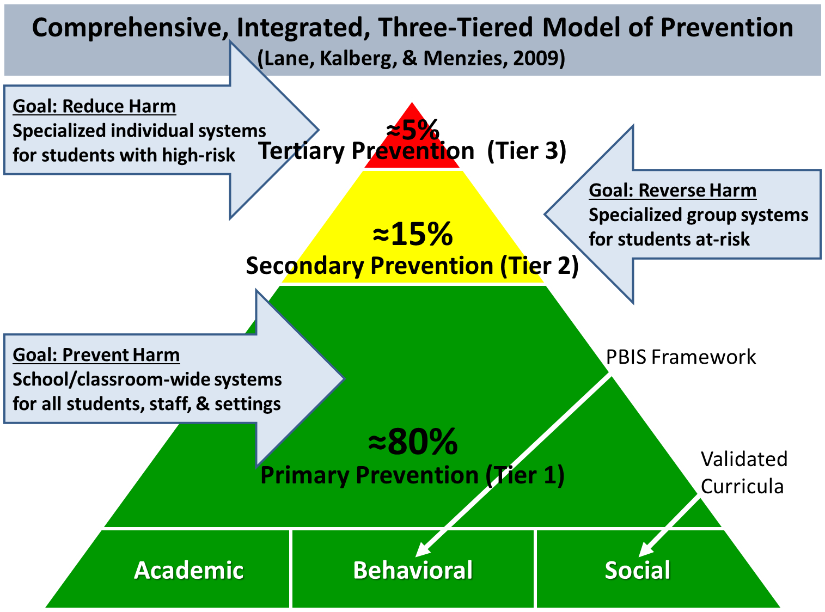

Primary Prevention
Primary prevention — also called Tier 1 —provides for a strong core program for all students with the goal of preventing academic and behavioral difficulties before they emerge. Primary prevention supports the needs of approximately 80% of students. Primary prevention is strong academic instruction aligned with College and Career Ready standards, a school-wide positive behavioral interventions and supports (PBIS) framework, and validated social skills/character education curricula.

Secondary Prevention
Secondary prevention — also called Tier 2 —provides for the delivery of more focused academic, behavioral, and/or social interventions for students who require more than primary prevention. Secondary prevention supports are provide for students who demonstrate need based on school-wide screening data. Examples are small-group social skills instruction, small-group academic skill instruction, behavior contracts or self-monitoring plans. These supports are low intensity and often provided within the general education classroom. Approximately 10-15% of students in a typical school are likely to require this level of support.

Tertiary Support
Tertiary prevention — often called Tier 3 —entails implementing specialized, one-to-one interventions for students who are experiencing difficulties academically, behaviorally, or socially. We anticipate that approximately 5-7% of students in a typical school may require this level of support. Tertiary supports are decided on in collaboration with families and specific to the individual needs of each student. Examples of tertiary preventions are functional assessment-based interventions, multi-systemic therapy, and one-to-one academic instruction often with specialized programs.

Three Core Components

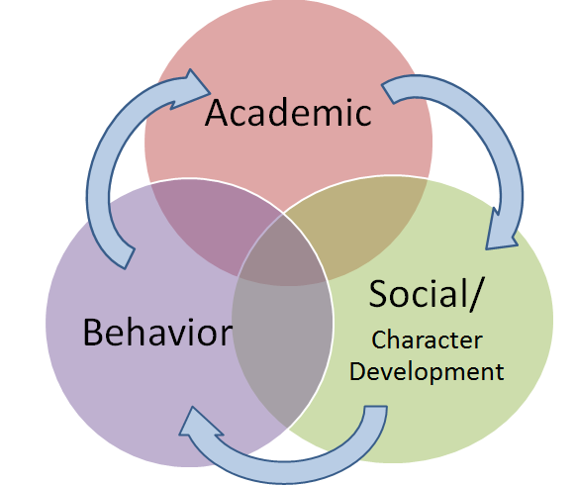

Academic Component
The academic component of the Ci3T model is content knowledge and skills. These are learning activities for developing in the areas of English language arts, mathematics, the sciences, social sciences, foreign languages, the arts, trades, athletics, technology and more. Using validated curricula adopted at the district level to meet the increased rigor and our desired outcomes for students. Teachers differentiate instruction and collaborate to meet all students’ needs.

Behavioral Component
The behavioral component of the Ci3T model is the Positive Behavioral Interventions and Supports (PBIS) framework. The PBIS component was designed by our school faculty and staff and guided by our mission and values. As a community, our school selected 3-5 behavioral expectations (Expectation 1, Expectation 2, Expectation 3) and defined how each expectation is demonstrated across all of our school settings (e.g., cafeterias, classrooms, clubs, hallways, buses). We take an instructional approach to behavior so that all students understand the behaviors expected at XXXX School. We use behavioral data, such as screenings, office disciplinary referrals, and attendance to proactively look for students who may require secondary or tertiary preventions so we can support them at the earliest possible time.

Social Component
The social component of the Ci3T model is our research-based character education curriculum school selected social skills curriculum name. Our school team considered the desired character traits important for students’ success at school and in the community. The chosen curriculum school selected social skills curriculum name addresses current school-wide issues (e.g., bullying) and will be taught school-wide for supporting the development of these skills for all students and for students to support each other in their interactions.

We invite parents to participate by: being aware and following parent academic, behavior, and social responsibilities listed in XXXXX’s Implementation Manual.

