School Name: Ci3T Leadership Team Meeting Agenda and Minutes

Meeting at a Glance
Meeting Date/Time | MM/DD/YY HH:MM PM | Next Meeting Date/Time | MM/DD/YY  HH:MM PM
20XX-20XX Meeting Dates | Ci3T Leadership Team  - [list all Ci3T Leadership Team meeting dates for the year remaining] | Faculty and Staff  - [list all faculty and staff meeting dates for the year remaining]
Place/Connect | Room:  Remote connect:
Ci3T Leadership Team Members in Attendance and Role | Team Member | Role
 | ☐
 | ☐
 | ☐
 | ☐
 | ☐
 | ☐
 | ☐
Guests
Pre-meeting checklist: | - Was the Ci3T Leadership Team given advanced notice and a reminder of the meeting? _ _ Yes _ _ No and Ci3T Coaches? _ _ Yes _ _ No  - Was the agenda updated, reflecting school needs and items discussed at previous meetings? _ _ Yes _ _ No  - Was the meeting agenda sent to all Ci3T Leadership Team members ahead of time? _ _ Yes _ _ No and Ci3T Coaches? _ _ Yes _ _ No  - Was the agenda shared with Ci3T technical assistance providers?  ___ Yes ___ No
Post-meeting checklist: | - Are meeting notes completed, saved and shared with the Ci3T Leadership Team? _ _ Yes _ _ No and Ci3T Coaches? _ _ Yes _ _ No  - Are action items listed with person responsible and completion date?  _ _ Yes _ _ No  3. Date for sharing progress with faculty and staff: ____________________

Agenda
Discussion  Points | Check topics to be discussed today and add additional discussion points  ___ 1. Sharing of Successes (SR+)  ___ 2. Academic, Behavior, and Social Skills Roles and Responsibilities  ___ 3. Procedures for Teaching  ___ 4. Procedures for Reinforcing  ___ 5. Procedures for Monitoring  ___ 6. Secondary (Tier 2) Prevention  ___ 7. Tertiary (Tier 3) Prevention

1. Sharing Successes
Positive Reinforcement (SR+)

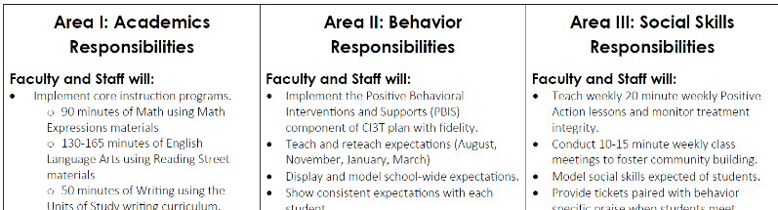
2. Academic, Behavior, and Social Skills
Roles and Responsibilities

ITEM | 2. Academic, Behavior, and Social Skills  Roles and Responsibilities | LEAD | [name] | TIME |  | [max time]
NOTES | Students  - Academics: Core  - Behavior: PBIS  - Social: name of social skills curriculum  Faculty and staff  - Academics: Core  - Behavior: PBIS  - Social: name of social skills curriculum  Parents  - Academics: Core  - Behavior: PBIS  - Social: name of social skills curriculum  Administrators  - Academics: Core  - Behavior: PBIS  - Social: name of social skills curriculum | Guiding Conversations
- Academics
  - Are core curriculum and instructional resources being accessed/delivered?
  - Are proactive, teacher-delivered strategies to increase students’ engagement in place?
  - Are Tier 2 and Tier 3 supports happening in addition to core?
- Behavior
  - Are behavior expectations being taught, modeled, reviewed, and reinforced?
  - Are proactive and reactive elements being implemented with fidelity?
- Social
  - Are curriculum and instructional resources being accessed/delivered?
  - Are social skills being connected and reinforced throughout the day?
  - Are students accessing reinforcement for showing pro-social behaviors?
- Implementation (Tier 1)
  - To what extent are we addressing academic, behavioral, and social domains?
  - What can be improved?
  - What professional development opportunities are in place/needed?
Actions |  | Person(s) |  |  | Due Date

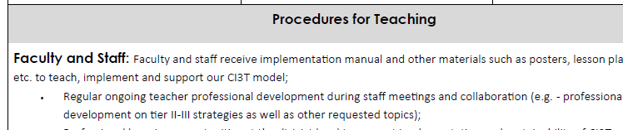
3. Procedures for Teaching

ITEM | 3. Procedures for Teaching the Plan to: | LEAD |  | TIME
NOTES | Faculty and Staff  Students  Parents/Community Members | Guiding Conversations
- Academics: Core
  - English language arts & Math
  - What are your expectations for differentiation and personalized learning?
  - What are the expectations regarding the use of technology?
  - What are the expectations regarding the use of low-intensity strategies?
- Behavior: Behavior Expectations
  - When are they being taught? Do we have plans for re-teaching (e.g., incidental, after winter break)?
  - Who is teaching and how is it going?
  - What expectations need to be retaught (data used to identify challenging areas)?
  - Have we identified areas of concern from our discipline data? How can we re-teach to improve student outcomes?
  - Are expectation matrices posted in all areas?
  - Are posters readily available to teachers to use as a teaching tool and consistent prompt for all?
- Social Skills Lessons
  - When are they being taught?
  - Who is teaching? (e.g., teachers, counselors)
  - How is it going?
  - What lessons need to be retaught?
  - Are social skills lessons posted?
Actions |  | Person(s) |  |  | Due Date

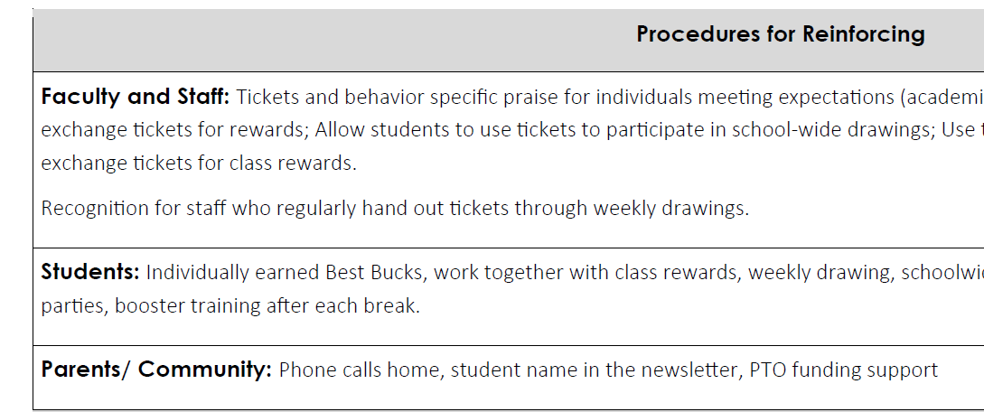
4. Procedures for Reinforcing

ITEM | 4. Procedures for Reinforcing | LEAD |  | TIME
NOTES | Faculty and Staff  Students  Parents/Community Members | Guiding Conversations
- PBIS Tickets
  - Do all adults have access to tickets?
  - Are they being distributed?
- Faculty & Staff
  - How do we recognize faculty and staff?
  - When will we reinforce faculty and staff?
  - What will the reinforcers be?
- Students
  - Are students being given tickets (with equitable access)?
  - When should we start fading tickets?
  - When is the next assembly?
    - When
    - Where
    - Who is in charge
  - Are students finding our reinforcers interesting/ desirable?
- Parents/Communities:
  - When will we reinforcer parents/community members?
  - How?
- Reinforcers
  - How are tickets being used, are students using tickets in meaningful ways?
  - Access/Escape
    - Attention
    - Tangible/non-tangible
    - Sensory
Actions |  | Person(s) |  |  | Due Date

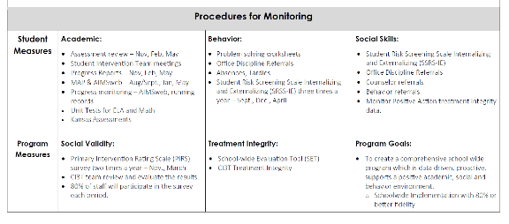
5. Procedures for Monitoring

ITEM | 5. Procedures for Monitoring | LEAD |  | TIME
NOTES | Student Measures  Academic  Behavior  Social Skills  Program Measures  Social Validity  Treatment Integrity  Program Goals | Guiding Conversations
- Academic screening
  - Name of screening measure
  - When?
  - Where?
  - Who is leading?
  - When will data be available to teachers for decision making?
- Behavior screening
  - When?
  - Where?
  - Who is leading?
  - When will data be available to teachers for decision making?
- Review of academic data
- Review of behavior data
- What professional learning is needed? Who should attend?
- Connecting students to supports
  - Which classrooms could benefit from focused Tier 1 instruction?
  - Who could benefit from support?
  - What support is appropriate?
  - Who is going to contact parents for permission?
- Tier 1 implementation
  - To what extent are we addressing academic, behavioral, and social domains?
  - What can be improved?
- Data sharing
  - What data will be shared?
  - When will the data be shared?
  - Who is responsible for organizing data to share with the faculty and staff?
Actions |  | Person(s) |  |  | Due Date

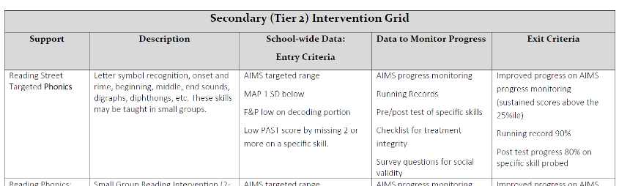
6. Secondary (Tier 2) Prevention

ITEM | 6. Secondary (Tier 2) Prevention | LEAD |  | TIME
NOTES |  | Guiding Conversations
- What supports are currently in place?
- What steps are needed to refine our secondary (Tier 2) intervention grids?
- Who is the expert on specific supports in our building?
- How many students could benefit from secondary supports?
- What supports? (intervention grid)
- Who will be in charge of supports?
- How are we assessing treatment integrity? What are data telling us is needed?
- How are we tracking which students participate in which supports and for how long?
- Are our current supports sufficient for student needs?
Actions |  | Person(s) |  |  | Due Date

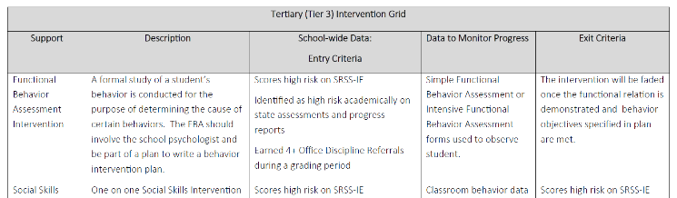
7. Tertiary (Tier 3) Prevention

ITEM | 7. Tertiary (Tier 3) Prevention | LEAD |  | TIME
NOTES |  | Guiding Conversations
- What supports are currently in place?
- What steps are needed to refine our tertiary (Tier 3) grids?
- Who is the expert on specific supports in our building?
- How many students could benefit from tertiary supports?
- What supports? (intervention grid)
- Who will be in charge of supports?
- How are we assessing treatment integrity? What are data telling us is needed?
- How are we tracking which students participate in which supports and for how long?
- Are our current supports sufficient for student needs?
Actions |  | Person(s) |  |  | Due Date

