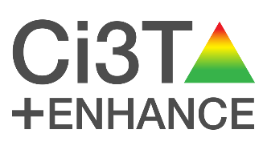
Virtual POSTCARD
[Insert message here]
During Teacher Appreciation Week, our team would like to acknowledge your commitment to meeting students’ and families’ needs. Thank you for all you do!

The Ci3T team recognizes your efforts and dedication to education! Customize this Virtual Pass the Praise Postcard to recognize a colleague or staff member for their outstanding work during Teacher Appreciation Week or any week! Remember to make your praise behavior specific!
Option 1: After customizing the postcard, take a screen shot or image snip and put it in an email to your colleagues.
Option 2: After customizing the postcard, delete these instructions and attach the word document in an email to your colleagues.

