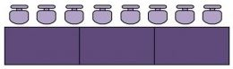­

REGISTRATION TABLE

**Large Venue Example Room Layout**

PROJECTOR

DOORS

DOORS

= Ci3T Coach



**Presenter**

**FOOD & DRINK TABLES**

PROJECTION SCREEN

**DISPLAY TABLE**

**FOOD & DRINK TABLES**

**DRINK TABLE**



Example Materials

**Example Room Layout**



**Presenter**

PROJECTION SCREEN

= Ci3T Coach



PROJECTOR

SCREEN

School 3

School 5

School 1

School 4

School 6

School 2

SCREEN

Registration

Table

Door

Food and Drink Table