XXXXX School

Comprehensive, Integrated, Three-

Tiered (Ci3T) Model

of Prevention

Spring 20XX
Ci3T Feedback Form
Report

Prepared by:

Reference: Lane, K. L. (2002). Primary Prevention Plan: Feedback Form. Unpublished rating scale.

Table of Contents

Survey Overview A
Ci3T Model of Prevention: Feedback Form Report B

REPORT SHARING

This report was designed to share faculty and staff feedback on the Ci3T plan. These data will be used to revise your school’s Ci3T plan based on stakeholder input. You may recall this is the second point of feedback from your faculty and staff, with the first being from the Primary Intervention Rating Scale (PIRS).
Social Validity Measures

Document A
Survey Overview
Ci3T Model of Prevention: Feedback Form

Overview of the Ci3T Model of Prevention:
Feedback Form
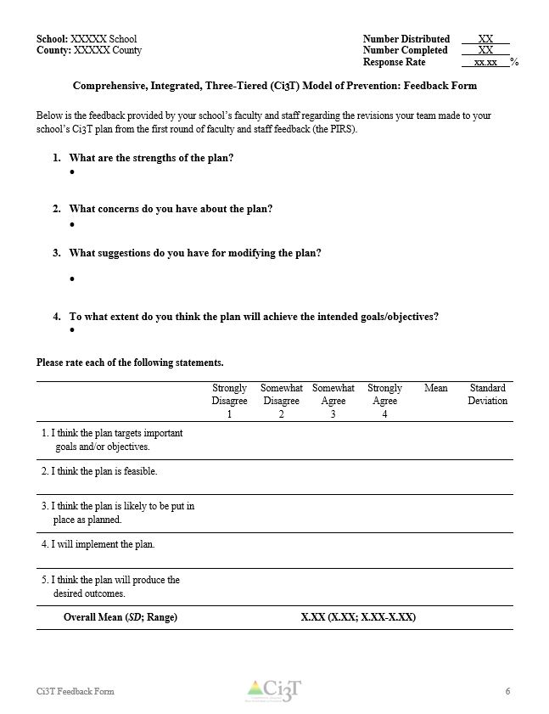
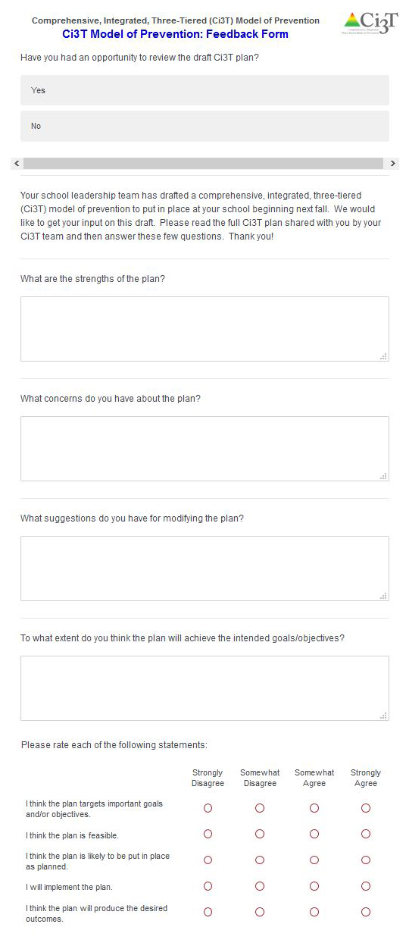
Survey data are aggregated and presented in this report
- Purpose: To obtain information from faculty and staff to guide final revisions to the drafted Ci3T Blueprint for your school, to be implemented in the coming academic year.
- Logistics:
  - All faculty and staff were given an opportunity to complete the Ci3T Model of Prevention: Feedback Form after reviewing the revised Ci3T plan.
  - Feedback, including data and comments, are aggregated in this report to share back to your school to guide final revisions of your Ci3T plan.

Document B
Report
Ci3T Model of Prevention: Feedback Form
School: XXXXX School Number Distributed XX
County: XXXXX County Number Completed XX
Response Rate xx.xx %
Reviewed Plan xx.xx %

Comprehensive, Integrated, Three-Tiered (Ci3T) Model of Prevention: Feedback Form

Below is the feedback provided by your school’s faculty and staff on the full Ci3T Blueprint, including the revisions your Ci3T Leadership Team made to the Ci3T primary (Tier 1) plan from the first round of faculty and staff feedback (see PIRS Report).

- What are the strengths of the plan?

- What concerns do you have about the plan?

- What suggestions do you have for modifying the plan?

- To what extent do you think the plan will achieve the intended goals/objectives?

Please rate each of the following statements.
 | Strongly Disagree  1 | Somewhat Disagree  2 | Somewhat Agree  3 | Strongly Agree  4 | Mean | Standard Deviation
1. I think the plan targets important goals and/or objectives.
2. I think the plan is feasible.
3. I think the plan is likely to be put in place as planned.
4. I will implement the plan.
5. I think the plan will produce the desired outcomes.
Overall Mean (SD; Range) | X.XX (X.XX; X.XX-X.XX)

For more information, visit
www.ci3t.org

