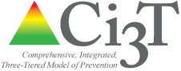
table talk 5

Topic: Current Data Sources tIME: 5 MIN

Instructions: Please take a moment to reflect on the information presented in the previous section. With your team, begin a constructive conversation to identify currentLY AVAILABLE SOURCES OF DATA.

Guiding Questions:
- What data do we currently collect to monitor student performance academically, behaviorally, and socially?
- Who is responsible for collecting each source of data?
- When are data collected?
- Do teachers have efficient access to data?
- How are data being used to inform decision making?
- How are data impacting decisions for supporting students?

What types of data does our school currently collect? | How are data being used to inform decision-making? | How are data used to support students?

