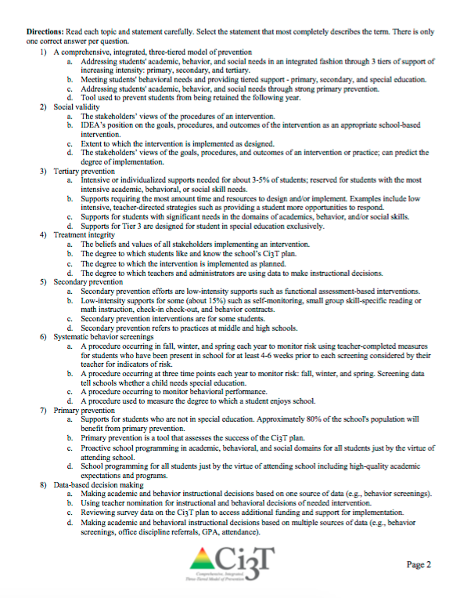
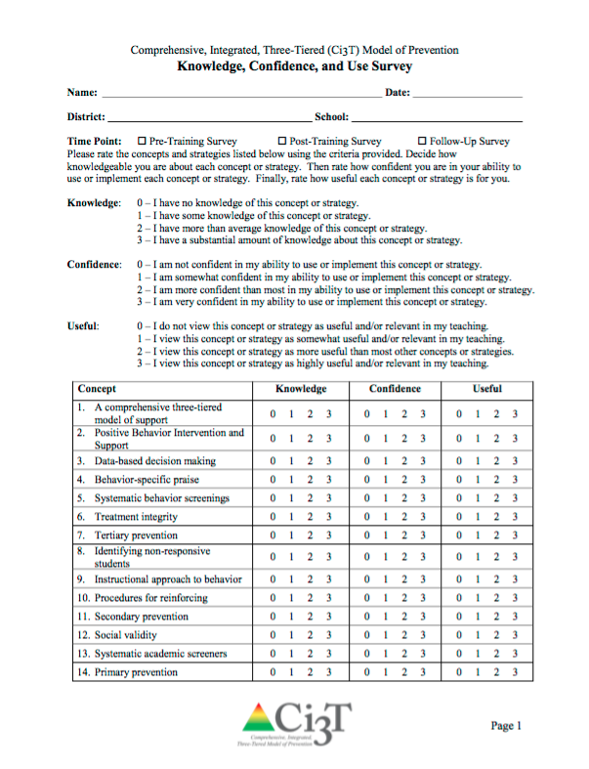
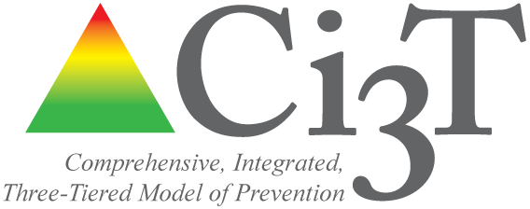

XXXXX SCHOOL

C omprehensive, Integrated,
Three-Tiered (Ci3T)

Model of Prevention
20XX-20XX
Knowledge Confidence and Use (KCU) Survey Report

This report can be used to show shifts in Ci3T Leadership Team participant knowledge, confidence and perceived usefulness of Ci3T concepts and strategies addressed during the Ci3T Professional Learning Series.

Prepared by:

Source: Lane, K. L. & Oakes, W. P. (2010). Project SUPPORT and INCLUDE: Knowledge, confidence, and use survey (full model training series). Unpublished rating scale.

School: County:

Comprehensive, Integrated, Three-Tiered (Ci3T) Model of Prevention
Knowledge, Confidence, and Use Survey
Please rate the concepts and strategies listed below using the criteria provided. Decide how knowledgeable you are about each concept or strategy. Then rate how confident you are in your ability to use or implement each concept or strategy. Finally, rate how useful each concept or strategy is for you.

Knowledge: 0 – I have no knowledge of this concept or strategy.
1 – I have some knowledge of this concept or strategy.
2 – I have more than average knowledge of this concept or strategy.
3 – I have a substantial amount of knowledge about this concept or strategy.

Confidence: 0 – I am not confident in my ability to use or implement this concept or strategy.
1 – I am somewhat confident in my ability to use or implement this concept or strategy.
2 – I am more confident than most in my ability to use or implement this concept or strategy.
3 – I am very confident in my ability to use or implement this concept or strategy.

Useful: 0 – I do not view this concept or strategy as useful and/or relevant in my teaching.
1 – I view this concept or strategy as somewhat useful and/or relevant in my teaching.
2 – I view this concept or strategy as more useful than most other concepts or strategies.
3 – I view this concept or strategy as highly useful and/or relevant in my teaching.

 | Pre-Training  n = |  |  | Post-Training  n = |  |  | Follow Up  n =
Concept | K  M (SD) | C  M (SD) | U  M (SD) | K  M (SD) | C  M (SD) | U  M (SD) | K  M (SD) | C  M (SD) | U  M (SD)
- A comprehensive three-tiered model of support
- Positive Behavior Intervention and Support
- Data-based decision making
- Behavior specific praise
- Systematic behavior screenings
- Treatment integrity
- Tertiary prevention
- Identifying non-responsive students
- Instructional approach to behavior
- Procedures for reinforcing
- Secondary prevention
- Social validity
- Systematic academic screeners
- Primary prevention
Total mean of all items (SD)

Directions: Tell us what you know about these topics in the space provided:

1) A comprehensive, integrated, three-tiered model of prevention
- [copy and paste or type in hand-written answers here, one bullet point per response] or
- [score using rubric available from authors]

2) Social validity

3) Tertiary prevention

4) Treatment integrity

5) Secondary prevention

6) Systematic behavior screenings

7) Primary prevention

8) Data-based decision making

Knowledge, Confidence, and Use Survey: Mean Score Comparisons

 | Time Point
Construct | Pre-Training  M (SD) | Post-Training  M (SD) | Effect Size  Hedges’s g
Knowledge | xx.xx (xx.xx)  n = xx | xx.xx (xx.xx)  n = xx | x.xx
Confidence | xx.xx (xx.xx)  n = xx | xx.xx (xx.xx)  n = xx | x.xx
Use | xx.xx (xx.xx)  n = xx | xx.xx (xx.xx)  n = xx | x.xx

