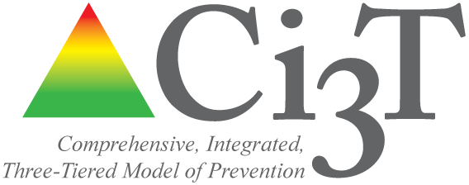
table talk 2

Topic: goals time: 10 min

Instructions: Please take a moment to reflect on the information presented in the previous section. With your team, begin a constructive conversation to identify THE ACADEMIC GOALS FOR yOUR STUDENTS AT THE STATE, DISTRICT, AND SCHOOL LEVEL.*

Guiding Questions:
- What are our academic areas for focus for improvement?
- What data were used to make this decision?
- What are our targets for improvement (e.g., increase oral reading fluency for 80% of students in the low-risk category by spring, increase average GPA to X.XX, decrease course failures to X school-wide, increase graduation rate to X)?
- What data will be used to decide when each goal has been achieved?

Consider:
- state-level goals
- district-level goals
- school-level goals
- goals for teaching
- goals for learning
*Recorder, please take notes on this topic for your team to refer to when discussing and drafting procedures for monitoring in Ci3T Blueprint A Primary (Tier 1) Plan.
Notes:

