Functional Assessment-based Intervention Process Guide: Component Checklist

Visual Analysis: Guiding Questions for Phase Change Decision Making
The purpose of this document is to assist district-level and school-site teams in the design, implementation, and evaluation of functional assessment-based interventions (FABI; Umbreit, Ferro, Liaupsin, & Lane, 2007) using single-case design methodology.
While there are many different types of information collected, student outcome data may focus on reducing a problem behavior (target behavior), or increasing a prosocial or academic behavior (replacement behavior; Horner et al., 2005). Target and replacement behaviors may be measured and graphed. If deciding between either target (e.g., off task) or replacement (e.g., on task), it is often desirable to measure and graph data measuring the replacement behavior to focus on the desired behaviors (e.g., on task or prosocial behavior).
Visual analysis techniques can be used by educators and therapists to inform decision-making tasks, with a main goal of evaluating the effects of the intervention on student outcomes (Gast & Spriggs, 2014).
In this guide, we refer to three basic techniques for conducting visual analysis for decision making, these are: level, trend, and stability. On occasion, we introduce descriptive statistics to complement your visual analysis, specifically: mean (M), standard deviation (SD), slope (b), and standard error of slope (SE YX). In this guide, we focus onsingle-case design: A-B-A-B or Withdrawal design. The guidelines presented in this guide should not be viewed as absolute or inflexible rules for interpreting graphic data or making phase change decisions, but as general guiding principles to help inform and support educators’ phase change decision making. Educators should consider the individual student, the context of the classroom, the designed intervention, as well as ethical considerations to inform decision making.

Table 1. Summary of Level, Trend, and Stability.
Indicator | Description
Level | The mean score for the data within a phase.
Mean (M) | A mean score is an average score, calculated by the sum of individual data point values divided by the total number of data points in a phase.
Standard Deviation (SD) | The standard deviation is a measure to quantify the amount of variation or a set of values.
Trend | The overall direction (slope) of data path.
Slope (b) | The slope of a line is a measure of the "steepness" of the line.
Standard Error of Slope (SE YX) | The standard error is a measure of the variability of the slope (i.e., regression line).
Stability | The overall variability in level or trend
Sources: Gast & Ledford (2014), Horner et al. (2005), and Kratochwill et al. (2010).
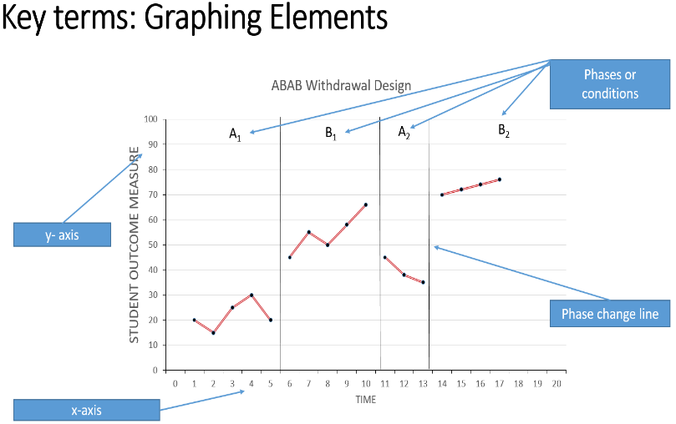

Figure 1. Graphing Elements
Table 2. Graphing and Visual Analysis Pre Planning Form
Graphing and Visual Analysis Pre Planning Form
See Functional Assessment and Behavior Intervention Plan: Planning Form | What behavior are you graphing? (select one)  ☐ Target Behavior ☐ Replacement Behavior  Label: Click or tap here to enter text.  Note: We recommend replacement behavior. | Update label on graph’s Key
See Functional Assessment and Behavior Intervention Plan: Planning Form | Check the measurement system used for your data collection:  ☐ Frequency  ☐ Rate  ☐ Duration  ☐ Latency  ☐ Interresponse Time  ☐ Whole Interval Recording  ☐ Partial Interval Recording  ☐ Momentary Time Sampling  ☐ Other (discuss with coach): Click or tap here to enter text.  Labeling the y-axis:  ☐ Percentage  ☐ Rate  ☐ Frequency/Number of occurrences  ☐ Time (hr, min, s)  ☐ Other (discuss with coach) | Update graph’s  y-axis title
 | Labeling the x-axis:  ☐ Date  ☐ Probe  ☐ Session number  ☐ Other (discuss with coach): Click or tap here to enter text.  Note: We recommend formatting your x-axis to reflect date. | Update graph’s  x-axis title

Behavioral Objective: Determining Desired Direction
See Functional Assessment and Behavior Intervention Plan: Planning Form | Baseline Statement (describing level and trend for baseline):  Click or tap here to enter text.  Mean (SD):  Click or tap here to enter text.(Click or tap here to enter text.)  Slope (SE YX):  Click or tap here to enter text.(Click or tap here to enter text.)
See Step 5 Summary Template (Excel) | Behavioral Objective:  Click or tap here to enter text.
 | During intervention conditions, the desired direction is for the behavior to (select one) .  ☐ Increase ☐ Decrease | This will be your desired (therapeutic) direction

Table 3. Behavior Objective: Determining Desired (Therapeutic) Direction
PHASE CHANGE COMPONENT CHECKLIST: ABAB Design
Directions: Complete phase change component checklist to inform phase change decision making. Additionally, educators should consider the individual student, the context of the classroom, and the designed intervention. Check and date when completed.
Who completed this component checklist (Check): ☐Team ☐ Coach Date: Click or tap to enter a date.
 | Baseline (A₁)  A₁ represents baseline  (current practices in place) | Intervention (B₁)  B₁ represents the first introduction of the intervention | Withdrawal (A₂)  A₂ represents a withdrawal of the intervention | Reintroduction (B₂)  B₂ represents the reintroduction of the intervention
Level  Visual inspection | Is the level: (select one)  ☐ Low ☐ Moderate ☐ High | Is the level: (select one)  ☐ Low ☐ Moderate ☐ High | Is the level: (select one)  ☐ Low ☐ Moderate ☐ High | Is the level: (select one)  ☐ Low ☐ Moderate ☐ High
Mean (SD)  Descriptive statistics | M: Click or tap here to enter text.  SD: Click or tap here to enter text. | M: Click or tap here to enter text.  SD: Click or tap here to enter text. | M: Click or tap here to enter text.  SD: Click or tap here to enter text. | M: Click or tap here to enter text.  SD: Click or tap here to enter text.
Trend  Visual inspection | Is the trend: (select one)  Increasing Decreasing Flat  Is this a desired change? (Is behavior improving, remaining the same, or getting worse?) | Is the trend: (select one)  Increasing Decreasing Flat  Is this a desired change?  (Is behavior improving, remaining the same, or getting worse?) | Is the trend: (select one)  Increasing Decreasing Flat  Is this a desired change?  (Is behavior improving, remaining the same, or getting worse?) | Is the trend: (select one)  Increasing Decreasing Flat  Is this a desired change? (Is behavior improving, remaining the same, or getting worse?)
Slope  (SE YX)  Descriptive statistics | Slope: Click or tap here to enter text.  SE YX: Click or tap here to enter text. | Slope: Click or tap here to enter text.  SE YX: Click or tap here to enter text. | Slope: Click or tap here to enter text.  SE YX: Click or tap here to enter text. | Slope: Click or tap here to enter text.  SE YX: Click or tap here to enter text.
Stability  Visual inspection | Is there stability: (select one)  ☐ Stable ☐ Variable | Is there stability: (select one)  ☐ Stable ☐ Variable | Is there stability: (select one)  ☐ Stable ☐ Variable | Is there stability: (select one)  ☐ Stable ☐ Variable
Treatment Integrity (TI)  Examine TI data | What elements of the intervention were in place?  Additional Considerations  Is contamination a concern?  Click or tap here to enter text. | Is the intervention happening and at what level?  (select one): ☐Yes ☐ No  TI: Click or tap here to enter text. / Click or tap here to enter text. Click or tap here to enter text. %  Additional Considerations  Is re-teaching or coaching needed?  Does the intervention need slight revision or does a new intervention need to be designed?  Click or tap here to enter text. | Were conditions returned to baseline? (Were all intervention components removed?)  (select one): ☐Yes ☐ No  TI: Click or tap here to enter text. / Click or tap here to enter text.  Click or tap here to enter text. %  What elements are in still in place?  Click or tap here to enter text. | Is the intervention happening and at what level?  (select one): ☐Yes ☐ No  TI: Click or tap here to enter text. / Click or tap here to enter text.  Click or tap here to enter text. %
Component Check:  See Guiding Questions Appendix (desired answers: YES) | - Is the behavior improving?  ☐Yes ☐ No  - Is the behavior predictable?  ☐Yes ☐ No | - Is the behavior improving?  ☐Yes ☐ No  - Is the behavior predictable?  ☐ Yes ☐ No | - Is the behavior improving?  ☐Yes ☐ No  - Is the behavior predictable?  ☐Yes ☐ No | - Is the behavior improving?  ☐Yes ☐ No  - Is the behavior predictable?  ☐Yes ☐ No
Note: This document illustrates a process for making phase change decision making using an ABAB design. A-B contrasts are robust feature of many single case research designs (e.g., multiple baseline). In general, introduce a phase change when sufficient data have been gathered and an acceptable data trend has been established for said condition (Gast & Baekey, 2014). See Guiding Questions Appendix for possible considerations of data indications to support the decision making process.

Appendix

In this Appendix, we offer a few guiding questions and considerations for phase changes while using an A-B-A-B or Withdrawal design. Graphing data provides a means of organizing the data you have collected and creates a picture that allows you to determine the effect of the intervention on the behavior of interest. Graphed data are easily shared with educators, students, and parents to show the student’s progress in each phase pictorially, rather than only describing observed changes in words and numbers. In this guide, we focus on single-case design: A-B-A-B or Withdrawal design. Elements for consideration when using visual analysis to guide phase change decisions are:
(a) number of data points plotted within a condition; (b) number of variables changed between adjacent conditions; (c) level, stability, and changes in level within and between conditions; (d) trend direction, trend stability, and changes in trend within and between conditions; and (e) percentage of data points in one condition that fall within the range of data plotted in an adjacent condition (Gast & Spriggs, 2014, p. 178).
Questions are posed to help you better understand the use of level, trend, and stability for decision making - helping to guide phase change decisions to test the effect of the intervention for a student. This process should not be viewed as absolute or inflexible rules for interpreting graphic data or making phase change decisions, but as general principles to help inform and support educators’ phase change decision making.

Baseline to Intervention  (A₁-B₁) | Intervention to Withdrawal  (A₁-B₁-A₂) | Withdrawal to Reintroduction (A₁-B₁-A₂-B₂)
Baseline data indicate:  - present levels of behavior support the need for intervention. The present levels warrant need of behavior change and  - data are somewhat predictable in their pattern (level, trend, stability) – that is the data are not fluctuating.  Guiding Questions  - Is the behavior improving?  No, then it may be time to implement.  Yes, then examine extent of change in level, trend, and stability. May continue baseline to see if behavior continues to improve without need of intervention or if improvement reverses.  - Is the behavior predictable?  No, may continue baseline and monitor stability, or implement and monitor changes. Across phase change (A₁ to B₁), monitor shifts in stability, level, and slope.  Yes, then it may be time to implement. Across phase change (A₁ to B₁), monitor shifts in level and slope, as well as stability. | Introduction of intervention data indicate:  - present levels of behavior show some indication of improvement and  - data are somewhat predictable in their pattern (level, trend, stability) – that is the data are not fluctuating.  Guiding Questions  - Is the behavior improving?  No, examine treatment integrity data to make sure the intervention is being put in place as planned, examine intervention plan. For issues of treatment integrity, consider re-teaching. If plan is in place, the function or method or a component of the intervention package may need to be modified – introduce B₁’ (slight modification to intervention) or a new intervention (C₁). Use a phase change line to indicate a change in the intervention B₁’ or C₁.  Yes, then examine magnitude of change in level, trend, and stability. Withdraw when appropriate.  - Is the behavior predictable?  No, may continue intervention and monitor stability. For phase change, monitor treatment integrity as well as shifts in stability, level, and trend at both phase changes (A₁ to B₁ and B₁ to A₂).  Yes, withdrawal when appropriate. Monitor shifts in level and slope, as well as stability at both phase changes  (A₁ to B₁ and B₁ to A₂). | Withdrawal data indicate:  - present levels of behavior show some indication of deteriorating (return to previous baseline levels) and  - data are somewhat predictable in their pattern (level, trend, stability) – that is the data are not fluctuating.  Guiding Questions  - Is the behavior deteriorating?  No, examine treatment integrity data to determine what if any intervention elements are still in place. It may be the student has learned the new behavior and is accessing natural reinforcements in the environment or that the intervention was not completely removed.  Yes, examine extent of change in level, trend, and stability. Reintroduce when appropriate.  - Is the behavior predictable?  No, may continue withdrawal and monitor stability. Monitor treatment integrity as well as shifts in stability, level, and trend across phases change (A₂ to B₂).  Yes, reintroduce when appropriate. Monitor shifts in level and slope, as well as stability across phase change (A₂ to B₂).

