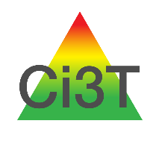
Ci3T Meeting Schedule
Please list your scheduled Ci3T Leadership Team meetings and faculty and staff meetings.
School name: _____________________ Date completed: ____________________
Month | Ci3T Leadership Team Meetings |  | Faculty and Staff Meetings*
 | Date | Time | Date | Time
July
August
September
October
November
December
January
February
March
April
May
June
*We suggest sharing data (e.g., treatment integrity, social validity, and screening results) and Ci3T updates at your regularly scheduled faculty and staff meetings. Faculty and staff value receiving these informational updates and appreciate feeling included in Ci3T implementation efforts.

