Ci3T Template Emails

Directions. Template sample emails are provided for preparing for the Ci3T professional learning series.

1. Pre-Training: Send Approval Letter Template to District Leaders and/or School Principals.

This template can be used to provide district and school leaders with the key information needed for their approval letter. Items in red are to be customized either by the Ci3T Trainer or by district/school leaders so please edit accordingly and ask school leaders to edit as they prefer. Some districts may already have standard approval letters for their use.

Dear [district leader or school principal],

Thank you for your interest in having me provide training on Comprehensive, Integrated, Three-Tiered (Ci3T) models of prevention in the 20XX-20XX school year. I have enjoyed getting to know you as we have talked through the possibility of this training series and I am very excited to work with you in the coming year! To secure your commitment, below I have included an approval letter template. If you would, please edit the template to include your letterhead, your information, sign and return to me by [date] and we can then begin scheduling informational meetings!

Replace this box with district or school letterhead.

[date]

[Ci3T Trainer name]
[Ci3T Trainer affiliation]
[Ci3T Trainer address]
[Ci3T Trainer city state zip]

Dear [Ci3T Trainer],

Thank you for the opportunity to participate in the upcoming Comprehensive, Integrated, Three-Tiered (Ci3T) Model of Prevention [add full research project name and study number if applicable] training series during the 20XX-20XX academic year. My colleagues and I are pleased you are able to offer this rigorous learning opportunity for [full district name].

I have read the study documents you provided and hereby grant approval for our district to participate. Our school-site teams are looking forward to participating in this year-long training series. I understand you will not be able to cover the cost of the substitute teachers needed in order for school-site team members to attend the three (3) full-day trainings.

I look forward to this professional learning experience.

Sincerely,

[district leader or research coordinator full name or school principal]
[full title and contact information]

Thank you again, this will be an exciting year of building!

Sincerely,
[Ci3T Trainer]
[attach to your email either the Ci3T Approval Letter District Template or Ci3T Approval Letter Principal Template as appropriate]

2. Principal Informational Email
Dear [principal],

Thank you for sending your letter of support. We are excited to have received both your district and school approval letters for the upcoming Comprehensive, Integrated, Three-Tiered (Ci3T) model of prevention professional learning series!

In this next month, we look forward to scheduling a meeting with your complete faculty and staff to provide information regarding Ci3T models of prevention, as well as invite faculty and staff to participate in completing two short surveys that will be used for the professional learning series. Additionally, we appreciate 15 minutes to meet with your school’s Ci3T Leadership Team members (see below) after the full faculty and staff meeting.

To make scheduling this time with your complete faculty and staff as convenient as possible, do you have any staff meetings already scheduled during the month of [desired meeting month]?
Please invite all staff to this informational meeting, including those who might not normally attend a faculty meeting (e.g., paraeducators, part-time staff, office staff, custodial staff, cafeteria staff, and bus drivers).

In the meantime, please consider which individual to include on your school’s Ci3T Leadership Team and attend the professional learning series. You might start with an existing building leadership team, or take this as an opportunity to start engaging new staff in leadership roles. We recommend that each Ci3T Leadership Team be representative of the entire school and consist of the following members:
- 1 administrator
- 1 district representative
- 2 general educators
- 1 special educator
- 1 parent (of a student who will be returning next year)
- 1 student (child of the parent team member, at least 8 years old)
*student member only attends sessions 3 and 5 that occur after school.
- 1-2 optional members (e.g., related service providers, instructional coaches, counselor)
Please ensure your chosen team members will be able to attend all Ci3T professional learning sessions.
Ci3T Session | Length | Ci3T Session Meeting Date
1 | 2 hour: x:xx PM – x:xx PM | [day of the week and full date]
2 | 7 hour: x:xx AM – x:xx PM | [day of the week and full date]
3*with students | 2 hour: x:xx PM – x:xx PM | [day of the week and full date]
4 | 7 hour: x:xx AM – x:xx PM | [day of the week and full date]
5*with students | 2 hour: x:xx PM – x:xx PM | [day of the week and full date]
6 | 7 hour: x:xx AM – x:xx PM | [day of the week and full date]

In one week we will email a link to a form that will enable you to register your team members for the professional learning series. Please let me know if you have any questions.
Sincerely,
[Ci3T Trainer]

3. Principal Ci3T Leadership Team Registration Email (sent from Qualtrics)
Dear Principal,

Welcome back to a new school year! We hope your summer was refreshing. We are preparing to host your school’s Ci3T Leadership Team at the Comprehensive, Integrated, Three-tiered (Ci3T) model of prevention professional learning series coming up soon. You are invited to participate in this opportunity with a few other school teams. The first step is for you to register your school’s Ci3T leadership team members for the professional learning series.

Please provide team member names, emails, and phone contact information. If possible, it would be very helpful to have a unique identification number for each team number in addition to their name (in case people have a name change). When you click the link below to register your team, you will see the roles represented on the team. For example, a school administrator with decision making authority is essential to the process, and therefore, must be a member of the team. You will be asked for your parent team member representative, who will attend each session and work on activities between sessions with the team. You will also see that your student representative needs to be the child of your parent member, as the parent must be in attendance at the session with the student. We also ask that the student member be at least 8 years old and that they will return to the school the following academic year. In addition, you will need two general education teachers, one special education teacher, one district representative, and the option of including up to two additional team members. Here is a screenshot of what team registration will look like online:
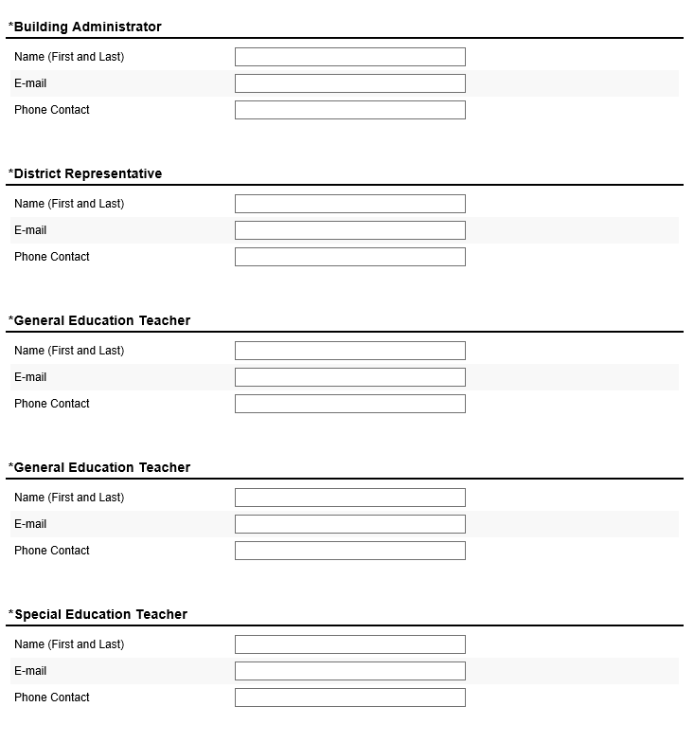
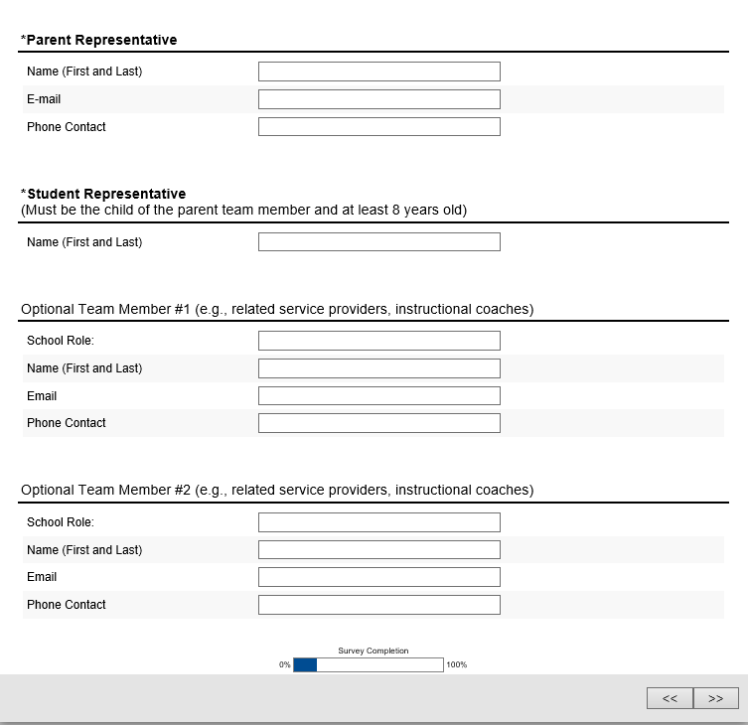
Please feel free to contact me with any questions – we look forward to meeting you, your team, and your full faculty and staff!

Respectfully,

4. Principal Faculty & Staff Roster Request
Dear [Principal],

[Personable greeting]. Thank you so much for being so responsive and positive about the upcoming Ci3T professional learning experience. As we begin planning school-site informational meetings, there are a few items we would like to request. Since we will be providing information and professional learning session surveys electronically, we ask that you please provide us with a complete faculty and staff roster of your school (everyone who works in your building) with the following information:
- First name
- Last name
- Email address
- Position / role (e.g., kindergarten teacher, music teacher, bus driver, cafeteria worker, counselor, secretary, principal)
- Grade level(s) of students they work with (whole class, small group, or 1:1 instruction)
- Shared status (yes or no) – Is each person shared between more than one school site? Include the names of other schools employed if possible.
We respectfully request this information be sent to us in a MS-Excel spreadsheet by [date and time]. If possible, it would be very helpful to have a unique identification number for each team number in addition to their name (in case people have a name change).

We recently emailed the team registration link, if you did not receive this survey link, please let us know and we will resend the link. Emails may end up in junk email folders, so please check that folder if you do not see it in your inbox. Team registration is needed to prepare for our brief (15 min) meeting with your Ci3T Leadership Team members following the full faculty and staff meeting.

If you have any questions, please contact us. We look forward to meeting your faculty and staff!

Sincerely,

5. Principal Recommended Readings
Dear [Principal],

[Personable greeting]. Thank you for your efforts in selecting your Ci3T Leadership Team and compiling a complete faculty and staff roster to email us (MS-Excel file preferred). As a reminder, the information needed in the roster includes every person that supports the work of your school, with the following information:
- First name
- Last name
- Email address
- Position / role (e.g., kindergarten teacher, music teacher, bus driver, cafeteria worker, counselor, secretary, principal)
- Grade level(s) of students they work with (whole class, small group, or 1:1 instruction)
- Shared status (yes or no) – Is each person shared between more than one school site? Include the names of other schools employed if possible.
As you and your Ci3T Leadership Team members prepare for the start of the Ci3T professional learning series, we offer a list of recommended books and one journal special issue. We recommend each school team purchase at least one set to be shared among team members for the homework readings between sessions.

Lane, K. L., Oakes, W. P., Cantwell, E. D., & Royer, D. J. (2019). Building and installing comprehensive, integrated, three-tiered (Ci3T) models of prevention: A practical guide to supporting school success (v1.3). Phoenix, AZ: KOI Education. (interactive eBook)

Lane, K. L., Menzies, H. M., Oakes, W. P., & Kalberg, J. R., & Menzies, H. M. (2019). Developing a schoolwide framework to prevent and manage learning and behavior problems (2nd ed.). New York, NY: Guilford Press.
Lane, K. L., Menzies, H., Bruhn, A., & Crnobori, M. (2011). Managing challenging behaviors in schools: Research-based strategies that work. New York, NY: Guilford Press.
Lane, K. L., Menzies, H., Ennis, R. P., & Oakes, W. P. (2015). Supporting Behavior for School Success: A step-by-step guide to key strategies. New York, NY: Guilford Press.

Journals: Ci3T special issues
Designing, Implementing, and Evaluating Comprehensive, Integrated, Three-Tiered Models of Prevention: A Step-by-Step Guide (2014).

A special issue of Preventing School Failure, volume 58, issue 3
http://www.tandfonline.com/toc/vpsf20/58/3

To order reprints, contact Taylor and Francis customerservice@TaylorandFrancis.com or visit https://taylorandfrancis.com/partnership/commercial/reprints/

Effective Low-Intensity Strategies to Enhance School Success: What Every Educator Needs to Know (2018).

A special issue of Beyond Behavior, volume 27, issue 3
https://journals.sagepub.com/toc/bbxa/27/3

This special issue contains articles on six low-intensity strategies: behavior-specific praise, instructional choice, instructional feedback, opportunities to respond, active supervision, and high-probability request sequences.

To order reprints, contact Sage Publishing
https://us.sagepub.com/en-us/nam/reprints

We look forward to meeting you and your Ci3T Leadership Team!

Sincerely,

6. Parent Email to Set Up Meeting Time to Explain Ci3T and Obtain Consent

Dear Potential Parent Ci3T Team Member:

I look forward to formally meeting you and obtaining your consent to be part of your school’s Comprehensive, Integrated, Three-tiered (Ci3T) Leadership Team! Please contact [contact name, email, phone number] to set up a time to meet with you. During this meeting I will have two letters for you to read and consider signing, indicating your consent to participate and your permission for us to obtain your child’s assent to participate on your school’s Ci3T Leadership Team. Additionally, I will have a brief demographic form for you to complete and a survey of your knowledge, confidence, and use of main topics that will be covered throughout the professional learning series. If you are able to bring a tablet or laptop computer, the latter survey can be done electronically if you prefer.

Sincerely,

[signature line]

**** Below is some general information should you decide to participate ****

We are excited to have you attend our Comprehensive, Integrated, Three-tiered (Ci3T) model of prevention professional learning series. This series is offered by [trainer name(s) and affiliation(s)] to provide professional learning and assistance to schools interested in a Ci3T model of prevention. Our goal is to build schools’ capacities to design, implement, and evaluate Ci3T models to prevent the development of learning and behavior problems and respond more effectively to students with existing learning and behavior problems in inclusive settings.
As a parent member of your school’s Ci3T team, you are committing to attend all six Ci3T session meetings on the dates and times listed below, and to bring your child with you after school only for sessions 3 and 5:

Ci3T Session | Length | Ci3T Session Meeting Date
1 | 2 hour: x:xx PM – x:xx PM | [day of the week and full date]
2 | 7 hour: x:xx AM – x:xx PM | [day of the week and full date]
3*with students | 2 hour: x:xx PM – x:xx PM | [day of the week and full date]
4 | 7 hour: x:xx AM – x:xx PM | [day of the week and full date]
5*with students | 2 hour: x:xx PM – x:xx PM | [day of the week and full date]
6 | 7 hour: x:xx AM – x:xx PM | [day of the week and full date]

Please mark your calendar now to reserve the above dates and times, and save this schedule for future reference. We are very excited to begin the Ci3T professional learning series!

