Implementing Ci3T Models 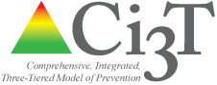

Ci3T Leadership Team: IMplementation Agenda April 03, 2018

Session 5: Planning for the Year Ahead

Agenda
- Welcome
- Procedures for Monitoring
  - Reviewing Your Implementation Data
  - Reviewing Your Screening Data
- Planning for the Year Ahead 2018-2019
- Utilizing Data-Informed Professional Learning
- Recommendations and Wrap Up

please visit ci3t.org for more information and resources.

