Ci3T Student Session 5 Clipart

Directions

* Print clipart for students to use during Session 5 to build tickets, setting expectation posters, and postcards
* Include grade level appropriate clipart for each setting (classroom, hallway, cafeteria, restroom, playground/common area, bus, arrival/dismissal)
* Add to the general clipart provided below by finding school-specific clipart for each school to show settings:
  + Include school logos, mascots, images related to mascots (e.g., paw prints for animal mascots, silhouettes of animals), and any other iconic imagery used by schools
  + Each school’s website is a great place to start
  + The clipart below is free of copyrights under Creative Commons and you may modify, distribute and use them royalty free; more information at https://creativecommons.org
  + Images below are vector based, meaning you can copy and resize them as needed without loss to quality
* Use the WordArt feature in Microsoft Word to create banners with the school name in school colors and in various shapes and sizes for students to use in the materials they create
* Create and print clipart pages for each school attending the Ci3T professional development series with a student team member

# SchoolName Elementary School

**Replace with school**

**LOGO**

**in various sizes**

**Replace with school**

**LOGO**

**in various sizes**

**Replace with school**

**LOGO**

**in various sizes**

**Replace with school**

**LOGO**

**in various sizes**

**School Name Elementary School**

**School Name Elementary School**

**School Name Elementary School**

## Classroom

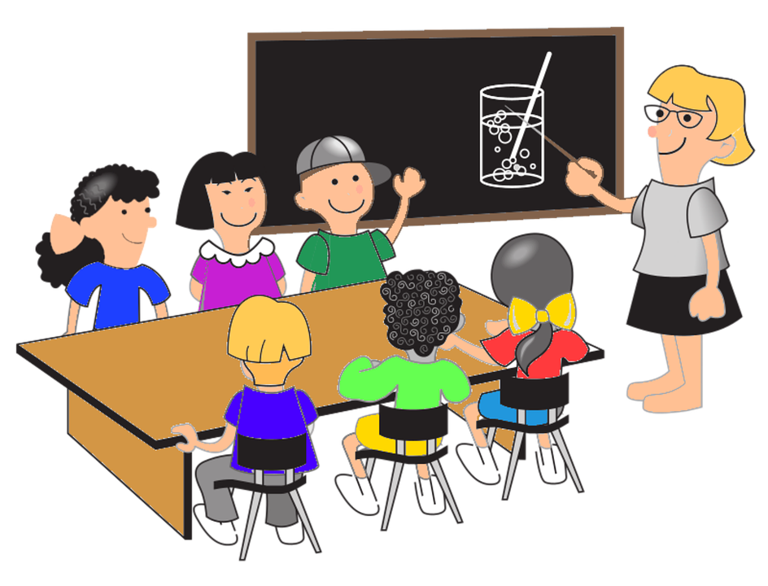  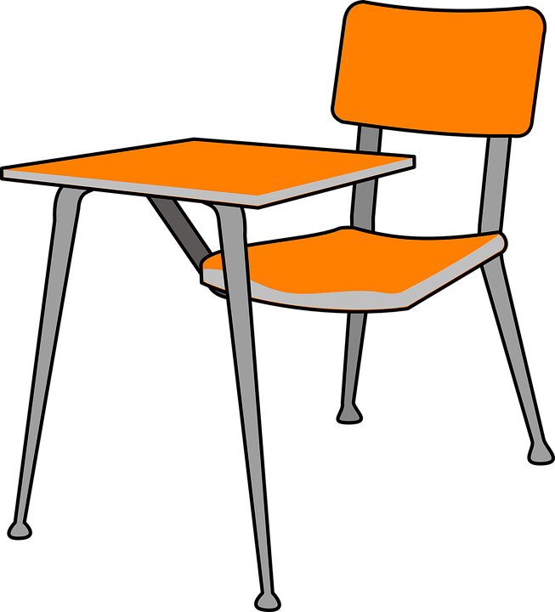   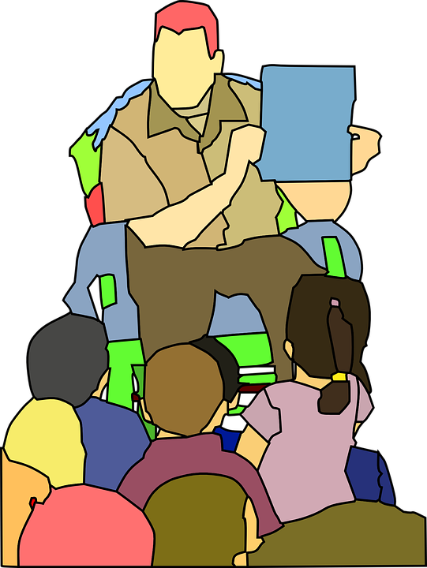 [](https://pixabay.com/en/school-pencil-pen-write-sketch-153561/) [](https://pixabay.com/en/binder-file-folder-office-1299915/) [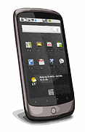](https://pixabay.com/en/nexus-one-smartphone-mobile-phone-295050/)[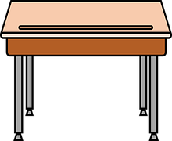](https://pixabay.com/en/desk-education-school-student-desk-1295603/) [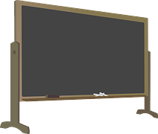](https://pixabay.com/en/blackboard-chalk-chalkboard-148590/) [](https://pixabay.com/en/graduation-cap-hat-achievement-309661/) [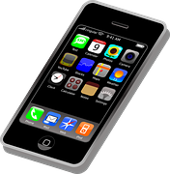](https://pixabay.com/en/iphone-cellphone-smartphone-mobile-37856/)

## Hallway

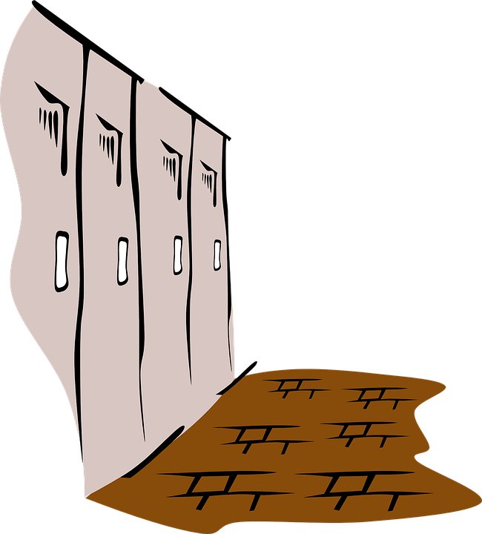

## Cafeteria

    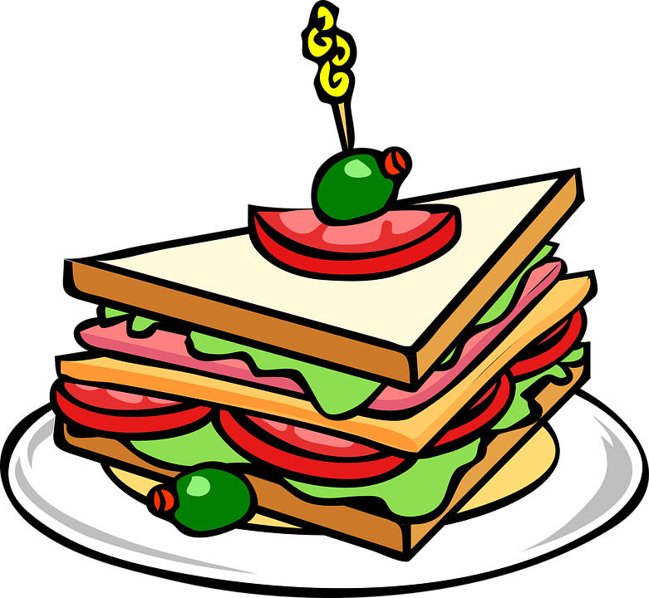 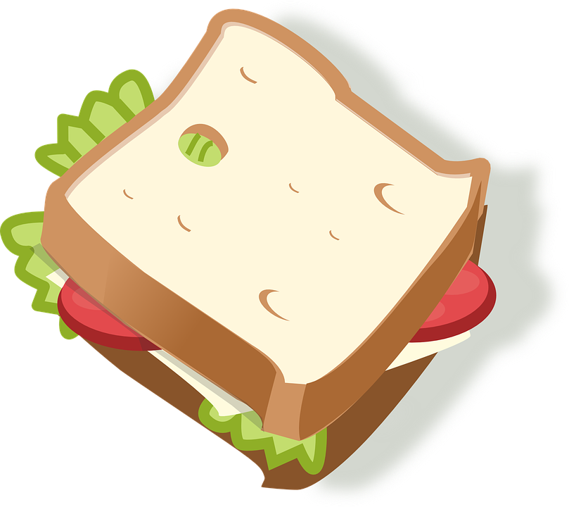 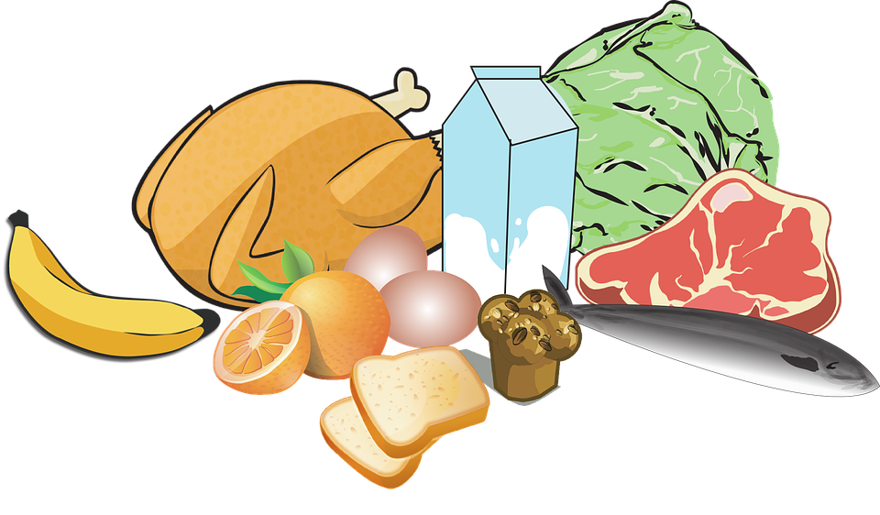

## Playground

[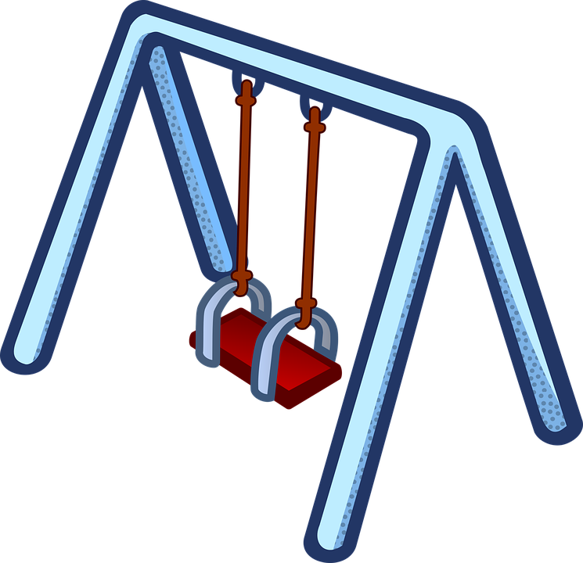](https://www.google.com/url?sa=i&rct=j&q=&esrc=s&source=images&cd=&cad=rja&uact=8&ved=0ahUKEwjRlbr-0NrMAhWm24MKHQa4DsoQjRwIBw&url=https://pixabay.com/en/children-play-kinder-playground-1295470/&bvm=bv.122129774,d.amc&psig=AFQjCNGACi1KL_PCOy-uDAbp5-lz_hV7pg&ust=1463351952659752) [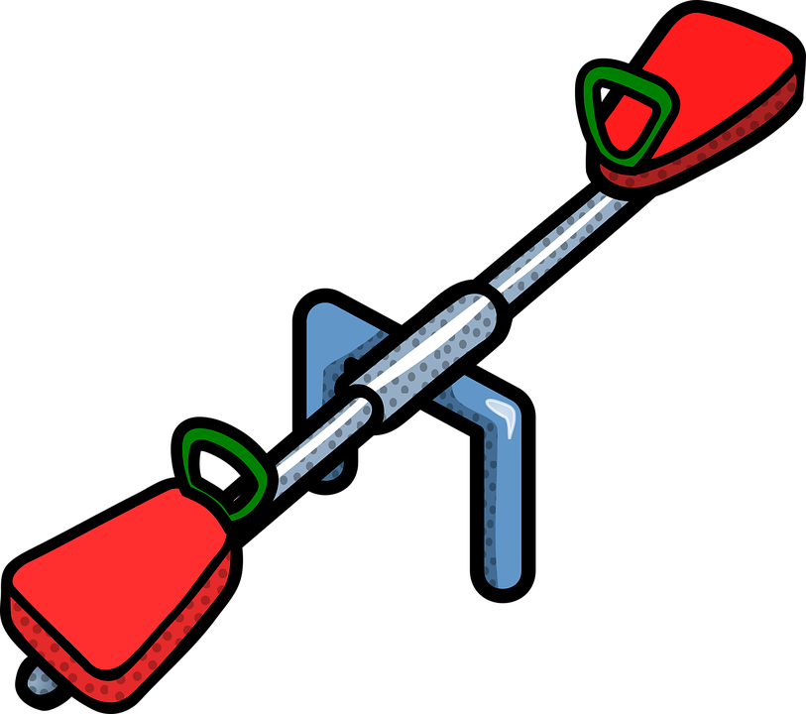](https://www.google.com/url?sa=i&rct=j&q=&esrc=s&source=images&cd=&cad=rja&uact=8&ved=0ahUKEwi8qoSJ0drMAhXsz4MKHXYiCP8QjRwIBw&url=https://pixabay.com/en/photos/playground/&bvm=bv.122129774,d.amc&psig=AFQjCNGACi1KL_PCOy-uDAbp5-lz_hV7pg&ust=1463351952659752)  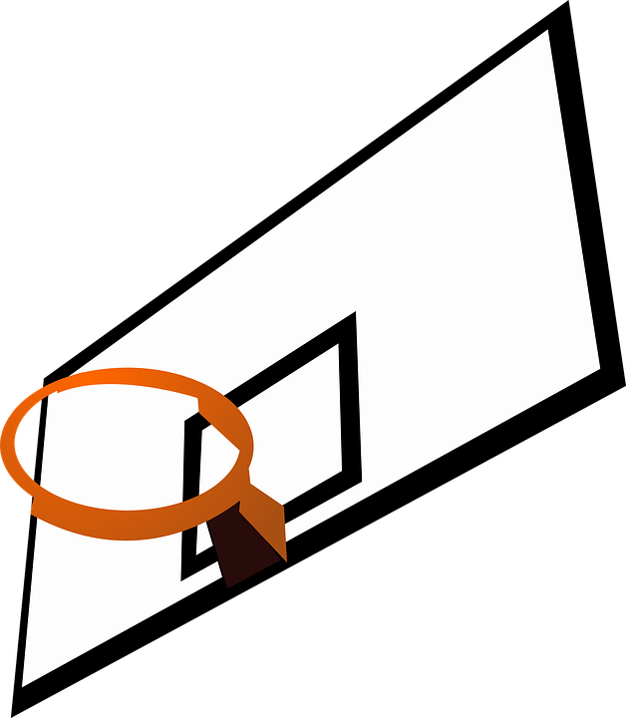 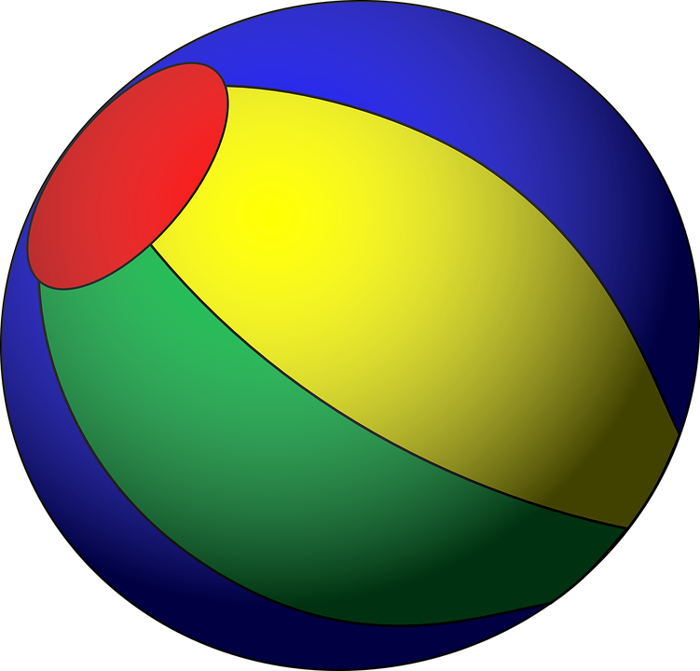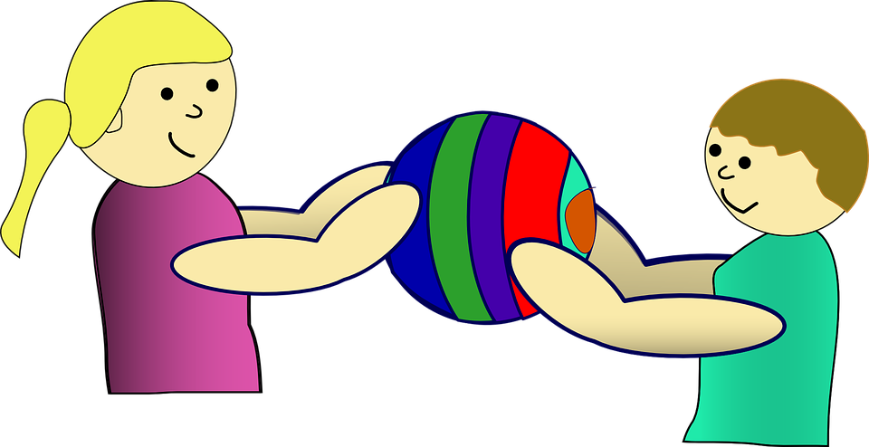 [](https://pixabay.com/en/american-football-football-egg-game-309795/)

## Restroom

[](https://pixabay.com/en/restroom-public-restroom-rest-room-99226/) [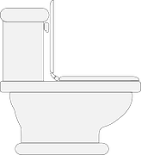](https://pixabay.com/en/toilet-restroom-lavatory-bathroom-145802/)[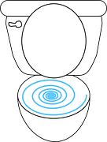](https://pixabay.com/en/toilet-open-bowl-bathroom-seat-34071/)[](https://pixabay.com/en/restroom-bathroom-sign-ladies-304986/)[](https://pixabay.com/en/toilet-paper-pink-hygiene-roll-30328/)

## Bus & Arrival/Dismissal

[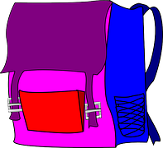](https://pixabay.com/en/backpack-school-bag-books-kids-33454/)