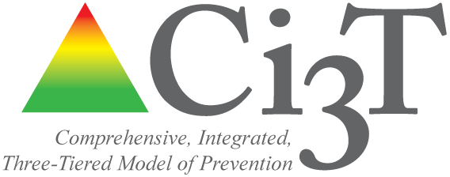

XXXXX School

Comprehensive, Integrated, Three-Tiered

(Ci3T) Model of

Prevention

Spring 20XX
Primary Intervention Rating Scale (PIRS)

Prepared by:

Primary Intervention Rating Scale (Lane, Robertson, & Wehby, 2002). Adapted with permission from J. C. Witt and S. N. Elliott (1985). Acceptability of classroom intervention strategies. In T. R. Kratochwill (Ed.). Advances in school psychology, Vol. 4 (pp. 251-288). Mahwah, NJ: Erlbaum.

Table of Contents

Survey Overview A
Social Validity (SV) Report B
Primary Intervention Rating Scale (PIRS)

REPORT SHARING

This report was designed to share faculty and staff feedback on the Ci3T plan. These data will be used to revise your school’s Ci3T model of prevention based on stakeholder input.

Document A
Survey Overview
Primary Intervention Rating Scale (PIRS)

Overview of the

Primary Intervention Rating Scale (PIRS)
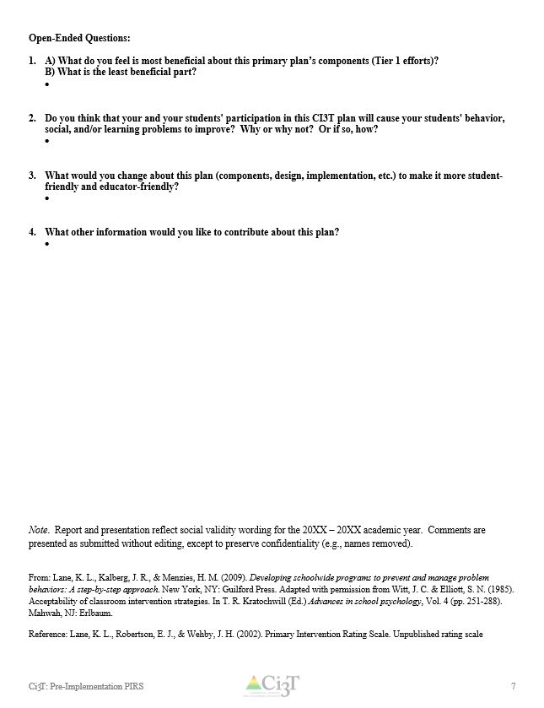
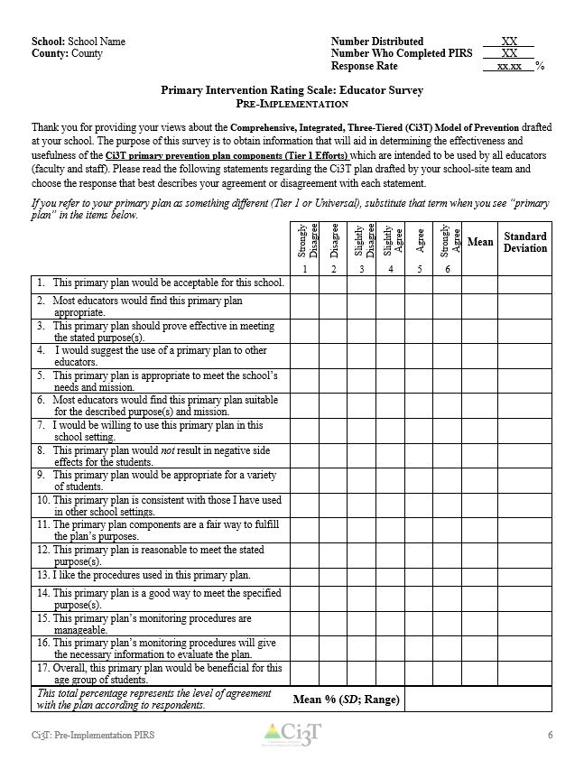
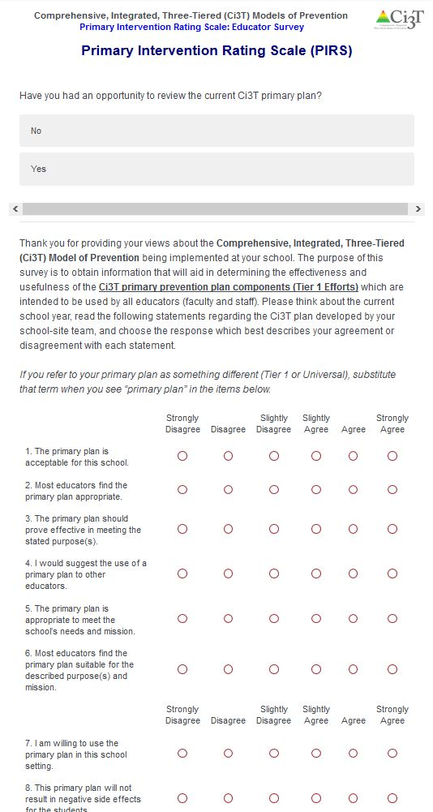
- Purpose: To obtain information from faculty and staff for revisions to the drafted Ci3T primary (Tier 1) plan components for your school.
- Logistics:
  - All faculty and staff were given the opportunity to complete the PIRS after the presentation of the draft Ci3T primary (Tier 1) plan.
  - Feedback, including data and comments, are aggregated in this report to share back to schools to revise elements of their school’s Ci3T plan based on feedback.

Survey data are aggregated and presented in this report
Document B
Social Validity (SV) Report
Primary Intervention Rating Scale (PIRS)

School: School Name Number Distributed XX
County/ District: County or District Number Who Completed PIRS XX
Response Rate xx.xx %

Primary Intervention Rating Scale: Educator Survey
Pre-Implementation

Thank you for providing your views about the Comprehensive, Integrated, Three-Tiered (Ci3T) Model of Prevention drafted at your school. The purpose of this survey is to obtain information that will aid in determining the effectiveness and usefulness of the Ci3T primary prevention plan components (Tier 1 efforts) which are intended to be used by all educators (faculty and staff). Please read the following statements regarding the Ci3T plan drafted by your school-site team and choose the response that best describes your agreement or disagreement with each statement.
If you refer to your primary plan as something different (Tier 1 or Universal), substitute that term when you see “primary plan” in the items below.
 | Strongly Disagree | Disagree | Slightly Disagree | Slightly Agree | Agree | Strongly Agree | Mean | Standard Deviation
 | 1 | 2 | 3 | 4 | 5 | 6
1. This primary plan would be acceptable for this school.
2. Most educators would find this primary plan appropriate.
3. This primary plan should prove effective in meeting the stated purpose(s).
4. I would suggest the use of a primary plan to other educators.
5. This primary plan is appropriate to meet the school’s needs and mission.
6. Most educators would find this primary plan suitable for the described purpose(s) and mission.
7. I would be willing to use this primary plan in this school setting.
8. This primary plan would not result in negative side effects for the students.
9. This primary plan would be appropriate for a variety of students.
10. This primary plan is consistent with those I have used in other school settings.
11. The primary plan components are a fair way to fulfill the plan’s purposes.
12. This primary plan is reasonable to meet the stated purpose(s).
13. I like the procedures used in this primary plan.
14. This primary plan is a good way to meet the specified purpose(s).
15. This primary plan’s monitoring procedures are manageable.
16. This primary plan’s monitoring procedures will give the necessary information to evaluate the plan.
17. Overall, this primary plan would be beneficial for this age group of students.
This total percentage represents the level of agreement with the plan according to respondents. | Mean % (SD; Range)
Open-Ended Questions:

- A) What do you feel is most beneficial about this primary plan’s components (Tier 1 efforts)?
B) What is the least beneficial part?

- Do you think that your and your students' participation in this CI3T plan will cause your students' behavior, social, and/or learning problems to improve? Why or why not? Or if so, how?

- What would you change about this plan (components, design, implementation, etc.) to make it more student-friendly and educator-friendly?

- What other information would you like to contribute about this plan?

Note. Report and presentation reflect social validity wording for the 20XX – 20XX academic year. Comments are presented as submitted without editing, except to preserve confidentiality (e.g., names removed).

From: Lane, K. L., Kalberg, J. R., & Menzies, H. M. (2009). Developing schoolwide programs to prevent and manage problem behaviors: A step-by-step approach. New York, NY: Guilford Press. Adapted with permission from Witt, J. C. & Elliott, S. N. (1985). Acceptability of classroom intervention strategies. In T. R. Kratochwill (Ed.) Advances in school psychology, Vol. 4 (pp. 251-288). Mahwah, NJ: Erlbaum.
Reference: Lane, K. L., Robertson, E. J., & Wehby, J. H. (2002). Primary Intervention Rating Scale. Unpublished rating scale

For more information, visit
www.ci3t.org

