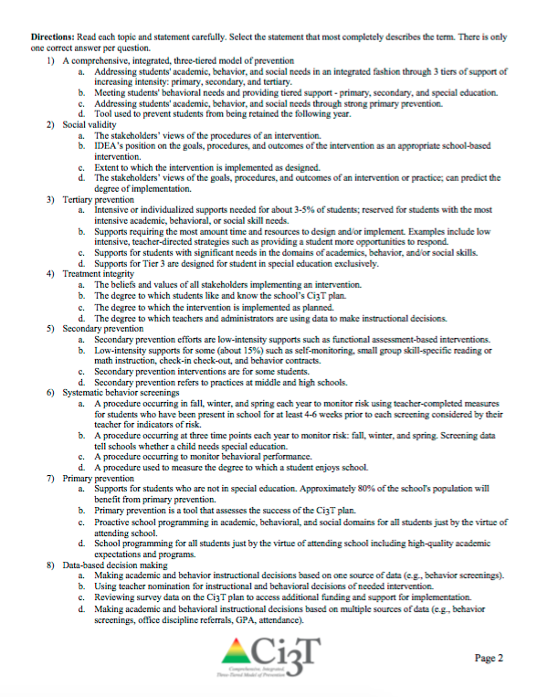
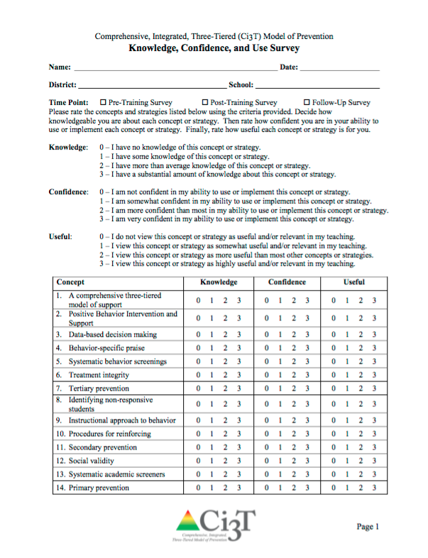
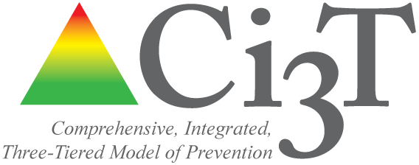

XXXXX SCHOOL

C omprehensive, Integrated,
Three-Tiered (Ci3T)

Model of Prevention
20XX-20XX
Knowledge Confidence and Use (KCU) Survey Report

This report can be used to show shifts in Ci3T Leadership Team participant knowledge, confidence and perceived usefulness of Ci3T concepts and strategies addressed during the Ci3T Professional Learning Series.

Prepared by:

Source: Lane, K. L. & Oakes, W. P. (2010). Project SUPPORT and INCLUDE: Knowledge, confidence, and use survey (full model training series). Unpublished rating scale.

School: County:

Comprehensive, Integrated, Three-Tiered (Ci3T) Model of Prevention
Knowledge, Confidence, and Use Survey
Please rate the concepts and strategies listed below using the criteria provided. Decide how knowledgeable you are about each concept or strategy. Then rate how confident you are in your ability to use or implement each concept or strategy. Finally, rate how useful each concept or strategy is for you.

Knowledge: 0 – I have no knowledge of this concept or strategy.
1 – I have some knowledge of this concept or strategy.
2 – I have more than average knowledge of this concept or strategy.
3 – I have a substantial amount of knowledge about this concept or strategy.

Confidence: 0 – I am not confident in my ability to use or implement this concept or strategy.
1 – I am somewhat confident in my ability to use or implement this concept or strategy.
2 – I am more confident than most in my ability to use or implement this concept or strategy.
3 – I am very confident in my ability to use or implement this concept or strategy.

Useful: 0 – I do not view this concept or strategy as useful and/or relevant in my teaching.
1 – I view this concept or strategy as somewhat useful and/or relevant in my teaching.
2 – I view this concept or strategy as more useful than most other concepts or strategies.
3 – I view this concept or strategy as highly useful and/or relevant in my teaching.

 | Pre-Training  n = |  |  | Post-Training  n = |  |  | Follow Up  n =
Concept | K  M (SD) | C  M (SD) | U  M (SD) | K  M (SD) | C  M (SD) | U  M (SD) | K  M (SD) | C  M (SD) | U  M (SD)
- A comprehensive three-tiered model of support
- Positive Behavior Intervention and Support
- Data-based decision making
- Behavior specific praise
- Systematic behavior screenings
- Treatment integrity
- Tertiary prevention
- Identifying non-responsive students
- Instructional approach to behavior
- Procedures for reinforcing
- Secondary prevention
- Social validity
- Systematic academic screeners
- Primary prevention
Total mean of all items (SD)

Directions: Read each topic and statement carefully. Select the statement that most completely describes the term. There is only one correct answer per question.

1) A comprehensive, integrated, three-tiered model of prevention | Percentage
- Addressing students' academic, behavior, and social needs in an integrated fashion through 3 tiers of support of increasing intensity: primary, secondary, and tertiary.
- Meeting students' behavioral needs and providing tiered support - primary, secondary, and special education.
- Addressing students' academic, behavior, and social needs through strong primary prevention.
- Tool used to prevent students from being retained the following year.
2) Social validity
- The stakeholders’ views of the procedures of an intervention.
- IDEA’s position on the goals, procedures, and outcomes of the intervention as an appropriate school-based intervention.
- Extent to which the intervention is implemented as designed.
- The stakeholders’ views of the goals, procedures, and outcomes of an intervention or practice; can predict the degree of implementation.
3) Tertiary prevention
- Intensive or individualized supports needed for about 3-5% of students; reserved for students with the most intensive academic, behavioral, or social skill needs.
- Supports requiring the most amount time and resources to design and/or implement. Examples include low intensive, teacher-directed strategies such as providing a student more opportunities to respond.
- Supports for students with significant needs in the domains of academics, behavior, and/or social skills.
- Supports for Tier 3 are designed for student in special education exclusively.
4) Treatment integrity
- The beliefs and values of all stakeholders implementing an intervention.
- The degree to which students like and know the school’s CI3T plan.
- The degree to which the intervention is implemented as planned.
- The degree to which teachers and administrators are using data to make instructional decisions.
5) Secondary prevention
- Secondary prevention efforts are low-intensity supports such as functional assessment-based interventions.
- Low-intensity supports for some (about 15%) such as self-monitoring, small group skill-specific reading or math instruction, check-in check-out, and behavior contracts.
- Secondary prevention interventions are for some students.
- Secondary prevention refers to practices at middle and high schools.
6) Systematic behavior screenings
- A procedure occurring in fall, winter, and spring each year to monitor risk using teacher-completed measures for students who have been present in school for at least 4-6 prior to each screening considered by their teacher for indicators of risk.
- A procedure occurring at three time points each year to monitor risk: fall, winter, and spring. Screening data tell schools whether a child needs special education.
- A procedure occurring to monitor behavioral performance.
- A procedure used to measure the degree to which a student enjoys school.

7) Primary prevention
- Supports for students who are not in special education. Approximately 80% of the school's population will benefit from primary prevention.
- Primary prevention is a tool that assesses the success of the CI3T plan.
- Proactive school programming in academic, behavioral, and social domains for all students just by the virtue of attending school.
- School programming for all students just by the virtue of attending school including high-quality academic expectations and programs.
8) Data-based decision making
- Making academic and behavior instructional decisions based on one source of data (e.g., behavior screenings).
- Using teacher nomination for instructional and behavioral decisions of needed intervention.
- Reviewing survey data on the CI3T plan to access additional funding and support for implementation.
- Making academic and behavioral instructional decisions based on multiple sources of data (e.g., behavior screenings, office discipline referrals, GPA, attendance).
9) Positive behavior interventions and support
- Using tickets and rewards to bribe students to behave appropriately.
- Establishing a school-wide model of prevention with clear expectations, teaching behaviors across all school settings, reinforcing students for meeting expectations, and using data to monitor student progress – a clearly defined proactive response and discipline plan.
- Establishing a school-wide model of prevention with clear expectations, teaching behaviors across all school settings, and reinforcing students who go above and beyond expectations, and reinforcing students with a system that is individual to each teacher (e.g., tickets, pulling a card, marble jar).
- Establishing a model of prevention with clear expectations and reinforcement across all school settings.
10) Behavior-specific praise
- Greeting students with a “high-five” when they come in to the classroom. “Hey! Great to see you today!”
- Praising other students next to the target student for whom you are trying to prompt the expected behavior, then prompting the student if necessary.
- Telling the student that they are meeting an expectation.
- Pairing a positive praise statement to a student with the specific behavior regarding the expectation that was met. “Jeremy, thank you for working with your group to clean up after art; that shows respect for our classroom.”
11) Identifying non-responsive students
- Using teacher referrals to determine students who do not progress because they ignore instruction and teacher directions.
- Regularly evaluating data from measures that are sensitive to change to determine which students need additional instruction or supports to meet expectations.
- Using office referrals to determine students who are disruptive and shouldn’t be included in school-wide activities.
- Evaluating data from measures to determine which students need additional instruction or supports.

12) Instructional approach to behavior
- Sending information home on the behavioral expectations for students and asking parents to make sure their student knows those expectations.
- Having students tell the teacher what they did wrong when they do not behave as expected in class.
- Providing multiple examples and non-examples of appropriate behavior (e.g., reading stories about students who get in trouble.
- Teaching the school-wide expected behaviors using strategies similar to those used for academic instruction – lessons that teach the behavior directly and offer guided practice, feedback, and reinforcement.
13) Procedures for reinforcing
- Using multiple sources of data to make instructional decisions.
- For example, each week the principal randomly selects the name of a student to be featured in that week’s newsletter home to parents.
- Having clearly defined school-wide procedures for communicating to stakeholders that they are meeting the expected roles and responsibilities with fidelity.
- Giving all students who received good grades on their report cards PBIS tickets for being smart.
14) Systematic academic screeners
- Brief measures to assess student academic performance.
- Brief, validated measures that predict important learning outcomes.
- Efficient measures of student opinion about the quality of their reading and math instruction.
- Efficient, validated, sensitive measures with evidence to predict important learning outcomes administered to students who are identified as below grade level in reading or math.

Knowledge, Confidence, and Use Survey: Mean Score Comparisons

 | Time Point
Construct | Pre-Training  M (SD) | Post-Training  M (SD) | Effect Size  Hedges’s g
Knowledge | xx.xx (xx.xx)  n = xx | xx.xx (xx.xx)  n = xx | x.xx
Confidence | xx.xx (xx.xx)  n = xx | xx.xx (xx.xx)  n = xx | x.xx
Use | xx.xx (xx.xx)  n = xx | xx.xx (xx.xx)  n = xx | x.xx

