This box is a placeholder for school logo

School Name
School Year 20XX-20XX
Implementation Manual
Comprehensive, Integrated, Three-Tiered (Ci3T)
Model of Prevention

Plan Designed by SCHOOL NAME Ci3T Leadership Team Members:

Member Name
Member Name
Member Name
Member Name
Member Name
Member Name
Member Name
Member Name

Ci3T Model of Prevention Implementation Manual

Table of Contents

Page
SCHOOL NAME Implementation Manual 3
Mission Statement 3
Statement of Purpose 3
Overview of the Ci3T Model of Prevention 4
SCHOOL NAME Primary (Tier 1) Plan 11
Expectation Matrix xx
Assessment Schedule xx
Reactive Plan and Discipline Procedures xx
Secondary (Tier 2) Intervention Grid xx
Tertiary (Tier 3) Intervention Grid xx
Frequently Asked Questions xx
References xx

SCHOOL NAME Implementation Manual

It is the goal of SCHOOL NAME YOUR GOAL STATEMENT HERE. In an effort to meet this goal, SCHOOL NAME has adopted a comprehensive, integrated, three-tiered (Ci3T) model of prevention (Lane, Oakes, & Menzies, 2010). This Ci3T model is designed to address our students’ academic, behavioral, and social needs using a continuum of supports, including a proactive approach for addressing students’ needs in all three areas. We have established systematic screening practices and a continuum of supports, ranging from universal, broad-based strategies to targeted and individualized interventions. The three-tiered model provides for: primary prevention (Tier 1 supports for all), secondary prevention (Tier 2 supports for some), and tertiary interventions and supports (Tier 3 supports for a few). The goal is to create a safe, positive learning environment including the accurate detection of students who need additional support beyond primary (Tier 1) prevention efforts and then providing these students with additional secondary (Tier 2) and tertiary (Tier 3) evidence-based supports.
This manual is a tool to help describe and explain the Ci3T model of prevention that our Ci3T Leadership Team designed based on: (a) our school’s specific needs and goals, and (b) feedback given to our team by our faculty and staff members.

Mission Statement
The mission of SCHOOL NAME is: insert mission statement

Statement of Purpose
The purpose of the comprehensive, integrated, three-tiered (Ci3T) model of prevention at SCHOOL NAME is: insert statement of purpose

Overview of the Comprehensive, Integrated,
Three-Tiered (Ci3T) Model of Prevention

SCHOOL NAME has developed a Ci3T plan for all students attending grades ENTER GRADES. This plan addresses three key components: academics, behavior, and social skills. This plan has both a proactive and reactive behavioral component. SCHOOL NAME’s plan was developed in response to information derived from school-wide surveys and student performance measures to determine teachers’ expectations and areas of need at SCHOOL NAME.

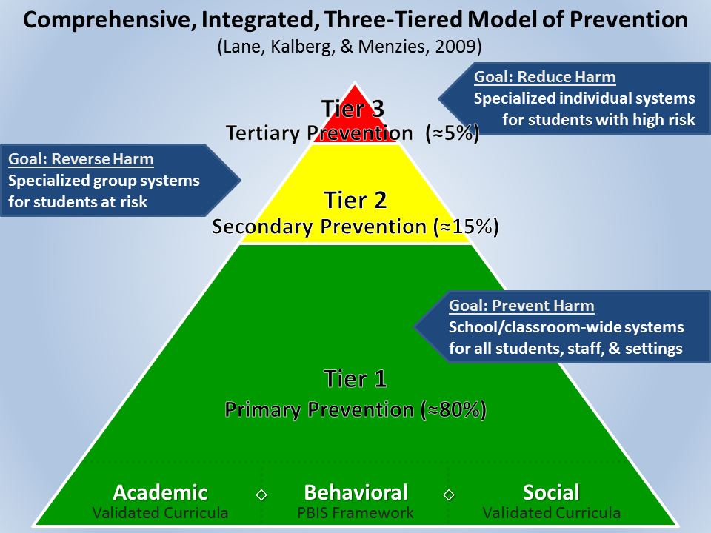
Ci3T Model of Prevention (Lane, Kalberg, & Menzies, 2009)

Three-Tiered Models of Prevention
There are three-tiered models of prevention used in schools today including response-to-intervention (RTI; Gresham, 2002; Sugai, Horner, & Gresham, 2002), positive behavioral interventions and supports (PBIS; Lewis & Sugai, 1999; Sugai & Horner, 2002), as well as other tiered systems. While these models aim to identify and serve students proactively with increasingly intensive levels of support, the models differ in their area of focus (RTI mainly on academic skills and PBIS mainly on behavior). Some educators advocate for the use of a comprehensive, integrated, three-tiered (Ci3T) model of prevention that combines the areas of academic, behavioral, and social skills to meet students’ multiple needs given that problems in these three areas are likely to manifest concurrently (Lane & Wehby, 2002; Lane, Kalberg, & Menzies, 2009; Lane, Oakes, Menzies, & Harris, 2013; Walker et al., 2004). A comprehensive, integrated, three-tiered model can address each area through screening procedures to identify students who have multiple needs.
Implementing any new system to improve student outcomes requires an initial investment of time and energy. However, multi-tiered models capitalize on effective instructional and classroom management practices that teachers already use (Lane, Menzies, Ennis, & Bezdek, 2013). One strength of Ci3T models is that they involve contribution from all faculty and staff to establish common expectations and procedures in academic, behavioral, and social domains. Then, these changes occur at a systems level. When a school’s staff members work collaboratively to identify and implement agreed upon strategies and practices, they create an opportunity to establish a positive school culture. Moreover, in a Ci3T model, school-site faculty and staff all have a voice: they individually and collectively contribute to decisions about behavioral expectations taught to all students to support positive behavior and facilitate participation in instruction. In addition – and equally important – faculty and staff determine a shared system for recognizing and reinforcing students’ efforts to reach those expectations. This is a major departure from previous models in which each teacher sets his or her own rules and has sole individual responsibilities for their own students. It is also a shift away from reactive approaches that involved focusing mainly on students’ misbehavior toward an instructional approach to behavior that involves actively looking for and recognizing students’ positive student behaviors using behavior-specific praise. Finally, expecting the entire school staff (e.g., office and custodial personnel, instructional aides, bus drivers) to support school-wide behavioral expectations as well as the school-wide social skills empowers them to participate proactively and positively, while teaching students the full skill sets needed to engage fully in instructional activities (Lane, Menzies, Ennis, & Bezdek, 2013)
Primary (Tier 1) prevention. In a Ci3T model, primary (Tier 1) prevention, or the core program, is designed to be preventative and includes academic, social, and behavioral components for all students. The academic component consists of the school or district chosen validated academic curriculum based on state standards and requires that all teachers deliver effective instruction.
To address students’ social needs, school site personnel may choose to implement a social skills curriculum (Elliott & Gresham, 2007a) or character education program (e.g., Positive Action; Allred, 1983). The focus of the social curriculum is determined by the school’s unique needs (e.g., the need to decrease bullying behavior). An evidence-based program should be selected, one with sufficient evidence to suggest that the desired changes will be observed at a given school site provided that the program is implemented with fidelity.
Finally, the behavioral component is a positive behavior interventions and support framework in which school site personnel establish 3-5 schoolwide expectations for student conduct (e.g., be respectful, be responsible, and be prepared to give best effort). The critical component here is that school staff explicitly teach all students the expectations which are operationally defined for each key setting in the building (e.g., classroom, hallways, cafeteria). Next, students have multiple practice opportunities where teachers model the expectations and then coach students on how to demonstrate them. Students demonstrating expectations are reinforced with behavior-specific praise. Some schools develop elaborate PBIS reinforcement plans that include school assemblies and tangible rewards, others implement on a smaller scale making decisions based on beliefs and resources. In either case, the important factor is that all students are directly taught and provided reinforcement for demonstrating the schoolwide expectations. The overall goal is to provide students with a behavioral repertoire that allows time for teaching and learning. Thus, teachers gain additional time to teach the academic and social skill or character development programs constituting the primary plan. Investing time in this instructional approach to behavior by explicitly teaching schoolwide expectations for behavior upfront, teachers will devote less time to addressing problem behaviors and may experience less stress (as will students) in the learning environment.
Implementing these three areas of foci schoolwide, all students are supported behaviorally, socially, and academically. Eighty percent of students are expected to respond satisfactorily and not require further intervention (Sugai & Horner, 2006). However, to determine which students need more intensive support, systematic screenings are conducted. The screenings will identify students for secondary (Tier 2) or tertiary (Tier 3) interventions.
Secondary (Tier 2) prevention. Secondary (Tier 2) supports are typically offered to small groups of students experiencing similar needs. For example, there might be groups to improve oral reading fluency using repeated readings (Chard, Ketterlin-Geller, Baker, Doabler, & Apichatabutra, 2009), peer-peer interactions using social skills groups (Kalberg, Lane, & Lambert, 2012; Lane, Menzies, Barton-Arwood, Doukas, & Munton, 2005; Miller, Lane, & Wehby, 2005) and anger management groups to improve conflict resolution skills (Kalberg, Lane, & Lambert, 2012). Decisions regarding which students and the types of supports needed are made using systematic screening data in conjunction with other data (e.g., office discipline referrals, absenteeism, and academic progress). Approximately 15% of students are apt to require this level of prevention. Students who do not respond to Tier 2 supports or those exposed to multiple risk factors are likely to require more intensive interventions and supports referred to as Tier 3 or tertiary prevention.
Tertiary (Tier 3) prevention. Tertiary (Tier 3) supports are the most intensive supports and are most often individualized. Examples include individualized reading programs (e.g., Scott Foresman Early Reading Intervention, Pearson Education, 2010), functional assessment-based interventions (Kern & Manz, 2004; Umbreit, Ferro, Liaupsin, & Lane, 2007), and intensive family supports (e.g., First Step to Success, Walker, Stiller et al., 1997). Tier 3 is typically reserved for students who experience multiple risk factors or for whom previous intervention efforts have been insufficient. Students may be immediately identified for tertiary intervention or may proceed through the tiers of increasing levels of intervention offered while responsiveness is closely monitored.
Tier 2 and 3 interventions are designed to meet the students’ specific characteristics and learning needs whether they are behavioral, social, academic, or combined. In these more intensive levels, students are monitored to determine whether they are responding to the intervention. School site personnel use this information to make instructional decisions regarding the continued need for the intervention, a change in the intervention or support, or a discontinuation of additional supports because the remediation has been successful.
This model uses a data-driven approach to both prevention and intervention, thereby meeting the increasing demand of data-based decision making. It also aims to respond to learning and behavior problems by capitalizing on currently available resources. Yet, an essential component of this model that is often overlooked is the accurate and early detection of students who require Tier 2 and Tier 3 supports. Screening tools are used to meet this charge by systematically measuring academic and socio-behavioral performance.

Systematic Screening within Tiered Models of Prevention
Screener procedures are essential for effective schoolwide prevention systems. They are the tools for early and accurate detection of students in need across the preK-12 continuum. Age appropriate screening tools should be used at each level of schooling (preschool, elementary, middle, and high school) to address the unique demands at each level. Differences in students’ developmental growth mean that they experience different risk factors related to their age. One of the most critical milestones students attain early in their school careers is learning to read. Those who are not proficient readers by fourth grade are likely to struggle academically throughout their school years (Fletcher, Foorman, Boudousquie, Barnes, Schatschneider, & Francis, 2002; Juel, 1988). Middle school students are entering adolescence which can be a time of emotional turmoil which can make it difficult to focus on academic learning. In high school, many demands, interests, and challenges compete with students’ ability to complete their required programs. Graduating high school is a gatekeeper of future success and students with behavioral, emotional, and academic challenges are at greatest risk for dropping out (Wagner & Davis, 2006). Screening tools at each level of schooling can help systematically identify those who require more support to ensure school success.
In sum, systematic screening procedures are necessary at all school levels, particularly as the behavioral, social, and academic demands change. It is imperative that a systematic approach be used in order to avoid missing students who would benefit from additional supports within the context of integrated three-tiered models of prevention.
Adapted from Lane, K. L., Oakes, W. P., & Menzies, H. M. (2010). Systematic screenings to prevent the development of learning and behavior problems: Considerations for practitioners, researchers, and policy makers. Journal of Disability Policy Studies, 21, 160-172.
Lane, K. L., Oakes, W. P., Menzies, H. M., & Harris, P. J. (2013). Developing comprehensive, integrated, three-tiered models to prevent and manage learning and behavior. In T. Cole, H. Daniels, & J. Visser (Eds.). The Routledge international companion to emotional and behavioural difficulties problems (pp. 177- 183). New York, NY: Routledge.
Lane, K. L., Menzies, H. M., Ennis, R. P., & Bezdek, J. (2013). Schoolwide systems to promote positive behaviors and facilitate instruction. Journal of Curriculum and Instruction, 7, 6-31.
Technical Assistance Center on Positive Behavioral Interventions and Supports: http://www.pbis.org

Please see the full articles for a more detailed description.

SCHOOL NAME Ci3T Primary (Tier 1) Plan

INSERT Ci3T Blueprint A Primary (Tier 1) Plan HERE

SCHOOL NAME Expectation Matrix

INSERT Ci3T Blueprint C Expectation Matrix HERE

SCHOOL NAME Assessment Schedule

INSERT Ci3T Blueprint D Assessment Schedule HERE

Reactive Plan: Responding to Problem Behavior

INSERT Ci3T Blueprint B Reactive Plan HERE

SCHOOL NAME Secondary (Tier 2) Intervention Grid

INSERT Ci3T Blueprint E Secondary (Tier 2) Intervention Grid HERE

SCHOOL NAME Tertiary (Tier 3) Intervention Grid

INSERT Ci3T Blueprint F Tertiary (Tier 3) Intervention Grid HERE

Frequently Asked Questions

Q: Do I still use my reactive procedures (e.g., pull a card, complete an office discipline referral form) if a student misbehaves?
A:

Q: Can I still use my current classroom reward system (e.g., marble jar, clip-up chart)?
A:

Q: Can I keep my own classroom rules if I also teach my students the schoolwide expectations?
A:

Q: Where do I get __________ tickets to hand out?
A:

Q: Where can I find posters to put in my room?
A:

Q: Where should I instruct students to place their tickets?
A:

Q: Whom do I ask if I have questions about the Ci3T plan?
A:

Q: What about the students who do not respond to the positive behavior interventions and supports ticket system?
A:

Q: What are the benefits of merging our positive behavior interventions and supports and response to intervention into one comprehensive three-tiered model of prevention?
A:

Q: How do I access additional professional learning for academic, behavior, or social skills programs and practices?
A:

Q: Whom do I ask if I am unclear about any procedure?
A:

Q: Add more questions here you anticipate from faculty and staff.
A:

References

Chard, D. J., Ketterlin-Geller, L. R., Baker, S. K., Doabler, C., & Apichatabutra, C. (2009). Repeated reading interventions for students with learning disabilities: Status of the evidence. Exceptional Children, 75, 263–281.
Elliott, S. N., & Gresham, F. M. (2007a). Social Skills Improvement System: Classwide intervention program guide. Bloomington, MN: Pearson Assessments.
Fletcher, J. M., Foorman, B. R., Boudousquie, A., Barnes, M., Schatschneider, C., & Francis, D. J. (2002). Assessment of reading and learning disabilities: A research-based, treatment-oriented approach. Journal of School Psychology, 40, 27–63.
Gresham, F. M. (2002). Responsiveness to intervention: An alternative approach to learning disabilities. In R. Bradley, L. Danielson, & D. Hallahan (Eds.), Identification of learning disabilities: Research to practice (pp. 467-519). Mahwah, NJ: Lawrence Erlbaum.
Juel, C. (1988). Learning to read and write: A longitudinal study of 54 children from first through fourth grades. Journal of Educational Psychology, 80, 437–447.
Kalberg, J. R., Lane, K. L., & Lambert, W. (2012). The utility of conflict resolution and social skills interventions with middle school students at risk for antisocial behavior: A methodological illustration. Remedial and Special Education, 33(1), 23-38. doi: 10.1177/0741932510362514
Kern, L., & Manz, P. (2004). A look at current validity issues of school-wide behavior support. Behavioral Disorders, 30(1), 47-59.
Lane, K. L., Kalberg, J. R., & Menzies, H. M. (2009). Developing schoolwide programs to prevent and manage problem behaviors: A step-by-step approach. New York, NY: Guilford.
Lane, K. L., Menzies, H., Barton-Arwood, S. M., Doukas, G. L., & Munton, S. M. (2005). Designing, implementing, and evaluating social skills interventions for elementary students: Step-by-step procedures based on actual school-based investigations. Preventing School Failure, 49, 18-26.
Lane, K. L., Menzies, H. M., Ennis, R. P., & Bezdek, J. (2013). Schoolwide systems to promote positive behaviors and facilitate instruction. Journal of Curriculum and Instruction, 7, 6-31.
Lane, K. L., Oakes, W. P., & Menzies, H. M. (2010). Systematic screenings to prevent the development of learning and behavior problems: Considerations for practitioners, researchers, and policy makers. Journal of Disability Policy Studies, 21, 160-172.
Lane, K. L., Oakes, W. P., Menzies, H. M., & Harris, P. J. (2013). Developing comprehensive, integrated, three-tiered models to prevent and manage learning and behavior. In T. Cole, H. Daniels, & J. Visser (Eds.). The Routledge international companion to emotional and behavioural difficulties problems (p. 177 – 183). New York, NY: Routledge.
Lane, K. L., & Wehby, J. (2002). Addressing antisocial behavior in the schools: A call for action. Academic Exchange Quarterly, 6, 4–9.
Lewis, T. J., & Sugai, G. (1999). Effective behavior support: A systems approach to proactive school-wide management. Focus on Exceptional Children, 31, 1–24.
Miller, M. J., Lane, K. L., & Wehby, J. (2005). Social skills instruction for students with high incidence disabilities: An effective, efficient approach for addressing acquisition deficits. Preventing School Failure, 49, 27–40.
Pearson Education (Ed.). (2010). Scott Foresman Early Reading Intervention. Glenview, IL: Author.
Positive Action. (2008). Positive Action: Positive development for schools, families and communities. Twin Falls, ID: Author.
Sugai, G., & Horner, R. (2002). The evolution of discipline practices: Schoolwide positive behavior supports. Child & Family Behavior Therapy, 24, 23–50.
Sugai, G., & Horner, R. H. (2006). A promising approach for expanding and sustaining school-wide positive behavior support. School Psychology Review, 35, 245–260.
Sugai, G., Horner, R., & Gresham, S. (2002). Behaviorally effective school environments. In M. R. Shinn, H. M. Walker, & G. Stoner (Eds.), Interventions for academic and behavior problems II: Preventive and remedial approaches (pp. pp. 315–350). Washington, DC: National Association of School Psychologists.
Umbreit, J., Ferro, J., Liaupsin, C., & Lane, K. (2007). Functional behavioral assessment and function-based intervention: An effective, practical approach. Upper Saddle River, NJ: Prentice Hall.
Wagner, M., & Davis, M. (2006). How are we preparing students with emotional disturbances for the transition to young adulthood? Findings from the National Longitudinal Transition Study–2. Journal of Emotional and Behavioral Disorders, 14, 86–98.
Walker, H., Stiller, B., Golly, A., Kavanagh, K., Severson, H., & Feil, E. (1997). First Step to Success: Helping young children overcome antisocial behavior (an early intervention program for grades K-3). Longmont, CO: Sopris West.
Walker, H. M., Ramsey, E., & Gresham, F. M. (2004). Antisocial behavior in school: Evidence-based practices (2nd ed.). Belmont, CA: Wadsworth.

