Template:
  - Individualized De-escalation Support Plan

Student: Date:

Teacher: Grade:

Staff present:
 | Assessment (student characteristics) | Strategies (specific adult responses)

CALM

TRIGGERS

AGITATION

ACCELERATION

PEAK

DE-ESCALATION

RECOVERY
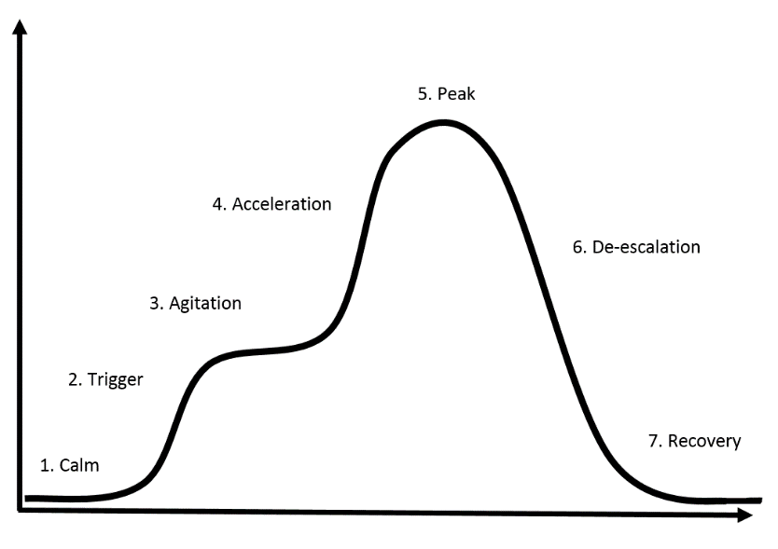
Intensity
Time

